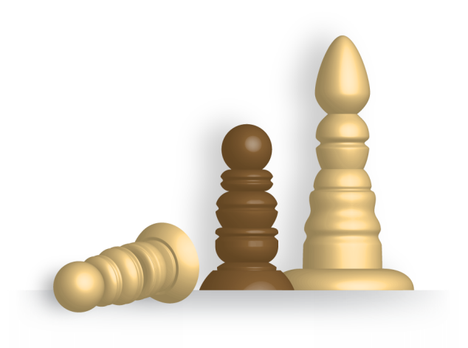
Stage 1 General Mathematics

Assessment Type 2: Mathematical Investigation

Topic 2: Measurement

Outdoor Chessmen

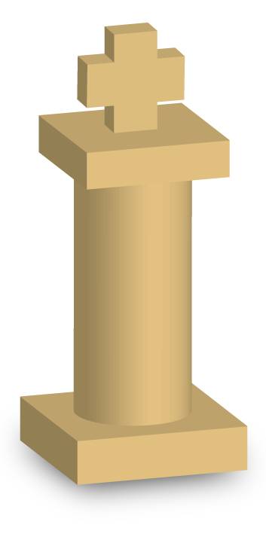
Your task is to design one chess piece for an outdoor chess set.

You need to decide which piece you are going to design –
Pawn, Knight, Rook (castle), Bishop, King or Queen.

You might like to have a look at designs that other people have used before you make your own design. There are plenty of outdoor chess set images on the internet for you to get some inspiration from. There’s a really way out set made for outdoor playing in a desert at night to be seen at the web site http://www.curple.com/chess/ if you’re interested.

Your design is required to be composed of mathematical solids.

These can be as simple or as complex as you like but the design must utilise at least two types of shape (see below), and have at least 4 parts:
- one of which has planar faces
- one which has a curved surface
- you could consider one shape which is ‘pointy’ or part of a pointy shape (for example a pyramid or truncated cone) for more complexity.

The complexity of the shapes you use in your design will determine the level of complexity in the calculations you have to carry out. Using only simple shapes may lead to calculations that are all routine in nature. Your chess piece must show pleasing proportions and fit comfortably on a paver which measures 290mm square. The chess piece needs to be a comfortable height for an adult to pick up and walk with to move it.
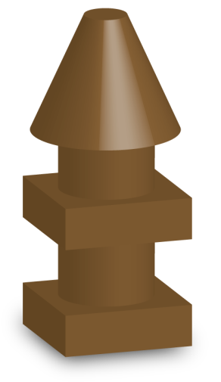

Part One – The Design
Create a design following the guidelines above. Draw a reasonable sketch of what your piece will look like and include the relevant measurements (no calculations are needed at this point).

Have your design approved by your teacher before you proceed with the investigation.

Part Two – Estimating and Calculating Volume
a) Consider what kind of simple solid would have approximately the same volume as your chess piece design. Using a few appropriate measurements from your design and your chosen approximate shape, find an estimate of the volume of the piece. For example, the shape on the previous page could be considered to be approximately cylindrical so an estimate of its volume could be calculated using height and average width. Show the process you use to do this.
b) Carry out all the calculations needed to find the actual volume of lightweight concrete that would be needed to manufacture your chess piece. You must show all working, formulas used, and measurement units. Set the calculations out clearly.
c) Compare your answers for parts a) and b) and discuss how accurate your prediction was. Are there are any ways that you could make a more accurate prediction without carrying out the full calculations?

Part Three – Calculating Surface Area
Carry out all the calculations needed to find the surface area that would need to be painted to protect and decorate your chess piece (this area includes all surfaces that are exposed to the air). As in Part Two, you must show all working, formulas used and measurement units, and set the calculations out clearly.
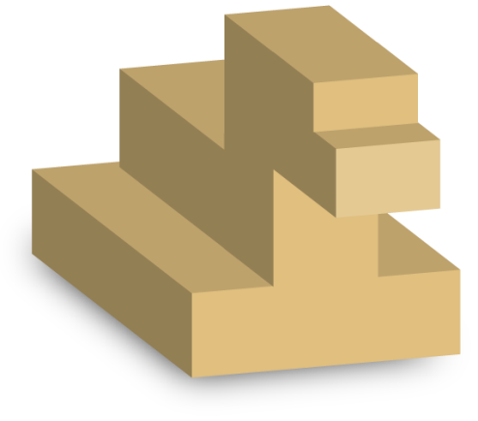
Part Four – Calculating Cost
The lightweight concrete has a density of 0.0823 g/cm³ and costs $34.95 for a 15kg bag. The special ‘glow in the dark’ decorative paint is $27.25 for a 500ml tin and can cover 16 m² per litre.

Use the information above to calculate the cost of making your chess piece. Show all your calculations clearly.

Part Five – The Report

- Write an introduction which explains in your own words what this project is about and how you went about deciding on your design.
- Include the 3D sketch of your design from Part 1 (this can be done on a computer if you have software that will do 3D drawing) and a scaled diagram of the profile(s) of your design showing the measurements.
- Provide all calculations and any discussion from Parts 2 to 4.
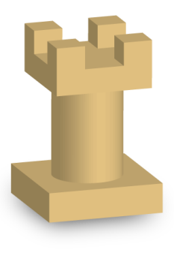


- A conclusion summarising your results, and a discussion of any assumptions that you have made and limitations to your results for this task.

Performance Standards for Stage 1 General Mathematics
 | Concepts and Techniques | Reasoning and Communication
A | Comprehensive knowledge and understanding of concepts and relationships.  Highly effective selection and application of mathematical skills, techniques, and algorithms to find efficient and accurate solutions to routine and complex problems in a variety of contexts.  Successful development and application of mathematical models to find concise and accurate solutions.  Appropriate and effective use of electronic technology to find accurate solutions to routine and complex problems. | Comprehensive interpretation of mathematical results in the context of the problem.  Drawing logical conclusions from mathematical results, with a comprehensive understanding of their reasonableness and limitations.  Proficient and accurate use of appropriate mathematical notation, representations, and terminology.  Highly effective communication of mathematical ideas and information reasoning to develop logical and concise arguments.  Formation and testing of appropriate predictions, using sound mathematical evidence.
B | Some depth of knowledge and understanding of concepts and relationships.  Mostly effective selection and application of mathematical skills, techniques, and algorithms to find mostly accurate solutions to routine and some complex problems in a variety of contexts.  Attempted development and successful application of mathematical models to find mostly accurate solutions.  Mostly appropriate and effective use of electronic technology to find mostly accurate solutions to routine and some complex problems. | Mostly appropriate interpretation of mathematical results in the context of the problem.  Drawing mostly logical conclusions from mathematical results, with some depth of understanding of their reasonableness and limitations.  Mostly accurate use of appropriate mathematical notation, representations, and terminology.  Mostly effective communication of mathematical ideas and information reasoning to develop mostly logical arguments.  Formation and testing of mostly appropriate predictions, using some mathematical evidence.
C | Generally competent knowledge and understanding of concepts and relationships.  Generally effective selection and application of mathematical skills, techniques, and algorithms to find mostly accurate solutions to routine problems in different contexts.  Application of mathematical models to find generally accurate solutions.  Generally appropriate and effective use of electronic technology to find mostly accurate solutions to routine problems. | Generally appropriate interpretation of mathematical results in the context of the problem.  Drawing some logical conclusions from mathematical results, with some understanding of their reasonableness and limitations.  Generally appropriate use of mathematical notation, representations, and terminology with reasonable accuracy.  Generally effective communication of mathematical ideas and information reasoning to develop some logical arguments.  Formation of an appropriate prediction and some attempt to test it using mathematical evidence.
D | Basic knowledge and some understanding of concepts and relationships.  Some selection and application of mathematical skills and techniques to find some partially accurate solutions to routine problems in context.  Some application of mathematical models to find some accurate or partially accurate solutions.  Some appropriate use of electronic technology to find some accurate solutions to routine problems. | Some interpretation of mathematical results.  Drawing some conclusions from mathematical results, with some awareness of their reasonableness.  Some appropriate use of mathematical notation, representations, and terminology, with some accuracy.  Some communication of mathematical ideas information with attempted reasoning and/or arguments.  Attempted formation of a prediction with limited attempt to test it using mathematical evidence.
E | Limited knowledge or understanding of concepts and relationships.  Attempted selection and limited application of mathematical skills or techniques, with limited accuracy in solving routine problems.  Attempted application of mathematical models, with limited accuracy.  Attempted use of electronic technology, with limited accuracy in solving routine problems. | Limited interpretation of mathematical results.  Limited understanding of the meaning of the results or their reasonableness.  Limited use of appropriate mathematical notation, representations, or terminology, with limited accuracy.  Attempted communication of mathematical ideas and information, with limited reasoning.  Limited attempt to form or test a prediction.

