
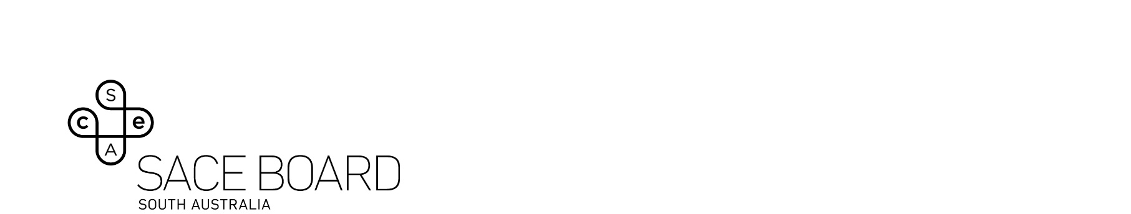
English Literary Studies – Assessment Type 3: Text Study

Part B: Critical Reading (15%)

Exemplar preamble
- The English Literary Studies exam values the transfer of critical reading skills using unseen texts.
- It encompasses many aspects of the course, all of which are also assessed in AT1. Unlike some subjects the ELS exam isn’t compartmentalised with discrete areas of knowledge and skills being assessed.
- The performance standards are common to AT1 and AT3.
- 8 of a possible 10 specific features are examinable.
- AT1 and AT2 are best completed by students using a writing process which allows for considered planning, drafting and revision. During this feedback can be sought from teachers, peers and family. This often occurs over an extended time and allows for optimal performance.
- However, the exam (AT3) is completed with limited opportunities for planning and drafting and, of course, no possibility for students to discuss their writing and obtain feedback.
- It’s natural that there’ll be a wish to compare performance across the assessment types however for most students it’s unhelpful to compare AT1 performance with that in the exam (AT3).
- Our vision for this exam includes incorporating literary film and audio content, and a possible restructuring to mirror real-life critical reading and writing situations.

