Additional Teaching Resources for Stage 1 & 2 Economics 2020/21

Year 11 and 12 Resources:
Reserve Bank of Australia – Education resources such as Inflation Explorer  Eg: find activities such as Exploring Inflation  - https://www.rba.gov.au/education/resources/digital-interactives/inflation-explorer/ | 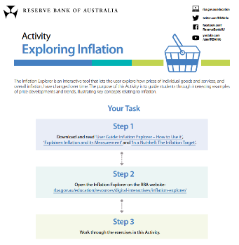
Gapminder – for tools and data  - Dollar Street – comparisons of how people live across the globe  https://www.gapminder.org/ | 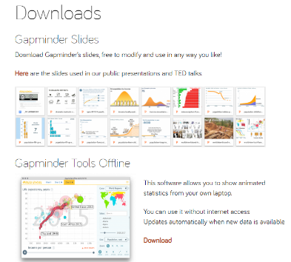  
Tutor2U - Economics  - https://www.tutor2u.net/economics/topics | 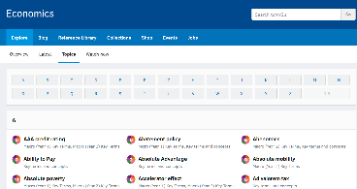
The Economic Lowdown video series is an American website created by the Federal Reserve Bank of St Louis. There are a series of videos (with transcripts) that cover topics in economics, banking and monetary policy.  - https://www.stlouisfed.org/education/economic-lowdown-video-series  - Eg: Inflation  https://mru.org/courses/principles-economics-microeconomics/office-hours-game-theory-nash-equilibrium  - Eg: Externalities (6min)  https://www.stlouisfed.org/education/economic-lowdown-video-series/episode-5-externalities | 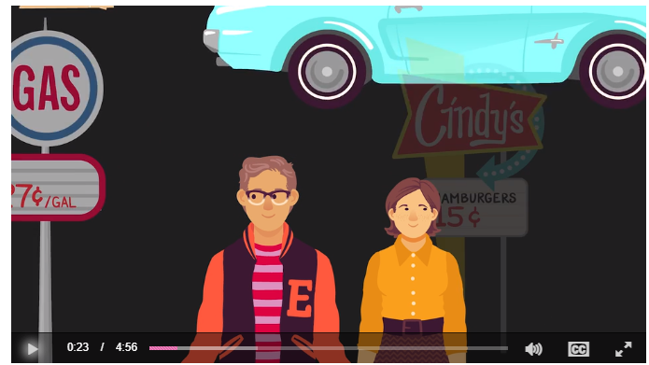  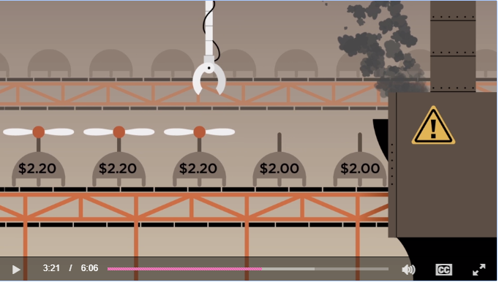
Economic online classroom games - Classroom games for teaching Economics  Eg – Public Goods Game (a closer look at experimental data)  - https://economics-games.com/games | 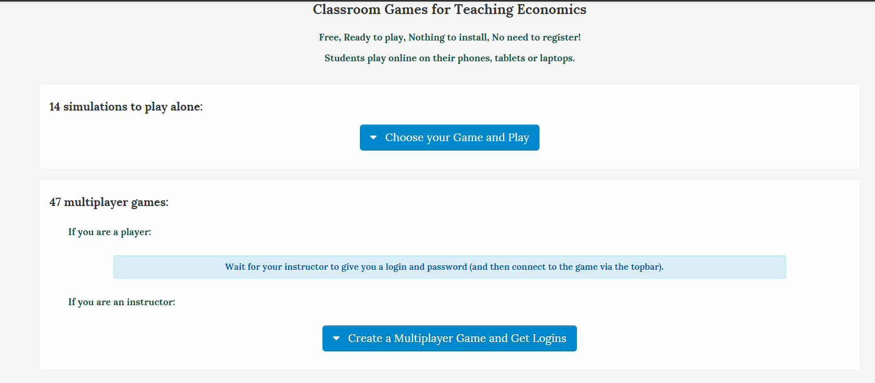
EconLife – American website that uses an economic lens to analyse concepts using real issues in language students can understand:  - https://econlife.com/ | 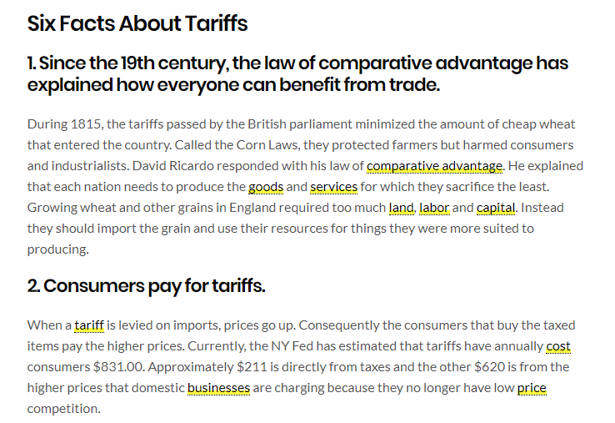
TedED – Business and Economics videos  - https://ed.ted.com/lessons?category=business-economics  - Eg: The paradox of value – water bottle vs diamonds  https://ed.ted.com/lessons/the-paradox-of-value-akshita-agarwal | 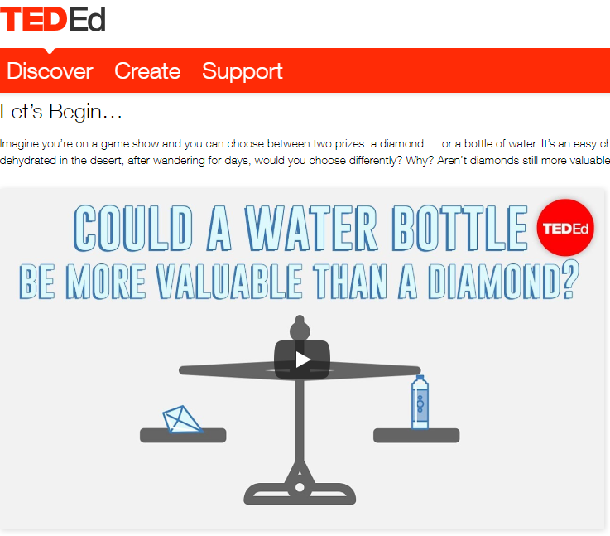
Marginal Revolution University – a series of short videos from this American university on core economic concepts.  - https://mru.org/everyday-economics  Eg: Introduction to Linear Regression  - https://www.mruniversity.com/courses/understanding-data/intro-linear-regression  Marginal Revolution University – Division of Labour – note: the practice questions tab at bottom right of screen enabling interactive way of checking knowledge for students.  - https://mru.org/courses/everyday-economics/division-labor-burgers-and-container-ships | 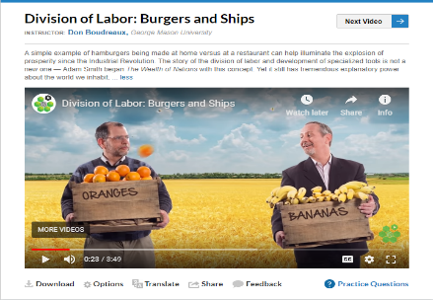  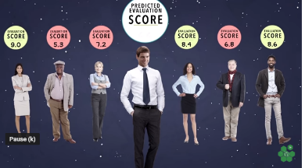

Year 12 Resources:
CoreEcon – online textbook (suitable for Year 12 course)  - https://core-econ.org/the-economy/book/text/0-3-contents.html  The text focuses on evidence on the economy, from around the world, and from history with the use on real life situations. | 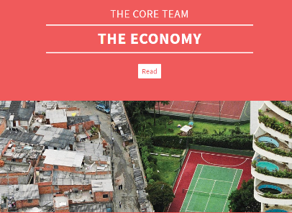
Innovation in Economics - Youtube  - Innovation in Economics – Patents Support Innovation in Pharmaceuticals  https://www.youtube.com/watch?time_continue=58&v=kYIcwNVk5y8 | 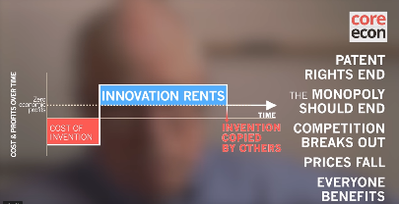
Khan Academy – www.khanacademy.org  - Khan Academy - Game Theory – Nash Equilibrium (Part 1)  https://www.youtube.com/watch?v=UkXI-zPcDIM  - Khan Academy - Nash Equilibrium (Part 2) (6 min)  https://www.youtube.com/watch?v=ewu_7Dmj_18 | 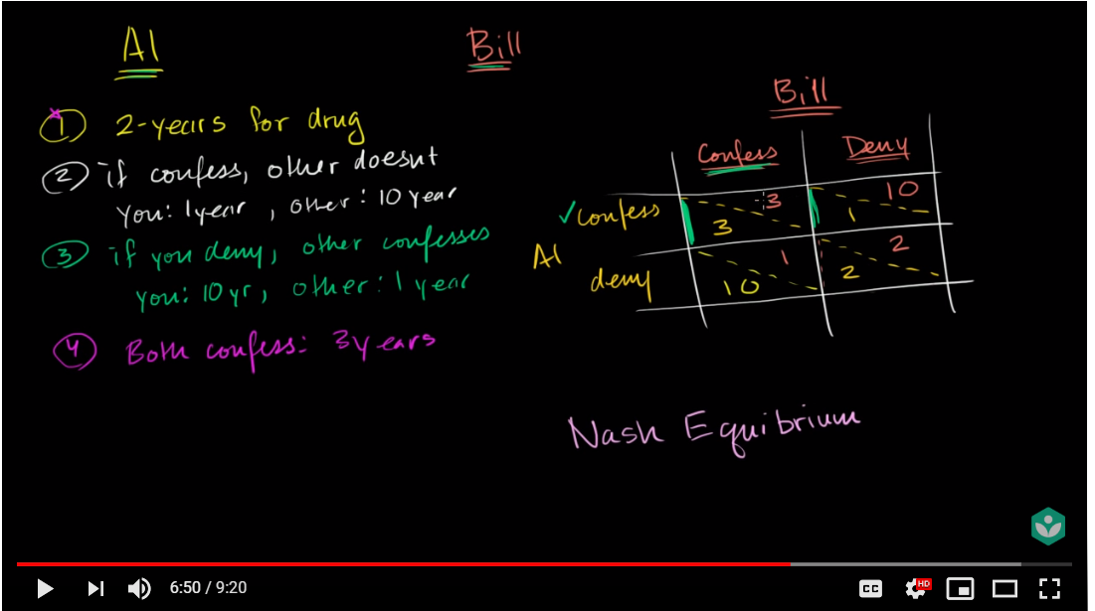  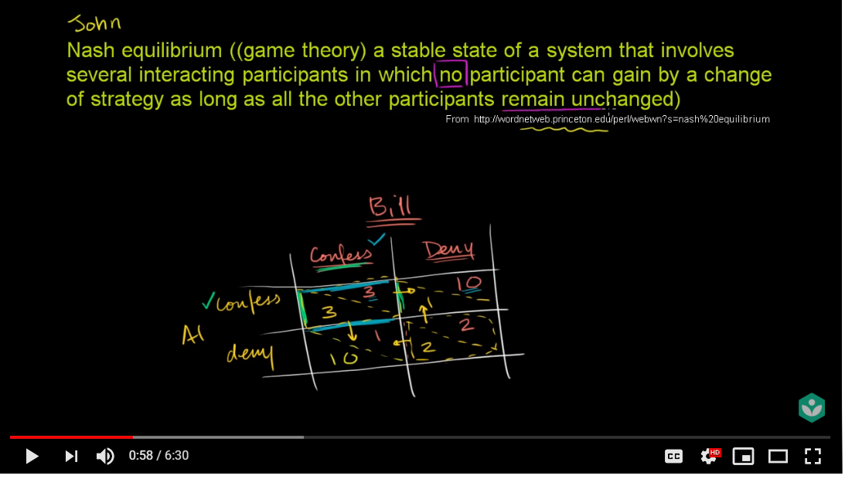
Youtube  - Jacob Clifford video series on various Economics topics using themes/movies that students can relate to.  - Eg: Oligopolies and Game Theory (The Dark Knight)  https://www.youtube.com/watch?v=JMq059SAQXM | 