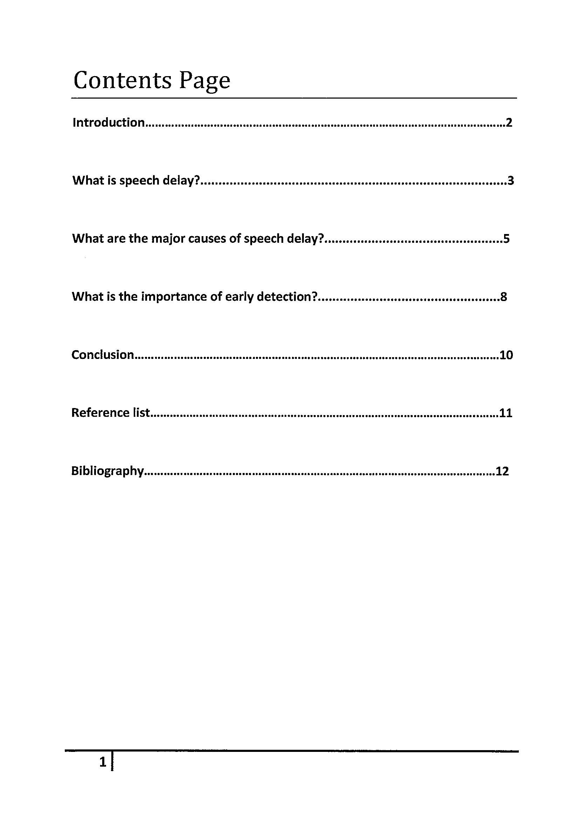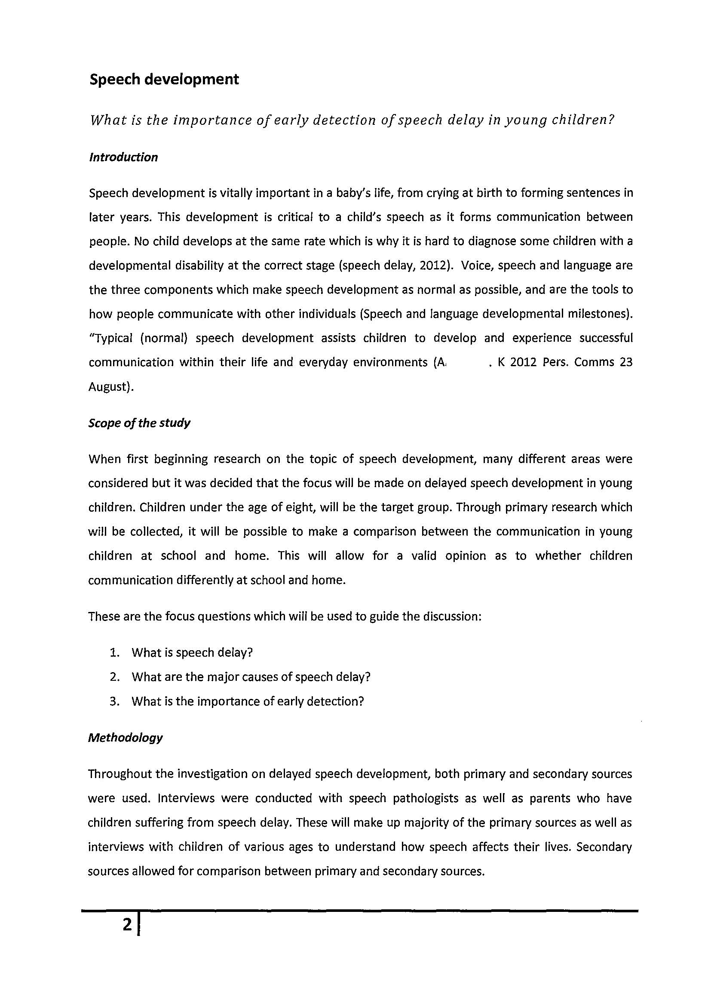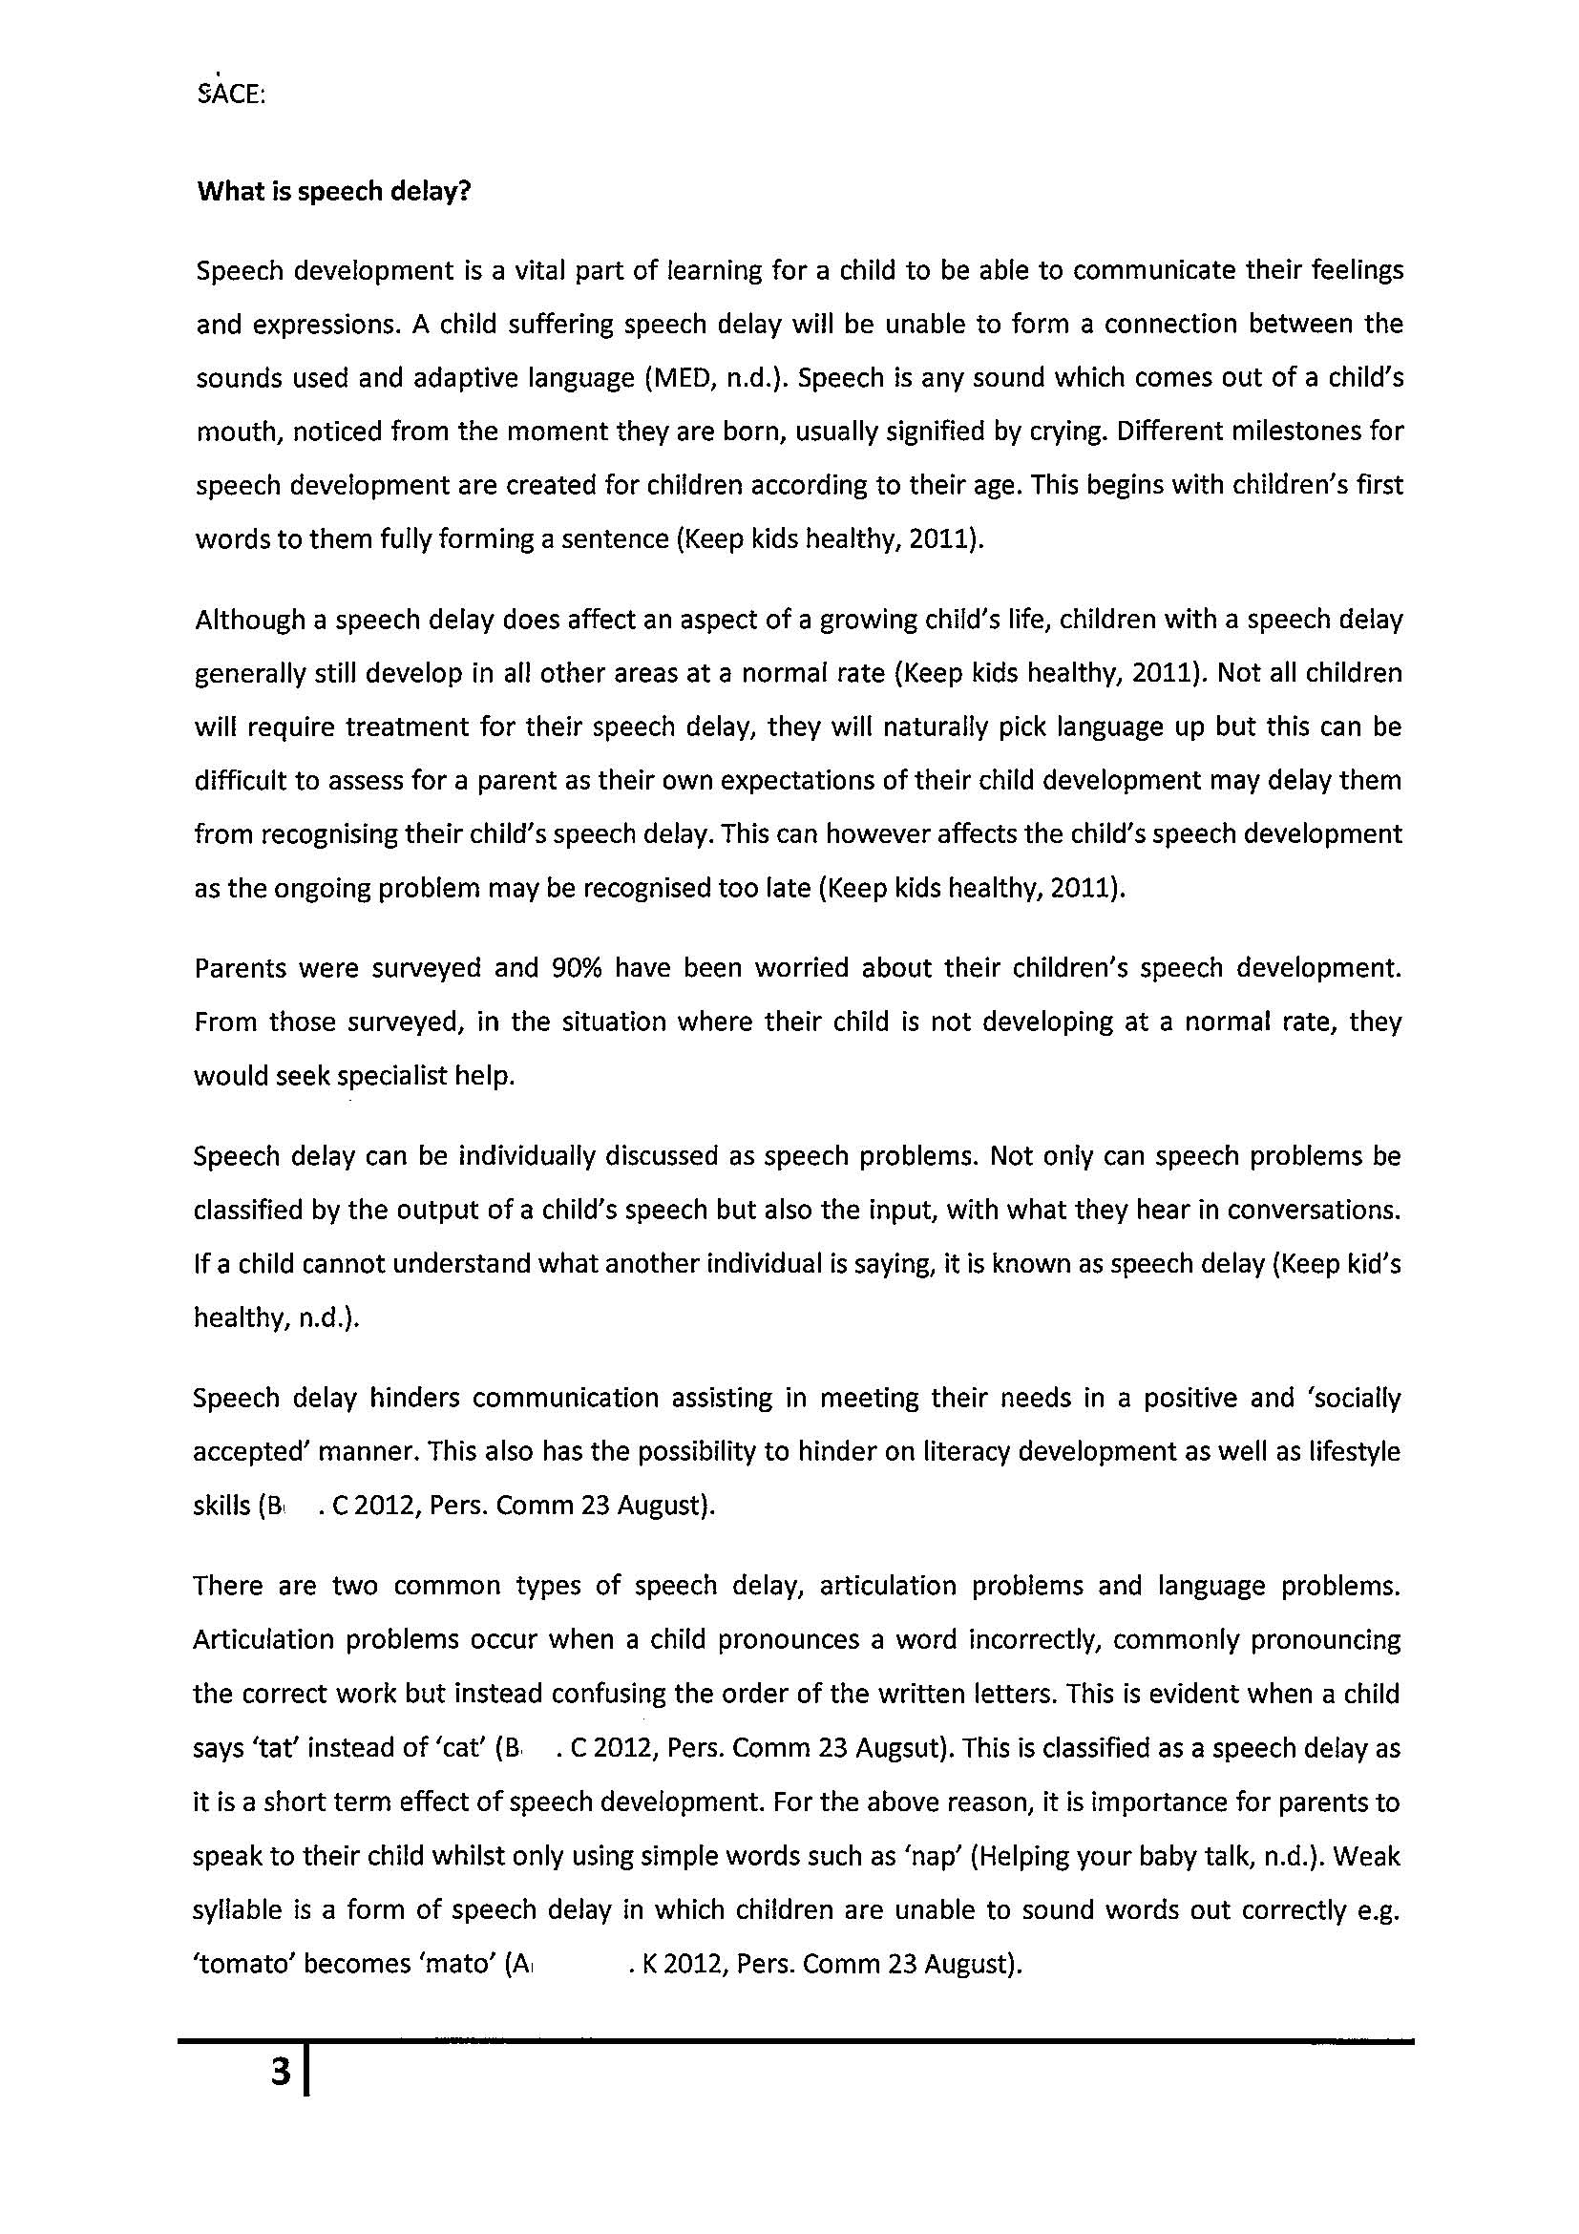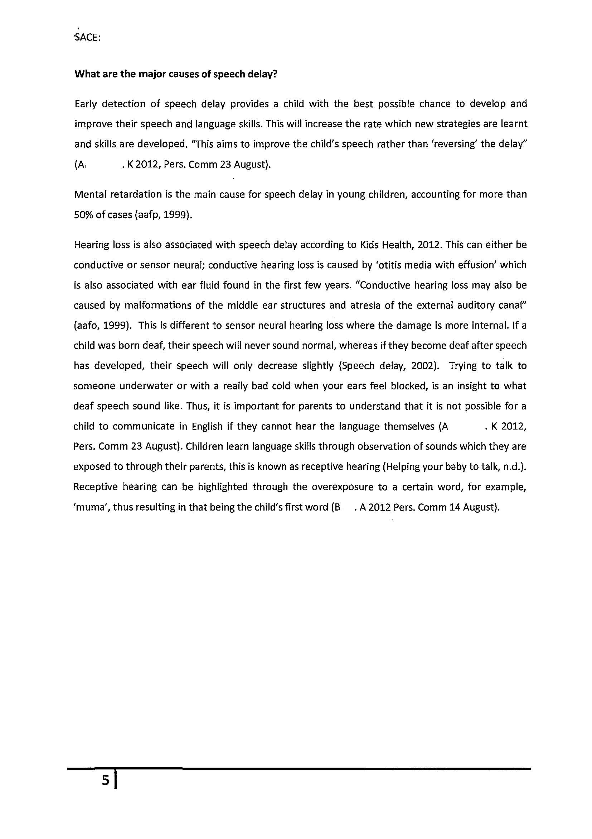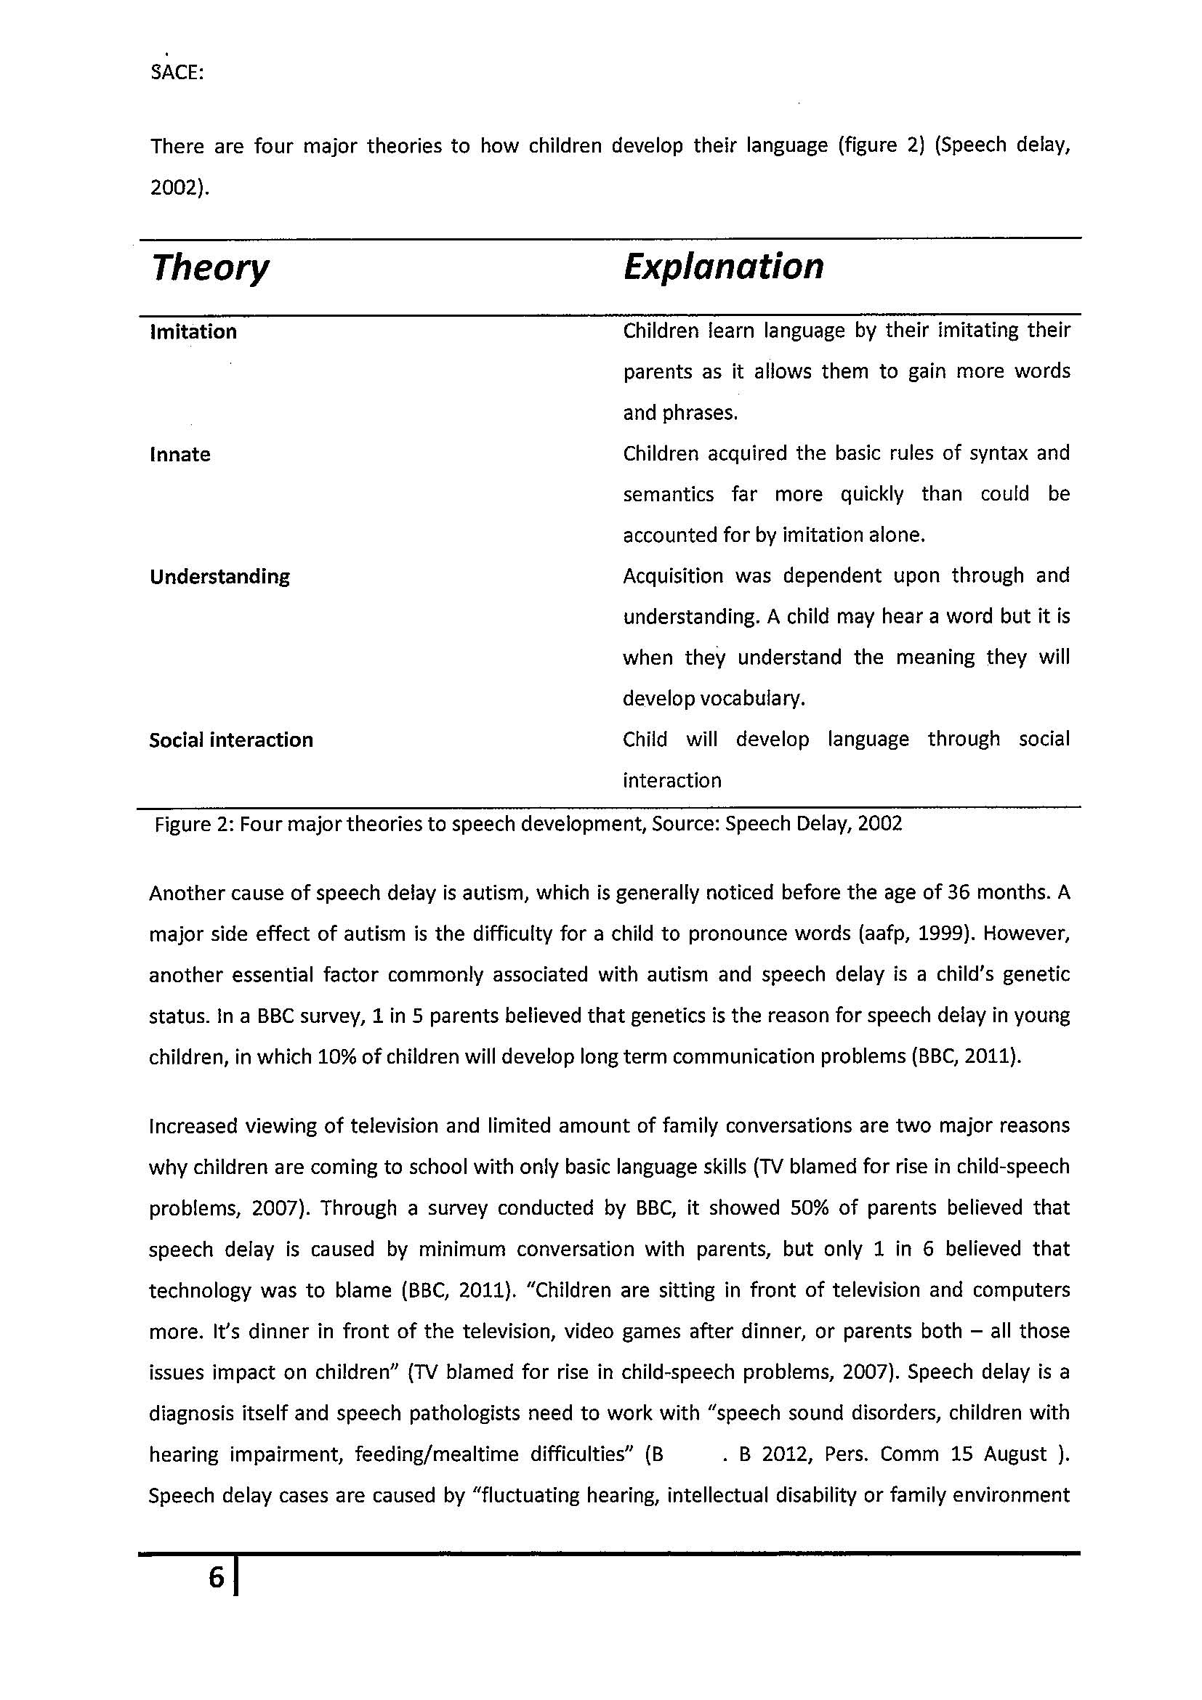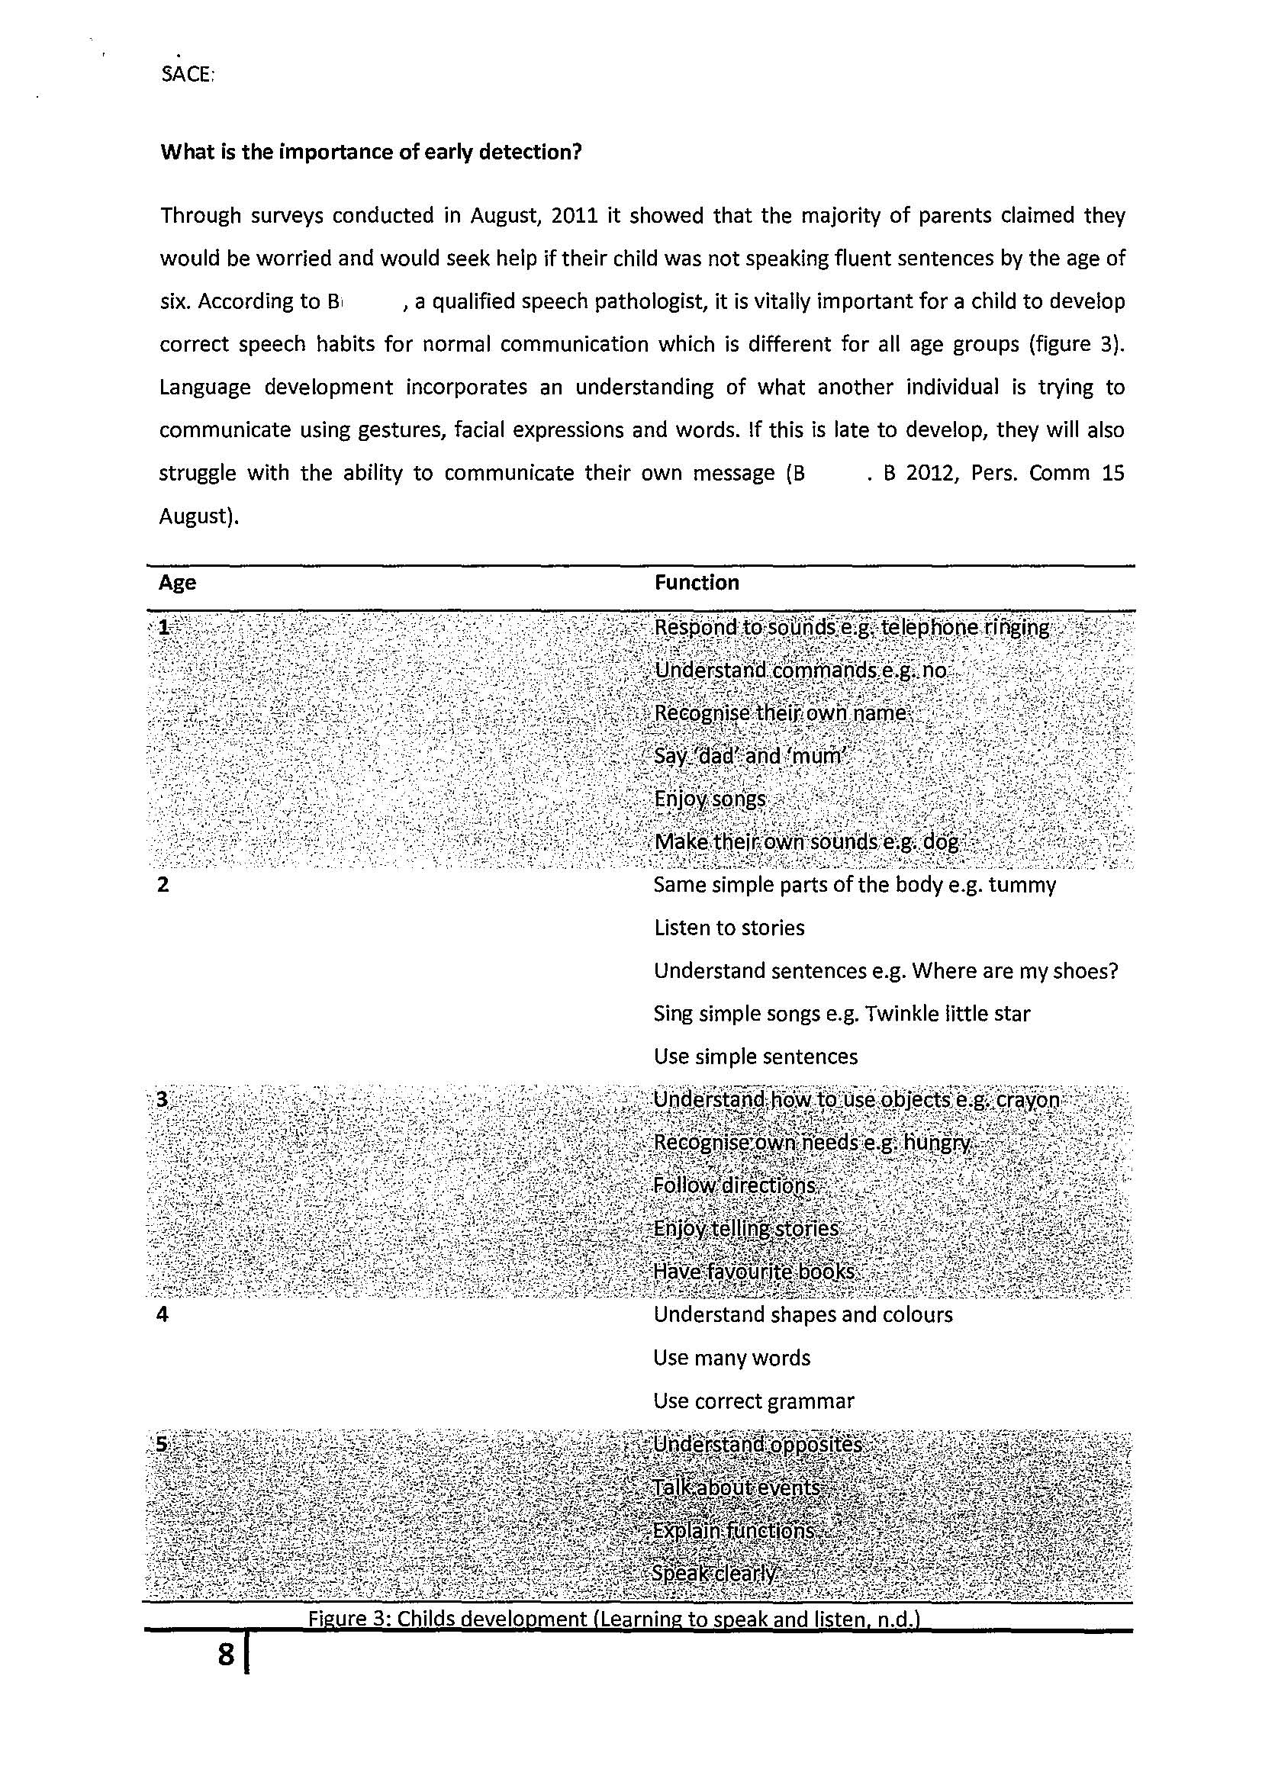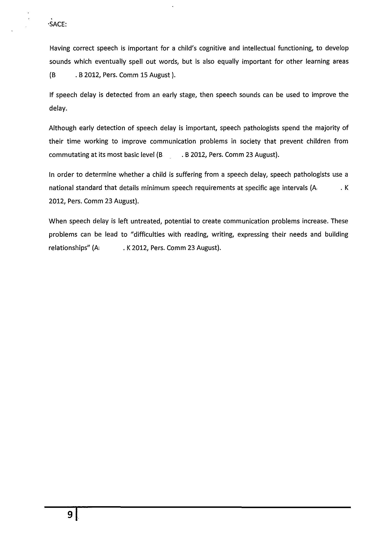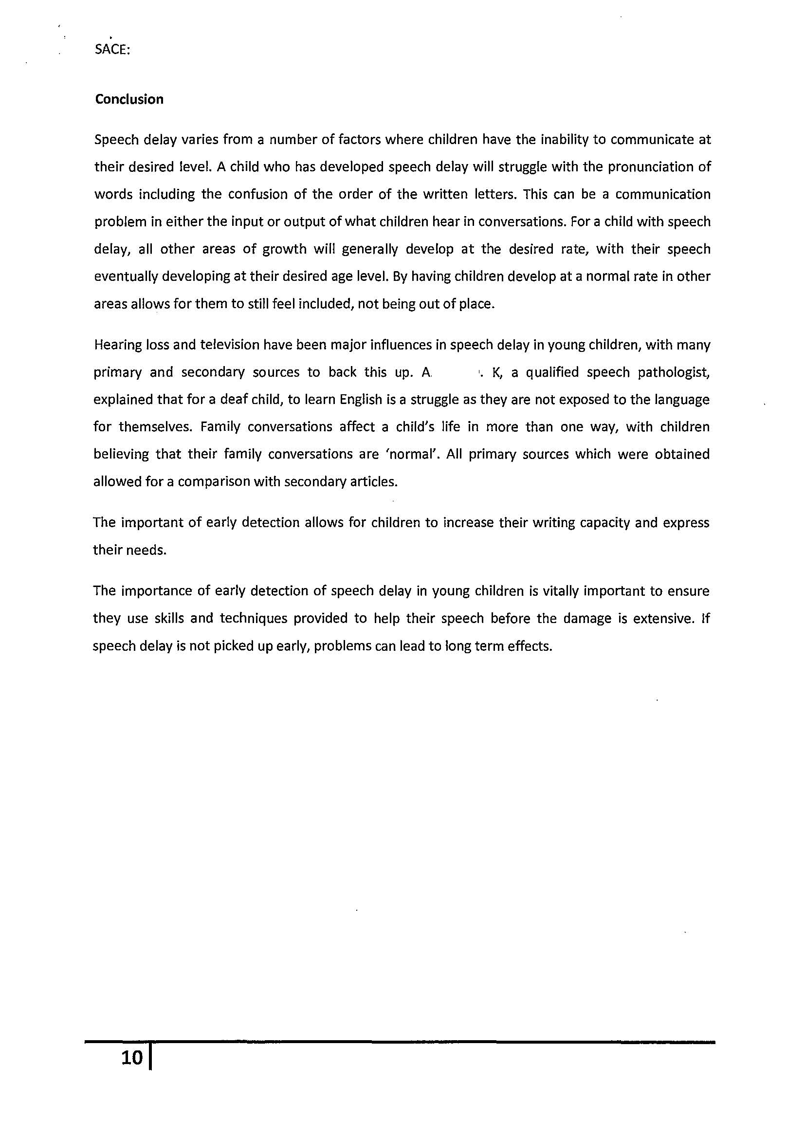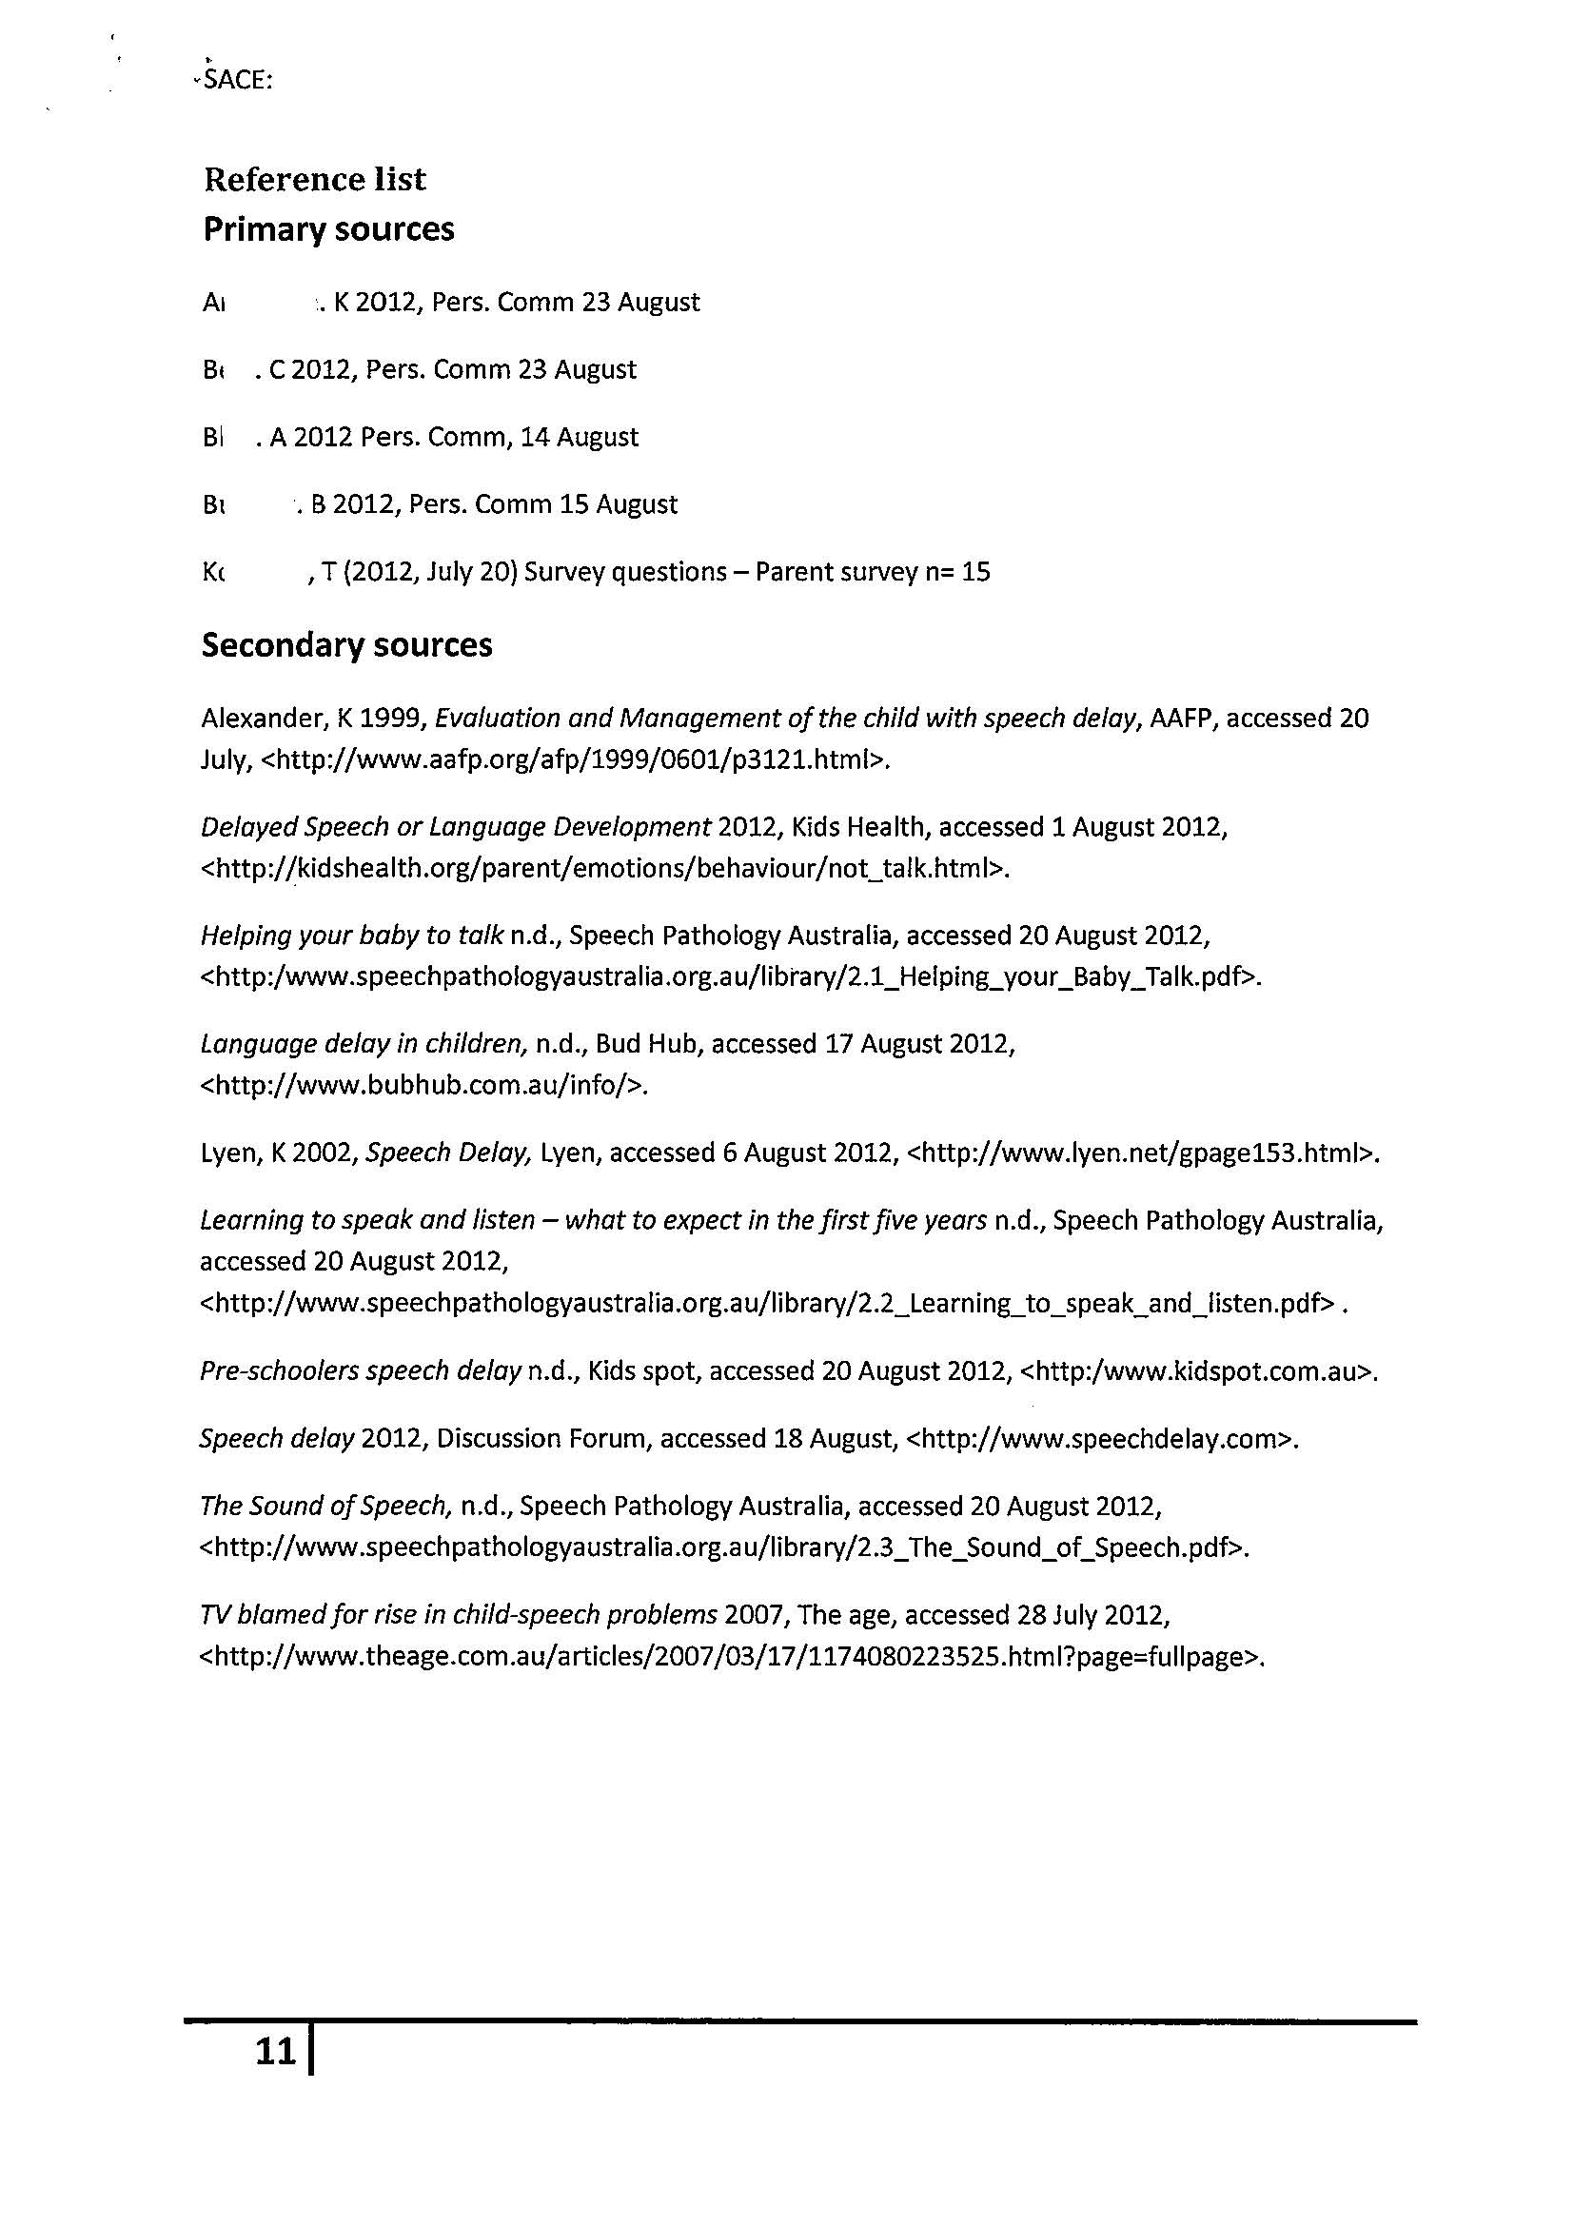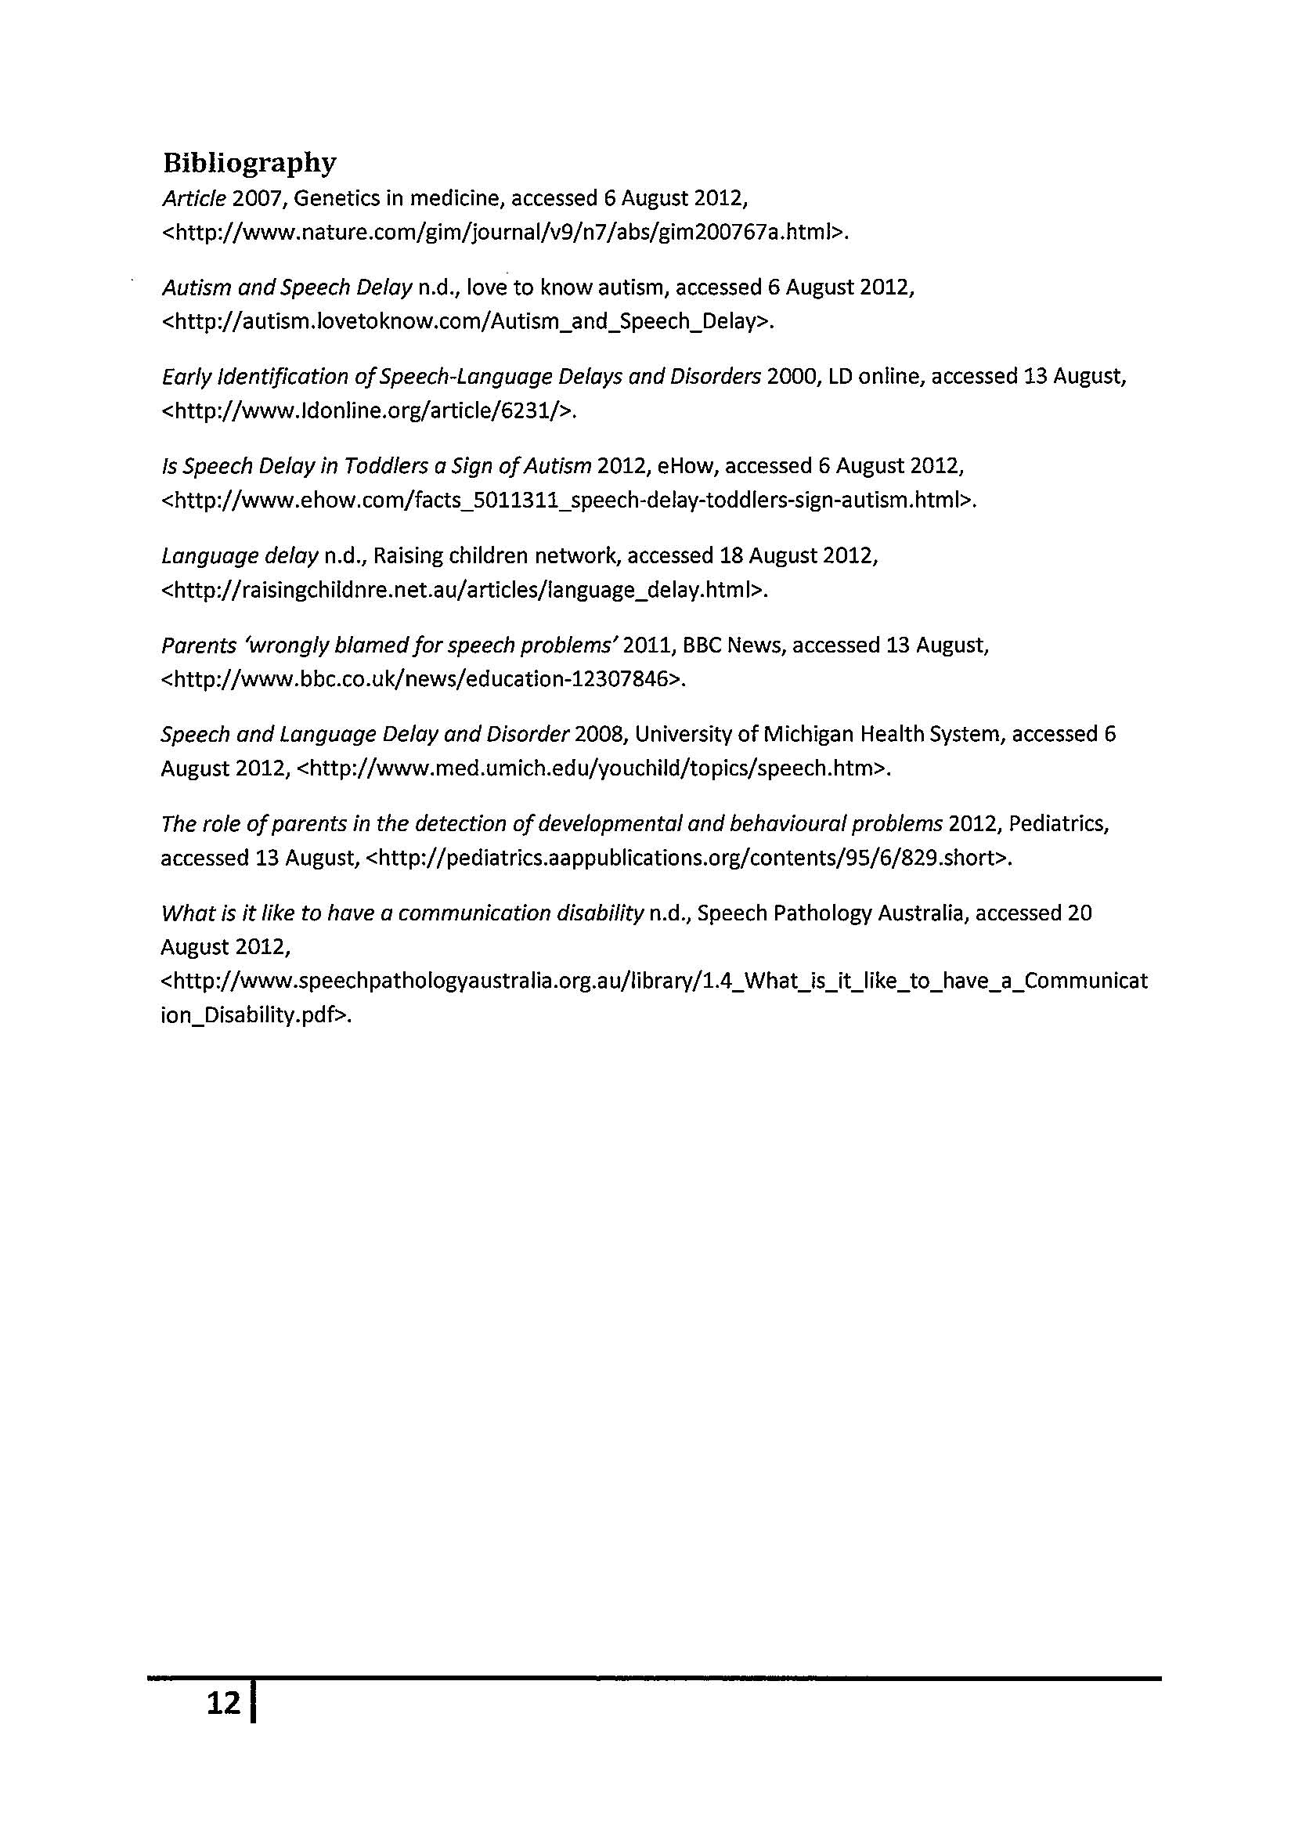
Stage 2 Child Studies
Assessment Type 3: Investigation
Assessment Comments
This investigation is an A grade.

Investigation and Critical Analysis
- Detailed / In-depth investigation and considered critical analysis.
- Issue about health and well-being of children 0-8.
- Extensive, relevant reference list of primary sources, websites, books, explanation of primary and secondary resources. However, no explanation of limitations or analysis of information for relevance and appropriateness.
- Appropriate acknowledgement of sources, footnotes and notes to ‘see figures’.
- Highly effective application of literacy (sophisticated language, effective editing) and effective numeracy (graphs).
- Clear and consistent use of appropriate terminology (appropriate use of terms relating to child health and well-being).

Evaluation
- Well-informed evaluation within the conclusion is informed about the issue related to child development in a variety of settings.
Performance Standards for Stage 2 Child Studies
 | Investigation and Critical Analysis | Problem-solving | Practical Application | Collaboration | Evaluation
A | In-depth investigation and perceptive critical analysis of contemporary trends and/or issues related to the health and well-being of children.  Perceptive analysis of information for relevance and appropriateness, with appropriate acknowledgment of sources.  Highly effective application of literacy and numeracy skills, including clear and consistent use of appropriate terminology. | Astute identification and discussion of factors involved in problem-solving related to the health and well-being of children.  Astute and very appropriate decision-making about problem-solving and implementation strategies.  Clear and very relevant justification of decisions about problem-solving and implementation strategies. | Ongoing and productive implementation of safe management practices and appropriate techniques, and sophisticated generation and maintenance of quality control.  Productive and efficient organisation and management of time and resources.  Logical selection and application of the most appropriate technology to prepare learning activities for children in a culturally diverse society. | Initiation of ideas and procedures, display of leadership within the group, and proactive and inclusive response to members of the group.  Proactive and focused involvement in group activities and discussions to support the health and well-being of children. | Insightful evaluation of the processes and outcomes of practical and group activities, including their own performance.  Sophisticated appraisal of the impact of technology on the health and well-being of children.  Insightful explanation of the connections between research and/or planning, and practical application.  In-depth evaluation of contemporary trends and/or issues related to child development in a variety of settings.
B | Detailed investigation and well-considered critical analysis of contemporary trends and/or issues related to the health and well-being of children.  Well-considered analysis of information for relevance and appropriateness, with appropriate acknowledgment of sources.  Effective application of literacy and numeracy skills, including mostly clear use of appropriate terminology. | Well-considered identification and discussion of factors involved in problem-solving related to the health and well-being of children.  Well-considered and appropriate decision-making about problem-solving and implementation strategies.  Mostly clear and relevant justification of decisions about problem-solving and implementation strategies. | Mostly productive implementation of safe management practices and appropriate techniques, and well-considered generation and maintenance of quality control.  Mostly productive organisation and management of time and resources.  Mostly logical selection and application of appropriate technology to prepare learning activities for children in a culturally diverse society. | Initiation of some ideas and procedures, some display of leadership within the group, and thoughtful and active response to members of the group.  Active and thoughtful involvement in group activities and discussions to support the health and well-being of children. | Thoughtful evaluation of the processes and outcomes of practical and group activities, including their own performance.  Well-informed appraisal of the impact of technology on the health and well-being of children.  Well-considered explanation of the connections between research and/or planning, and practical application.  Well-informed evaluation of contemporary trends and/or issues related to child development in different settings.
C | Competent investigation and some considered critical analysis of contemporary trends and/or issues related to the health and well-being of children.  Considered analysis of information for relevance and appropriateness, with generally appropriate acknowledgment of sources.  Generally effective application of literacy and numeracy skills, including competent use of appropriate terminology. | Considered identification and discussion of some factors involved in problem-solving related to the health and well-being of children.  Generally considered and appropriate decision-making about problem-solving and implementation strategies.  Generally relevant justification of decisions about problem-solving and implementation strategies, with some clarity. | Competent implementation of safe management practices and techniques, and considered generation and maintenance of quality control.  Competent organisation and management of time and resources.  Appropriate selection and application of technology to prepare learning activities for children in a culturally diverse society. | Some initiative with ideas or procedures, occasional leadership within the group, and generally active response to members of the group.  Active involvement in group activities and discussions to support the health and well-being of children. | Considered evaluation of the processes and outcomes of practical and group activities, including their own performance.  Informed appraisal of the impact of technology on the health and well-being of children.  Considered explanation of the connections between research and/or planning, and practical application.  Informed evaluation of contemporary trends and/or issues related to child development in different settings.
D | Some investigation and basic description of one or more contemporary trends or issues related to the health and well-being of children.  Some consideration of information for relevance or appropriateness, with some inconsistent acknowledgment of sources.  Inconsistent application of literacy and numeracy skills, with use of some terminology that may be appropriate. | Superficial identification and discussion of some factors involved in solving basic problems related to the health or well-being of children.  Some basic and inconsistent decision-making about problem-solving and/or implementation strategies.  Some description and partial justification of one or more problem-solving and/or implementation strategies. | Basic implementation of one or more safe management practices and/or techniques, and some basic consideration of the generation and maintenance of quality control.  Inconsistent organisation and management of time and resources.  Identification and some application of technology that may be appropriate to prepare learning activities for children in a culturally diverse society. | Some participation within the group, and some response to members of the group. Participation is often passive.  Some basic involvement in group activities or discussions to support the health or well-being of children. | Basic consideration of the processes and/or outcomes of practical and group activities, which may include their own performance.  Superficial consideration of the impact of technology on the health or well-being of children.  Some basic description of one or more connections between research and/or planning, and practical application.  Superficial reflection on one or more contemporary trends or issues related to child development, tending towards basic description.
E | Limited investigation or basic description of one or more contemporary trends or issues related to the health or well-being of children.  Limited identification or acknowledgment of information that may have some relevance.  Attempted application of literacy and numeracy skills, with attempted use of some basic terminology that may be appropriate. | Identification of one or more factors involved in solving basic problems related to the health or well-being of children.  Attempted decision-making about problem-solving or an implementation strategy.  Attempted description of one or more problem-solving or implementation strategies. | Attempted development or implementation of a safe management practice or a technique, and some awareness of the need for quality control.  Limited organisation or management of time and resources.  Limited identification or application of technology that may be appropriate to prepare learning activities for children in a culturally diverse society. | Some attempted participation in one or more aspects of group work, and occasional response to members of the group.  Attempted involvement in one or more group activities or discussions to support the health or well-being of children. | Attempted consideration of one or more processes or outcomes of a practical or group activity, which may include their own performance.  Attempted description of an impact of technology on the health or well-being of children.  Limited awareness of any connections between research and/or planning, and practical application.  Some recognition of one or more contemporary trends or issues related to child development.

