Stage 2 Health
Assessment Type 4: Investigation
The Yorke Peninsula is located West of Adelaide separated by Spencer Gulf. Prominent towns include Kadina, Moonta and Wallaroo, which form the Copper Coast, and farming districts and towns such as Maitland, Minlaton, Yorketown and Ardrossan. Currently, there is only one hospital equipped for labour and delivery of a baby across the entire peninsula. Wallaroo Hospital is located 147 Kilometres North-West of Adelaide (approx 2hrs), and a significant distance from other towns on the Lower Yorke Peninsula such as Yorketown (128kms, 1 hour 54 minutes) and Marion Bay (181kms, 2 hours 21 minutes). As the Wallaroo Hospital has recently become the only hospital equipped with birthing facilities, this is a real community issue.
My aim was to investigate whether the services provided for pregnant women on the Peninsula are sufficient, with my focus being those provided by Wallaroo Hospital’s Midwifery Team. I investigated multiple aspects of pregnancy, including how to prepare for delivery in a rural location, delivery by midwives and GP’s, ante-natal classes and post-natal visits. To do this I have narrowed my research down to three guiding questions.
- What services are required by pregnant women?
- What community services are offered on the Yorke Peninsula?
- How do midwives feel about the services available to support pregnant women on the Yorke Peninsula?
Investigation
Productive and discerning approach to accessing, organising, and using information about health.
My primary resources included my interview, surveys and observation during my work placement at Wallaroo Hospital’s Midwifery Clinic. My secondary resources were brochures and leaflets provided by the Midwifery Clinic and websites. I was able to gain the most information about the services from my interview, work placement as these primary sources encompassed the social and emotional components of health as well as the physical.
I created a survey relating to the services and support offered on the Yorke Peninsula and also asked about concerns delivering a baby in a rural location. I distributed 22 surveys and a pleasing 17 were returned. I gave the surveys to students to pass on to their mothers, family friends, relatives, colleagues and mothers at sport. My surveys were not targeted at a specific age group or new mothers, but at mothers who had delivered their baby(ies) at Wallaroo Hospital so as to help answer my key question.
I chose to interview X , a midwife, on my placement at the Hospital as she would have experienced the issues rural pregnant women face. My work placement at the Midwifery Clinic at Wallaroo, the only local clinic, highlights the worrying lack of support for pregnant women locally. I organised my placement by visiting the clinic at the Hospital and explaining my intentions. The midwives were pleased that I showed interest in the nursing and midwifery industry and arranged for me to shadow a midwife for three days scattered over the school holidays. Unfortunately my designated midwife was ill for a few days so my placement was scattered and I was shadowing various nurses and midwives. Seeing and hearing a range of nurses and midwives helped me gain a clearer and more honest picture of what is actually happening rather than through the eyes of only one midwife. I spent four full days at the Hospital to make up for my midwives absence.
Application
Sustained and effective application of participation, interpersonal, practical, and group skills to an area related to health.
Team Midwifery was established in 2009 as women delivering at Wallaroo had minimal previous association with their midwives. GP’s were responsible for ante-natal care and ward midwives would deliver the baby. I observed that Team Midwifery consists of 3 midwives, with one on call and two conducting ante-natal and post-natal checks. The team believe their services are sufficient and benefit everyone involved as it gives the mother the opportunity to bond with the three midwives throughout their entire pregnancy and have their baby delivered by a midwife they know and trust, an important factor as delivery can be a time of high stress.
Investigation
In-depth and critical investigation into and critique of current health trends and issues.
Ante-natal and post-natal care involves major decision making for a mother. Ante-natal care is the care provided before birth and post-natal is provided after birth. Many women aim to have a natural vaginal birth; however this is not practical in every birth. Some complications diagnosed before labour may unfortunately make it too dangerous for baby and mother for a natural birth and a caesarean may be required.
Pregnancy is considered in three stages, also known as trimesters. As soon as a woman assumes they may be pregnant, it is recommended that they see their GP for a referral to a midwifery clinic. There is no specific number of required visits to the midwife or GP, as it depends on individual circumstances. Ante-natal care aims to identify problems before birth and negotiate the best care plan for both mother and baby. Ante-natal care also provides the opportunity to ask either the midwife or GP about anything they are unsure about during pregnancy to help allay fears and stress. The visits involve a basic pregnancy assessment involving questions relating to previous pregnancies and health conditions, blood pressure check, weight and height check, blood tests, urine tests and the woman is given an ‘Orange Book’ (South Australian Pregnancy Record). These visits usually range from 30-60 minutes. As the woman progresses further into pregnancy, the baby’s heart rate is checked and birthing options negotiated, such as pain relief during labour. Having a number of midwives who can take as much time as needed, have experienced the birth process themselves and are females reduces inhibitions to ask questions and gives patients confidence and a sense of support. These clinics are also offered to mothers residing on the peninsula choosing to deliver their baby in Adelaide.
Critical Analysis and Evaluation
Insightful evaluation of personal and social actions to promote improved health outcomes for individuals and communities.
Post-natal care differs depending on the birthing process. Low risk pregnancies, as identified prior to labour by either a doctor or midwife, are often suitable for delivery at Wallaroo Hospital and the midwives provide care. Women are supported during the birth with a midwife with whom they have developed a relationship present throughout the entire birth again helping reassure and comfort during this time of stress for the mother. Higher risk pregnancies are referred to a hospital such as Women’s & Children’s Hospital or Flinders Medical Centre, where caesarean is sometimes needed.
The midwives arrange to visit the mother and baby at home once or twice a week for up to six weeks after birth answering questions, reassuring the mother or refining any processes such as breast feeding or bathing the baby. By addressing issues immediately reduces the level of anxiety and problems that isolated women have had to face. The local midwives also provide post-natal care for those who reside on the peninsula but choose to deliver in another hospital. In addition, there are multiple 24-hour helplines such as parent helpline, breastfeeding helpline, health direct or mothers are able to contact Wallaroo Hospital and speak to the midwife on duty. Hence providing a reasonable amount of support pre and post-natally for mothers in the Yorke Peninsula. Indeed mothers surveyed (see graph below) were generally content with the provision of these services
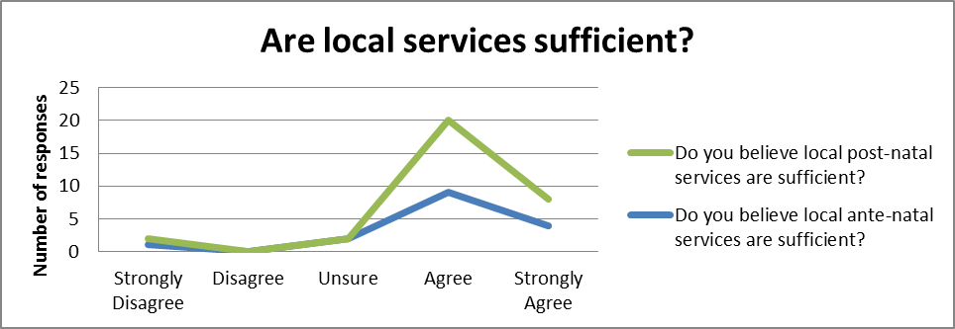
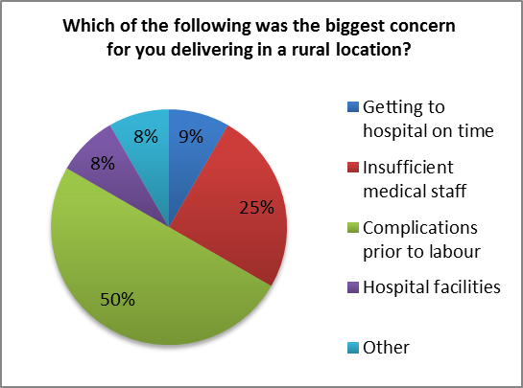
When interviewing midwife X , we discussed the roles of Team Midwifery and their services. One of the key topics involved the difference in the care provided in a country location versus the city. The main difference she implied is that sadly country hospitals have fewer doctors and specialists readily available in the event of an emergency at delivery. Only some local GP’s have obstetrics qualifications whereas in Adelaide they have a number of obstetricians and paediatricians to assist with the delivery and any complications should they arise. This was a major concern for the mothers I surveyed (see graph at right). The city hospitals also offer specialised care units such as breastfeeding day service and women’s assessment clinics. The birthing suite at Wallaroo is very similar to those in the city hospitals, equipped with a large shower, birthing ball, monitoring equipment and infant resuscitation equipment. Regrettably Wallaroo just has one birthing suite, compared to the city hospitals containing multiple natural birthing suites with nearby theatres. X did feel however that under the circumstances that they had to work in they provided an invaluable and sufficient service for low-risk births.
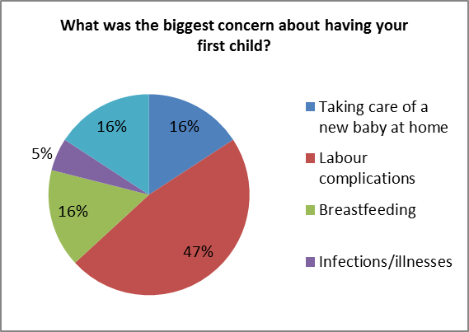
Surprisingly, 75% of mothers surveyed were not concerned about delivering a baby in a rural location. Of those who were concerned, 50% of these were rightfully concerned about complications prior to labour (see graph at right). Interestingly, the concern of complications prior to/during labour were similar to those of a first time mum. This is understandable considering the distance required to travel to a city hospital, equipped to treat pregnancy complications. 25% were concerned about insufficient medical staff, also understandable considering country hospitals are already stretched as it is.

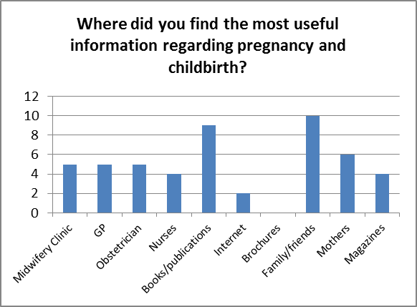
When surveying mothers about the useful information they received regarding pregnancy and childbirth (see graph at right), I was not surprised to see family/friends and books/publications being the most popular choices. This shows the ways in which residents in small country towns communicate with each other about many family related topics. It also shows the lack of reliable, consistent internet access over time to be able to surf for the most recent information.

My work placement provided me with the opportunity to experience different sections of Wallaroo Hospital, such as the emergency department and the acute ward in addition to the midwifery clinic and birthing suite. During one of the ante-natal clinics, a woman experienced contractions leading to the safe delivery of a baby boy later that afternoon, of which I was able to observe. I was able to see two of the midwives in action and I was extremely impressed with the emotional and physical support provided to the women and her family during her labour. With such personal and professional support it is no wonder that the women I interviewed were comfortable with the level of support provided in Yorke Peninsula.
Application
Highly productive involvement in personal and social actions to promote improved health outcomes for individuals and communities.
However, I do not believe the services are sufficient should a serious complication arise during labour. GPs are not readily available at Wallaroo Hospital, they have to be called in. Although medSTAR is on standby for retrieval during labour, precious minutes are wasted waiting for a transfer, potentially affecting the survival chances of the infant. Retrieval is an emotional event for anyone, let alone a mother if she has already given birth, as there is only room for one patient in their helicopters leaving mum with no emotional support through the ordeal at an already stressful time. In Adelaide hospitals, this risk is significantly reduced as specialist staff is readily available. Some city hospitals also have specialised care units, such as the High Dependency Unit and Neonatal Intensive Care Units. However, Midwives aim to prevent such situations happening, by advising women with possible complications to deliver in an Adelaide Hospital.
In conclusion, I believe the services offered at Wallaroo Hospital are definitely sufficient for a natural, complication-free birth. Team Midwifery offer exceptional support to pregnant women and their families throughout the entire pregnancy and birth. They identify potential problems and put in place procedures to minimise physical and emotional trauma to the mother and baby. The problem is when something goes wrong.

Total word count = 1980

Bibliography

Websites:
Australian travel distances, Journey times and route maps, 2012, AU Info, accessed 12 June 2012, <http://www.auinfo.com/australian%20distance%20calculator.html>.
Government of South Australia 2011, Pregnancy Week by Week, accessed 26 June 2012, <http://www.cyh.com/HealthTopics/HealthTopicDetails.aspx?p=438&np=457&id=2753>.
Government of South Australia 2012, Types of care during pregnancy and birth in South Australia, accessed 26 June 2012, <http://www.cyh.com/HealthTopics/HealthTopicDetails.aspx?p=438&np=458&id=2750>.
Government of South Australia 2011, Community agencies for advice and support in South Australia, accessed 26 June 2012, <http://www.cyh.com/HealthTopics/HealthTopicDetails.aspx?p=438&np=458&id=2752>.
Government of South Australia 2012, Antenatal visits - check-ups during your pregnancy, accessed 28 June 2012, <http://www.cyh.com/HealthTopics/HealthTopicDetails.aspx?p=438&np=459&id=2758>.

Printed publications:
Yorke Peninsula Country Times 2012, 'Midwifery Team Recognised', 07, p.18, accessed 12 July 2012.

Ante-Natal Education, Early Labour, Leaflet, SA Health, Wallaroo Hospital.

Ante-Natal Education, General care in pregnancy, Leaflet, SA Health, Wallaroo Hospital.

The national depression initiative, Emotional health during pregnancy and early parenthood, Brochure, Beyond Blue.

Interviews:
X interviewed by , Services provided by Team Midwifery, Wallaroo Hospital, Ernest Tce, Wallaroo, interview conducted 5th July 2012
Additional Comments
This investigation is an A+ grade.

On balance the response provides evidence of:
- Consistent application of well-developed health literacy skills to relevant tasks (Application)
- Astute and critical analysis of a variety of current health trends (Critical Analysis and Evaluation)
General
In addition, the analysis shows insightful personal reflection regarding the role of education in enhancing health outcomes.

Performance Standards for Stage 2 Health
 | Investigation | Understanding | Application | Critical Analysis and Evaluation
A | In-depth and critical investigation into and critique of current health trends and issues.  Productive and discerning approach to accessing, organising, and using information about health.  Sustained and cohesive investigation into and critique of the roles and responsibilities of individuals, communities, and governments in addressing health and well-being issues and priorities. | In-depth, coherent, and critical understanding of a variety of influences on personal and community health and well-being.  In-depth and critical understanding of health and related social justice issues. | Sustained and effective application of participation, interpersonal, practical, and group skills to an area related to health.  Consistent application of well-developed health literacy skills to relevant tasks.  Highly productive involvement in personal and social actions to promote improved health outcomes for individuals and communities. | Astute and critical analysis of a variety of current health trends and issues.  Discerning and comprehensive analysis of health-promoting strategies and the role of education in promoting and enhancing health outcomes.  Insightful evaluation of personal and social actions to promote improved health outcomes for individuals and communities.
B | Some depth of investigation into and critique of current health trends and issues.  Systematic and considered approach to accessing, organising, and using information about health.  Thoughtful and systematic investigation into and critique of the roles and responsibilities of individuals, communities, and governments in addressing health and well-being issues and priorities. | Thoughtful, and some critical, understanding of a variety of influences on personal and community health and well-being.  Some depth of understanding of health and related social justice issues. | Effective application of participation, interpersonal, practical, and group skills to an area related to health.  Mostly consistent application of health literacy skills to relevant tasks.  Productive involvement in personal and social actions to improve health outcomes for individuals and communities. | Thoughtful and critical analysis of a variety of current health trends and issues.  Clear and convincing analysis of health-promoting strategies and the role of education in promoting and enhancing health outcomes.  Thoughtful evaluation of personal and social actions to promote improved health outcomes for individuals and communities.
C | Some investigation into and critique of current health trends and issues.  Generally organised approach to accessing, organising, and using information about health.  Competent investigation into and critique of the roles and responsibilities of individuals, communities, and governments in addressing health and well-being issues and priorities. | Some thoughtful understanding of influences on personal and community health and well-being.  Some informed understanding of health and related social justice issues. | Competent application of participation, interpersonal, practical, and group skills to an area related to health.  Some application of health literacy skills to relevant tasks.  Competent involvement in personal and social actions to promote improved health outcomes for individuals and communities. | Some informed and critical analysis of some current health trends and issues.  Some considered analysis of health-promoting strategies and the role of education in promoting and enhancing health outcomes.  Some considered evaluation of personal and social actions to promote improved health outcomes for individuals and communities.
D | Identification of current health trends and issues.  Some attempt to access, organise, and use information about health.  Partial investigation into and description of the roles and responsibilities of individuals, communities, and governments in addressing health and well-being issues and priorities. | Some awareness of influences on personal and community health and well-being.  Basic description of health issues. | Some application of participation, interpersonal, practical, and group skills to an area related to health.  Attempted application of basic health literacy skills to tasks.  Some attempt to participate in personal and social actions to promote improved health outcomes for individuals or communities. | Some description of current health trends and issues.  Some explanation of a health-promoting strategy and the role of education in promoting or enhancing health outcomes.  Recounts of personal and social actions to promote improved health outcomes for individuals and communities.
E | Attempt to recognise one or more current health trends and/or issues.  Isolated attempts to access and use information about health.  Limited and fragmented investigation into and attempted description of the roles and responsibilities of individuals, communities, or governments in addressing health and well-being issues and priorities. | Emerging awareness of an influence on personal or community health and well-being.  Emerging awareness of health issues. | Attempted application of participation, interpersonal, practical, or group skills to an area related to health.  Attempted application of a basic health literacy skill to a task.  Limited attempt to participate in personal or social actions to promote improved health outcomes for individuals or communities. | Brief description of current health trends or issues.  Superficial description of a health-promoting strategy or the role of education in promoting or enhancing health outcomes.  Attempted recount of a personal or social action to promote health.

X interviewed by , Services provided by Team Midwifery, Wallaroo Hospital, Ernest Tce, Wallaroo, interview conducted 5th July
Australian travel distances, Journey times and route maps, 2012, AU Info, accessed 12 June 2012, <http://www.auinfo.com/australian%20distance%20calculator.html>.
Yorke Peninsula Country Times 2012, 'Midwifery Team Recognised', 07, p.18, accessed 12 July 2012.
X interviewed by , Services provided by Team Midwifery, Wallaroo Hospital, Ernest Tce, Wallaroo, interview conducted 5th July 2012
Government of South Australia 2012, Types of care during pregnancy and birth in South Australia, accessed 26 June 2012, <http://www.cyh.com/HealthTopics/HealthTopicDetails.aspx?p=438&np=458&id=2750>.
Government of South Australia 2011, Pregnancy Week by Week, accessed 26 June 2012, <http://www.cyh.com/HealthTopics/HealthTopicDetails.aspx?p=438&np=457&id=2753>.
Government of South Australia 2012, Antenatal visits - check-ups during your pregnancy, accessed 28 June 2012, <http://www.cyh.com/HealthTopics/HealthTopicDetails.aspx?p=438&np=459&id=2758>.
X interviewed by , Services provided by Team Midwifery, Wallaroo Hospital, Ernest Tce, Wallaroo, interview conducted 5th July 2012
X interviewed by , Services provided by Team Midwifery, Wallaroo Hospital, Ernest Tce, Wallaroo, interview conducted 5th July 2012

