

# Drama (Stage 2)

Subject Outline

# Subject outline changes

Below are the current changes to the subject outline. Teachers are encouraged to explore the changes in detail and make relevant adjustments to their teaching, learning, and assessment programs.

|  |  |  |
| --- | --- | --- |
| From 2024 | To 2025 onwards | page |
| Stage 2 | | |
|  | Where ‘audience’ appears in the subject outline, this can be considered in the broadest possible form, including live, virtual, and/or intended audience performance modes*.* | 4, 10 |
|  | Evidence provided to the SACE Board of a recorded performance for an intended audience will be sufficient; however, performance to a live audience, where possible, is desirable. | 11 |

# Subject description

Drama is a 20-credit subject at Stage 2.

In Drama, students develop their creativity, collaboration, critical thinking and communication skills. They refine their literacy, numeracy, ethical understanding, and intercultural understanding, and develop self-belief and confidence.

In Drama, students engage in learning as practising dramatic artists. They learn to think and act as artists, and to develop as cultural leaders and creative entrepreneurs. They develop their leadership of public discussion by communicating a range of meaningful viewpoints, by refining their aesthetic understanding, and by learning the skills and processes required to present these in innovative and engaging ways.

In Drama, students develop their capacities as critical and creative thinkers, meaningful storytellers, and lifelong learners. They learn highly valuable and transferable life skills, including problem-identifying and problem-solving, collaboration skills, project-work skills, informed risk-taking, creativity and innovation skills, and applied entrepreneurial skills — including maximising viability and sustainability. Through focused practical and theoretical study, and by visualising and making real drama products, students collaborate to create valuable and viable outcomes for audiences, and analyse and evaluate artistic processes and products.

Drama is the art of enriching our understanding of human relationships, from the personal to the global. It engages others through the creation of original connections between presenters, audiences, ideas, and narratives. In Drama, students adopt individual roles from a variety of options within the dramatic fields of theatre and/or screen. They refine their understanding and internalisation of these roles to create innovative dramatic outcomes that reflect the world as it is, and imagine the world as it might be. Drama asks us to question — as individuals, as societies, and as a species — not what we do and how we do it, but also why we choose to think and do things the way we do. In asking these questions and creating dramatic ways of considering these ideas, Drama students develop their unique gifts as creative, informed, wise, productive, and interpersonally skilled artists, leaders, and collaborators.

# Capabilities

The capabilities connect student learning within and across subjects in a range of contexts.

The SACE identifies seven capabilities.

Literacy

In this subject students extend and apply their literacy capability by, for example:

* presenting ideas, thoughts, opinions, and feelings in a variety of forms
* researching, explaining, and justifying their ideas and approaches as they experiment, plan, edit, synthesise, and make aesthetic decisions about their drama practice
* extending dramatic vocabulary particular to a range of specialised dramatic roles in order to express and communicate ideas
* developing skills and strategies needed to express, interpret, and communicate complex information and ideas.

Numeracy

In this subject students extend and apply their numeracy capability by, for example:

* using measurements to quantify and analyse the physical world through a dramatic context
* using spatial sense and geometric reasoning to visualise, represent, and make sense of dramatic works and texts
* using systems of graphical representation, such as timelines, storyboards, technical drawings, graphical illustrations, charts, maps, and diagrams, to represent ideas
* demonstrating entrepreneurial skills to estimate costs, record expenditure, and keep budgets
* gathering and analysing data on audiences, such as demographics and attendance trends.

Information and communication technology (ICT) capability

In this subject students extend and apply their ICT capability by, for example:

* using ICT to research, conceptualise, explore, experiment with, refine, create, and evaluate a range of dramatic works
* using digital technologies in the timing, sequencing, and staging of live and recorded productions
* using digital technologies in a variety of forms in the staging, researching, and recording of drama performance
* exploring and experimenting with video, voiceover, and a variety of software programs to use as a tool for reflection on the drama practices of self and others
* exploring the use of new technologies, such as special effects, computer-generated images, robotics, and 3D-projected landscapes in drama products.

Critical and creative thinking

In this subject students extend and apply their critical and creative thinking capability by, for example:

* drawing links between theory and practice through exploration, taking informed artistic risks, and practical experimentation
* applying the dramatic process to conceive, create, and present tangible outcomes
* critically analysing and evaluating their own and others’ dramatic outcomes for their artistic and cultural merit
* working individually and collaboratively through the creative process to research and find solutions to problems.

Personal and social capability

In this subject students extend and apply their personal and social capability by, for example:

* building self-confidence through taking risks, having confidence in decisions, and achieving success through participation
* building vocal, physical, and group skills and strategies to increase resolve and resilience and to accomplish personal goals, such a performing for a live audience
* evaluating and reflecting on their own participation in the development of dramatic works
* collaborating to create a theatre and/or screen company and product
* working collaboratively to create a group production for a live audience or a screen company screening its production to a live or online audience
* building confidence in demonstrating entrepreneurial skills when working individually or in collaboration with others
* being actively involved in workshops, mentorships, and/or masterclasses conducted by professional local and global practitioners.

Ethical understanding

In this subject students extend and apply their ethical understanding capability by, for example:

* considering the role that drama plays in representing and shaping cultural identities and issues, such as the refugee experience
* exploring and analysing drama as an avenue for socio-political change
* understanding moral and legal issues related to the performing arts, such as respecting the intellectual property rights of playwrights and film-makers
* considering ethical strategies in relation to access, inclusivity, and equity in drama
* respecting the rights of individuals with regards to their personal values about subject matter, movements, space, physical contact, and communication style.

Intercultural understanding

In this subject students extend and apply their intercultural understanding capability by, for example:

* investigating dramatic styles and/or innovations from local, global, contemporary and historical contexts
* exploring world theatre traditions and extending global awareness and their appreciation of cultural diversity
* understanding the role of drama in social and cultural contexts
* exploring and analysing the theatre and/or film of Aboriginal artists for its perspectives on and contributions to Australian and global drama.

# Aboriginal and Torres Strait Islander knowledge, cultures, and perspectives

In partnership with Aboriginal and Torres Strait Islander communities, and schools and school sectors, the SACE Board of South Australia supports the development of high-quality learning and assessment design that respects the diverse knowledge, cultures, and perspectives of Indigenous Australians.

The SACE Board encourages teachers to include Aboriginal and Torres Strait Islander knowledge and perspectives in the design, delivery, and assessment of teaching and learning programs by:

* providing opportunities in SACE subjects for students to learn about Aboriginal and Torres Strait Islander histories, cultures, and contemporary experiences
* recognising and respecting the significant contribution of Aboriginal and Torres Strait Islander peoples to Australian society
* drawing students’ attention to the value of Aboriginal and Torres Strait Islander knowledge and perspectives from the past and the present
* promoting the use of culturally appropriate protocols when engaging with and learning from Aboriginal and Torres Strait Islander peoples and communities

# Learning requirements

The learning requirements summarise the knowledge, skills, and understanding that students are expected to develop and demonstrate through their learning in Stage 2 Drama.   
  
In this subject, students are expected to:

1. explore and understand dramatic theories, texts, styles, conventions, roles, and processes
2. experiment with dramatic theories, ideas, aesthetics, processes, and technologies
3. apply dramatic ideas, theories, and practice to develop dramatic outcomes collaboratively and individually
4. apply and integrate the skills of drama to create and present original and culturally meaningful dramatic products
5. analyse and evaluate dramatic theories, practice, works, styles, events, and/or practitioners from a range of personal, local, global, contemporary, and/or historical contexts.

# Content

Stage 2 Drama is a 20-credit subject that consists of the following two areas of dramatic study:

* Company and Production
* Exploration and Vision.

The two areas of study integrate exploring, analysing, conceiving, creating, making, and evaluating drama. They provide students with valuable collaborative learning opportunities to explore creative possibilities as artists. Students apply the dramatic process to make meaningful drama for audiences.

Where ‘audience’ appears in the subject outline, this can be considered in the broadest possible form (which includes live, virtual, and/or intended audience performance modes).

Programs of study should take into account the context of the students, their interests, and the availability of resources.

In the two areas of study, students draw links between theory and practice through exploration, taking informed artistic risks, and practical experimentation. They create drama from ideas and theoretical foundations, and by experimenting with concepts, processes, aesthetics, and the application of skills. Students assume dramatic roles and explore and analyse ideas, forms, conventions, styles, and innovations. They reflect on their own and others’ dramatic ideas and products, and analyse and evaluate dramatic choices.

Students learn to develop and apply the contemporary skill of consciously switching between a creative, imaginative, and playful mindset, in order to generate original ideas and possibilities, and a logical, analytical, and evaluative mindset, in order to examine the quality and viability of these ideas and possibilities. Through the development of this essential skill, students investigate creative opportunities, explore the meaning and value of dramatic ideas, and imagine potential futures.

Teachers are encouraged to provide students with opportunities to engage with local theatre and/or screen practitioners, where possible. Students are encouraged to integrate the innovative use of technology in the creation of their outcomes, where possible.

Drama students learn, develop, and apply the dramatic process to conceive, create, and express tangible outcomes. The dramatic process involves a progression of phases in the creation of drama. It may take a variety of forms including, for example, the model shown in the diagram below. This model indicates a dynamic sequence of phases in the creation of meaningful drama. It is context-dependent and not intended to be prescriptive or exhaustive. Valuable learning opportunities may include revisiting or re-ordering features of the model. The diagram of the dramatic process below also models a version of entrepreneurial thinking and design and includes reference to entrepreneurial processes and activities.

       
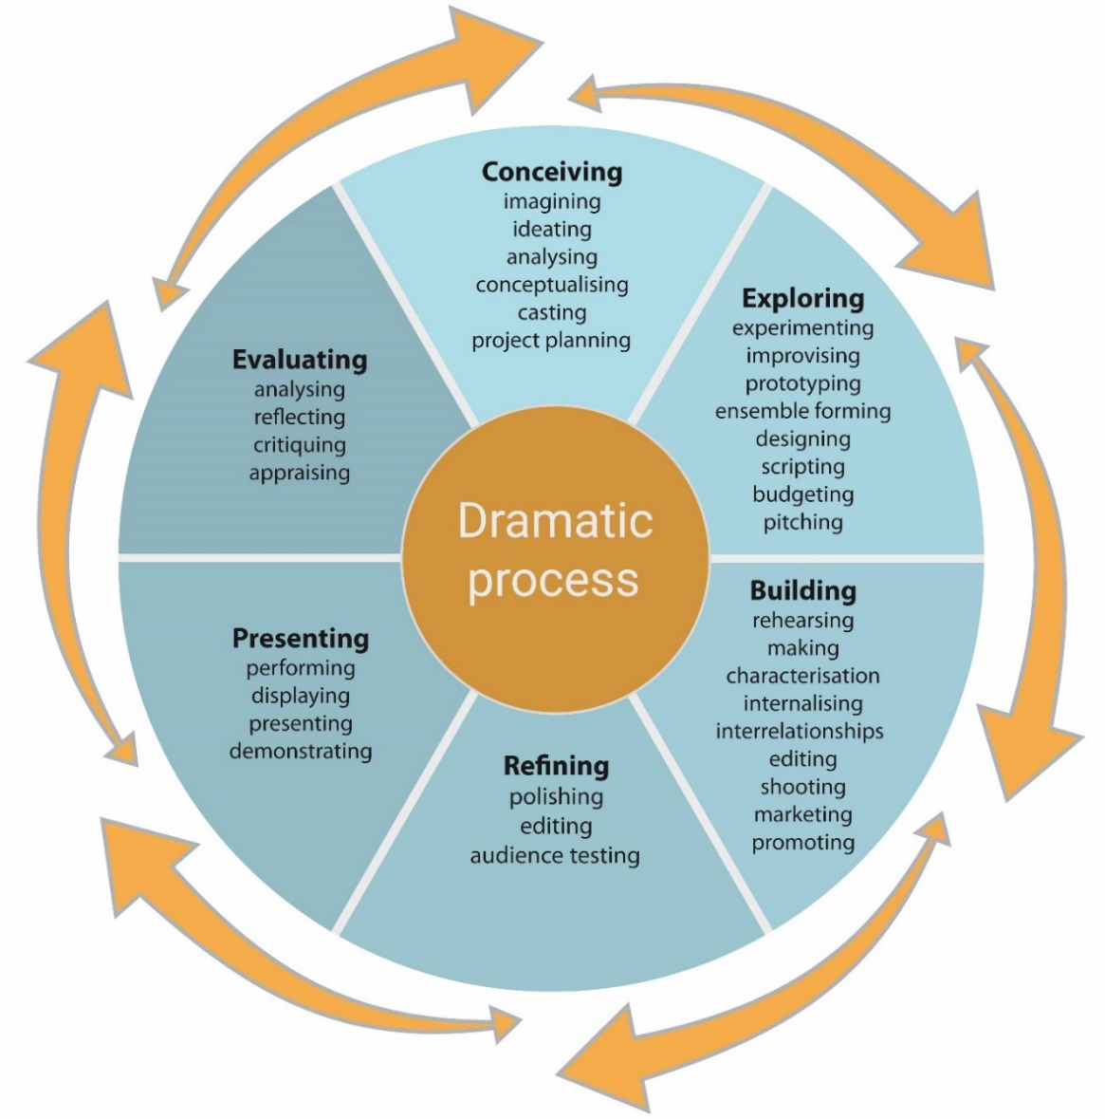  
  
  
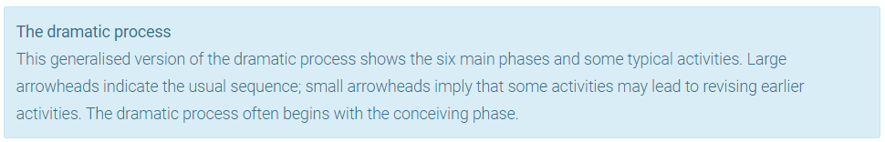

In addition to creating drama, students analyse and evaluate their own and others’ dramatic outcomes for artistic and cultural merit. They connect the analysis with their learning, development, and creativity as dramatic artists.

The two areas of dramatic study for Stage 2 Drama are discussed in more detail below.

Company and Production

In the Company and Production area of study, students collaborate to create a dramatic company (or companies). This may involve:

* the class as a whole in a single company
* a number of smaller companies from small groups within the class
* individual students who wish to collaborate with others, including, for example but not limited to, students from another year level or a community theatre company.

Students may choose to name their company and develop a rationale, vision statement, or mission statement of their shared dramatic intent.

In the company, students choose one or more roles from the range of creative, production, and entrepreneurial roles available. Through their roles, they learn the transferable skills of project management, collaborative problem-solving, entrepreneurialism, and processes for realising creative outcomes.

Students specialise in one (or more) roles within their company to develop their knowledge, skills, and understanding. Teachers guide the selection of roles to provide adequate scope for students to demonstrate their learning in manageable ways.

Individual dramatic roles within the company may include, for example:

* actor
* designer#
* director
* stage manager
* production manager
* dramaturge
* playwright
* screenwriter
* film-maker
* cinematographer
* editor
* producer
* publicist and promoter.

# e.g. set or production, costume, make-up and hair (and/or mask), publicity and promotions, lighting,

sound, music and/or composition, SFX, multimedia, front-of-house.

Students collaborate to develop two dramatic outcomes:

* the group production
* the creative presentation.

Group production

As a company (or companies), students are led by the teacher through the dramatic process to develop a group production or a selection of smaller productions. The scope and scale is dependent upon the interests of the students, the context and culture of the school, and the resources available. For example, productions could range from an inclass performance for peers, through to a full-scale stage production in a theatre or the equivalent for a screen production.

A production may be based on an established dramatic text or it may be self-devised. Teachers should ensure that scripts provide adequate focused stage-time for each actor to develop, perform, and evaluate their own role or roles. Similarly, adequate scope should be provided for designers, production practitioners, and dramatic entrepreneurs to explore and create successful dramatic outcomes. Teachers should ensure that the length of theatre and/or screen productions is manageable for students.

Teachers negotiate ideas and process with students, emphasising collaborative decision-making. Students deepen their understanding of on-stage and/or off-stage roles (or equivalent screen roles). The ideas, exploration, and development culminate in a company performing a production to a live audience and/or screening its production to a live or online audience.

The group production is assessed through Assessment Type 1: Group Production.

*Creative presentation*

Students form small groups of two to five students to independently devise a dramatic work or products in an area of interest. They apply the dramatic process in collaboration to conceive a vision for the work, and rehearse and develop the work leading to a final, polished outcome. The creative presentation is led by students, with the teacher guiding or facilitating only.

Students may choose to produce their work as an ensemble within the company that they formed as a whole class for the group production, or they may create a new company with an independent artistic intent.

This collaboration to create a polished dramatic outcome is assessed in Assessment Type 3: Creative Presentation (the external assessment).

Exploration and Vision

In the Exploration and Vision area of study, students focus on the development of their critical and creative thinking skills. They explore dramatic ideas, theories, and works by critically viewing a range of live theatre and/or screen productions, by engaging in workshops with professionals (where possible), and by investigating dramatic styles, and/or innovations from local, global, contemporary, and historical contexts.

In Exploration and Vision, teachers program the study of a dramatic text (or texts) and a selection of two or more dramatic styles, innovators, or movements. The choice of texts in Exploration and Vision must be different from the texts produced by students in the group production, but may be written by the same authors and may involve the same dramatic styles.

Students are provided with opportunities to explore a selection of dramatic styles, innovators, and/or movements. They are encouraged to experiment, take risks, suggest innovations, and explore hypothetical possibilities. Teachers provide access to a range of dramatic works, events, and source material, including, where possible, local and/or Australian drama, Aboriginal and Torres Strait Islander drama or perspectives, and drama from other cultures and/or periods.

Teachers should provide students with opportunities to analyse, compare, and contrast dramatic works, events, and source material. Analysis and evaluation may involve stylistic, thematic, and/or aesthetic connections between dramatic sources. Students identify and analyse how works, events, and source material have informed and/or influenced their own dramatic ideas and/or practice.

In this subject students extend and apply their intercultural understanding capability by, for example:

* viewing, analysing, and evaluating two or more current live professional theatre and/or screen productions, with a view to informing and shaping the student’s own development as a dramatic artist in a role (e.g. actor, director, designer, playwright)
* engaging in workshops, mentorships, and/or masterclasses conducted by professional local and global practitioners, to shape and influence the student’s own dramatic understanding and skills development
* investigating and experimenting with contrasting dramatic styles or innovations
* exploring and analysing a dramatic text with a view to creating a director’s or designer’s vision for staging, informed by the student’s investigation of theory, theatre viewing, and practical experimentation
* exploring and analysing drama as an avenue for social change with a view to conceiving a self-devised hypothetical performance
* exploring and analysing theatre and/or film of Aboriginal artists for its perspectives and contributions to Australian and global drama
* exploring and analysing a variety of theories and styles and how they might influence the staging of a text or a design for a production; for example, how might Artaud, butoh and verbatim theatre be synthesised to inform the staging of a contemporary hypothetical production of Macbeth
* investigating, exploring, and analysing creative, entrepreneurial, and logistical processes for mounting a hypothetical touring production
* exploring and analysing two or more film-making styles and how they might influence a treatment and/or screenplay for an original film
* researching, experimenting with, and evaluating live-streamed theatre, and its capacity for conveying the ideas and aesthetics of theatre
* researching, experimenting with, and analysing processes for adapting a short story for stage or screen, with a view to a hypothetical creative outcome.

Exploration and Vision is mainly assessed through Assessment Type 2: Evaluation and Creativity.

The relationship between content and assessment is shown through the following diagram.  
  
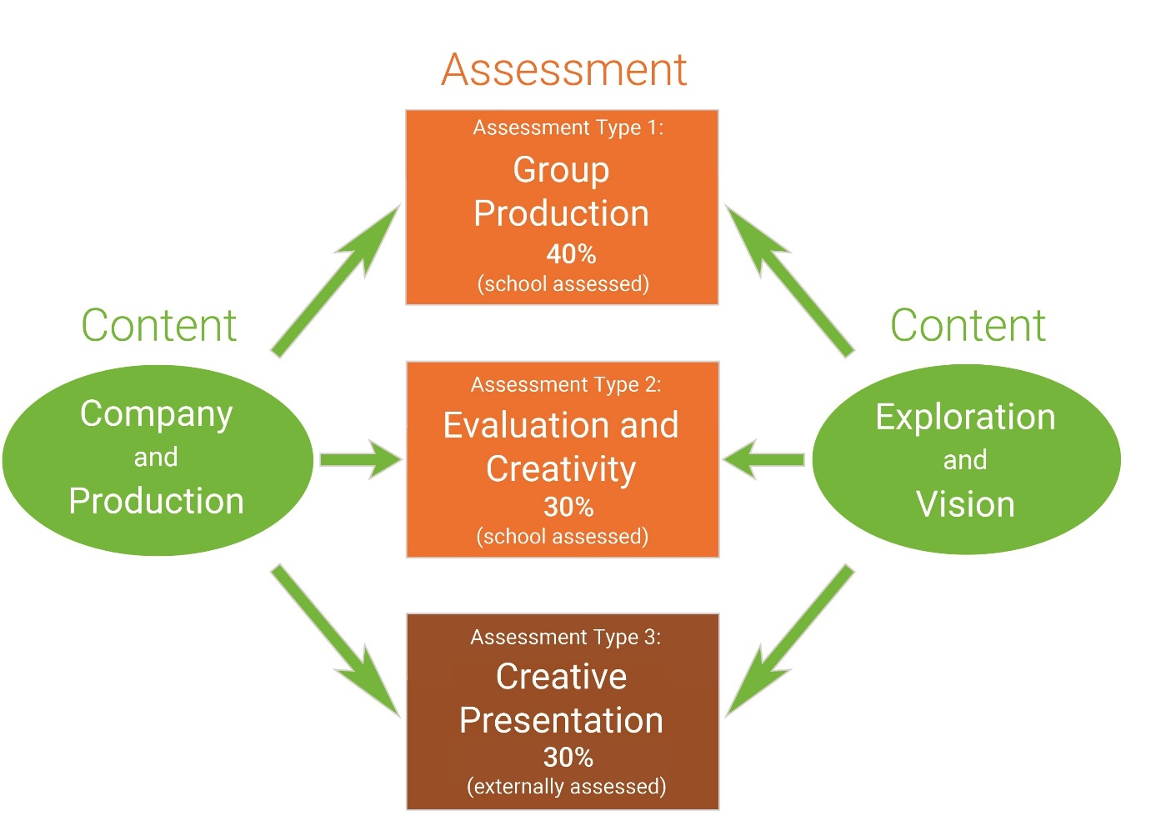  
  
  


# Evidence of learning

All Stage 2 subjects have a school assessment component and an external assessment component.

The following assessment types enable students to demonstrate their learning in Stage 2 Drama.

*School assessment (70%)*

* Assessment Type 1: Group Production (40%)
* Assessment Type 2: Evaluation and Creativity (30%)

*External assessment (30%)*

* Assessment Type 3: Creative Presentation (30%).

Students provide evidence of their learning through three or four assessments, including the external assessment component. Students complete:

* one group production task
* one or two evaluation and creativity tasks
* one creative presentation.

# Assessment design criteria

The assessment design criteria are based on the learning requirements and are used by teachers to:

* clarify for students what they need to learn
* design opportunities for students to provide evidence of their learning at the highest level of achievement.

The assessment design criteria are the specific features that:

* students need to demonstrate in their evidence of learning
* teachers look for as evidence that students have met the learning requirements.

For this subject, the assessment design criteria are:

* knowledge and understanding
* critical and creative thinking
* creative application.

## Knowledge and Understanding

KU1 Exploration and understanding of dramatic theories, texts, styles, conventions, roles, and processes.

KU2 Understanding and evaluation of the artistic and cultural value of local, global, contemporary, and/or historical drama.

## Critical and Creative Thinking

CCT1 Creative thinking and experimentation in the development of dramatic ideas.

CCT2 Analysis and evaluation of the student’s own drama-making and others’ dramatic works, styles, and/or events..

## Creative Application

CA1 Application of dramatic processes, individually and in collaboration with others.

CA2 Application of dramatic skills.

CA3 Integration of theory and practice to make meaningful dramatic outcomes.

# School assessment

The school assessment component for Stage 2 Drama consists of two assessment types:

* Assessment Type 1: Group Production
* Assessment Type 2: Evaluation and Creativity.

Assessment Type 1: Group Production (40%)

Students undertake one group production task. 

Process and performance

For the group production, students are led by the teacher to work collaboratively through the framework of the Company and Production area of study to conceive, explore, develop, produce, refine, and perform (or present) a dramatic work or product. They apply the dramatic process by undertaking roles and collaborating in an ensemble to achieve individual and shared outcomes. 

Students present their production to an audience. ‘Audience’ can be considered in the broadest possible form (which includes live, virtual, and/or intended audience performance modes). The length of the performance or presentation is dependent upon the size of the group, the nature of the class of students, and the availability of resources. The scale of the production may range from an in-class performance for peers, through to a full-scale production in a theatre or the equivalent for a screen production. 

Students complete a group production, developed, and presented in one of the following ways:

* a production and live performance of a published play or plays (or self-devised works in either text form or conceptual form), involving all or most of the class members in a single theatre company
* two or more live productions and performances of published plays or self-devised works by smaller groups from within the class as theatre companies
* the production, shooting, editing, and screening of a short film (or films), or pilot episode for a teleseries, involving part or all of the class as a screen production company or companies
* an individual dramatic performance or presentation developed in collaboration with at least one other person from within or outside the class. Examples of collaboration by individual performers or presenters may include, but are not limited to:
* directing students from a younger year’s class in a live performance or film
* conceiving and producing a monologue performance which involves the technical, design, or directorial assistance of at least one other student or a dramatic practitioner
* designing costumes in collaboration with an external dramatic organisation, such as a community theatre company
* creating and presenting several film trailers for a range of original, hypothetical films, in collaboration with at least one other student or a dramatic practitioner.

*Presentation of evidence*

Each individual student selects and presents evidence of their understanding, creativity, analysis, evaluation, application, and development in the form of a recorded presentation of up to 15 minutes (or equivalent, see below).

For actors, within the 15 minutes of evidence, approximately 5 minutes should comprise a selection of recorded evidence of the student’s performance in their role(s) to an audience.

For off-stage and off-screen presenters, the time allocation for recorded evidence is up to a maximum of 15 minutes. 

The selection of evidence from the process and performance should be an authentic representation of the range of the student’s learning and application. Evidence may be selected from various parts of the process and performance, and may be edited.

The presentation of evidence is provided by the student in an accepted video (or video and written) format. Evidence provided to the SACE Board of a recorded performance for an intended audience will be sufficient; however, performance to a live audience, where possible, is desirable.

Examples of forms for the presentation of evidence may include, but are not limited to:

* a video-recorded oral presentation
* a mini-documentary in the style of a ‘the making of …’ documentary, to creatively demonstrate learning and intentions
* a video essay
* an annotated multimedia presentation
* a vlog with analysis and evaluation of learning and development
* a video of excerpts of rehearsal and performance accompanied by a written commentary
* a video diary.

The aim of the presentation of individual evidence is to demonstrate each student’s analysis and evaluation of their learning and application throughout the group production process and performance.

Students may choose to begin their presentation of evidence with a question to be answered, a statement of intent, or an artist’s statement to establish the context of their dramatic intention and learning.

Features of the presentation may include, but are not limited to:

* discussion of dramatic, aesthetic, creative, conceptual, developmental, analytical and evaluative learning
* articulation of how the intentions of the group production support the artistic vision or mission of the company
* analysis of significant moments and features of the performance with regard to students deepening their learning of roles, both individually and collaboratively
* evaluation of skills development over the course of the production process and the performance or presentation, through analysis of well-chosen examples
* analysis of the relationship with the audience, including engagement and connection
* reflection on collaboration and collaborative learning in drama, relevant to the production
* analysis of and reflection on page-to-stage or page-to-screen choices
* analysis of and reflection on the artistic merit of individual and collaborative choices
* analysis of creativity skills and development
* analysis of real and potential audience development for the production.

The video recording of the presentation of evidence may be up to 15 minutes for multimodal or oral presentations. Where the presentation of evidence includes a written component, it must be accompanied by a video of excerpts. The written component should not exceed 1250 words. (Please note: 6 minutes is equivalent to 1000 words.)

For this assessment type, students provide evidence of their learning in relation to the following assessment design criteria:

* knowledge and understanding
* critical and creative thinking
* creative application.

Assessment Type 2: Evaluation and Creativity (30%)

Students undertake one or two evaluation and creativity tasks.

To demonstrate their analysis, evaluation, and creativity as authentic drama practitioners, students complete two tasks, or they may choose to integrate the tasks to produce one single piece that synthesises the ideas, theories, practice, learning, and/or subject matter investigated.

In this assessment type, evidence of student learning may be informed by analysis and evaluation of dramatic works, theories, events, and source material that have been explored in the Exploration and Vision area of study, and from the practical and contextual learning gained from the Company and Production area of study.   
  
One task (or part-task) should focus on responding to drama. Students produce an analysis and evaluation of dramatic events created by professional drama practitioners. The evaluation should provide opportunities for students as artists to link reflection of their own development with their learning from professional dramatic events. Events may include live theatre performances, onsite masterclasses and workshops, dramatic film, and/or online drama performances.

The second task (or part-task) should focus on creating drama. It may be linked to the study of the shared text and dramatic styles explored and analysed during Exploration and Vision, or to another text and style(s), or it can be self-devised.  The chosen texts must be different from the texts produced by the students in the group production; however, they may be written by the same authors and may involve the same dramatic styles. In this task, each student is encouraged to take creative risks and to experiment while imagining, conceiving, and developing a hypothetical creative outcome.  

Examples of tasks may include, but are not limited to:

* an original design or directorial concept and pitch for a hypothetical production of the shared text studied in Exploration and Vision, with justified examples of staging choices
* a pitch for an original creative vision or concept of a hypothetical production of another dramatic text (or self-devised work), with justified examples of staging choices
* a written response making links between a live theatre production and their own practice as an actor, director, film-maker, or designer
* an original script (or part of a script) with an annotated analysis and justification of choices and intentions, with a synopsis of the whole work
* a business plan and pitch as the producer of a hypothetical regional tour of the group production (or another actual or hypothetical production). The pitch and plan may include consideration of the dramatic and artistic intentions of the production, audience development, touring viability, budget, marketing, sustainability with a view to carbon neutrality, artists’ salaries, and touring logistics
* an oral presentation which analyses and evaluates the experience of a workshop or masterclass by visiting professional performers to the school, and how the student artist might link the learning gained to inform and improve the development of their own practice
* a multimedia presentation exploring how a theatre practitioner or film-maker has used technology innovatively and how this might influence ideas for a new hypothetical work
* an oral presentation analysing and evaluating how a live production has inspired the student artist, and how the ideas, aesthetics, and skills have spurred the student to envisage an original theatrical work
* a discursive essay detailing the student’s personal philosophy of theatre for the purpose of social change, e.g. ‘a theatre of hope’, ‘a theatre of provocation’.
* an oral presentation of a director’s or auteur’s vision for a self-devised production, exploring the issue of climate change, racism, or another social issue
* a vlog for a target audience, such as Inside the Actors Studio, reflecting on how theatre or film provides opportunities for presenting viewpoints through drama about a contemporary issue
* a recorded oral discussion with a peer, a small group, or a teacher exploring how ideas from a performance tradition might be applied in a local, contemporary dramatic context, e.g. the Balinese chorus or butoh dramatic movement
* a tutorial presentation about the use of non-literal devices such as symbolism in one or more plays or films, and how these might influence a directorial concept or set design.

The combined total for tasks in this assessment type is a maximum of 12 minutes if oral or multimodal, or 2000 words if written.

For this assessment type, students provide evidence of their learning primarily in relation to the following assessment design criteria:

* knowledge and understanding
* creative and critical thinking
* creative application.

# External assessment

The external assessment component for Stage 2 Drama consists of a creative presentation.

Assessment Type 3: Creative Presentation (30%)

Students undertake one creative presentation.

The creative presentation comprises two parts: a presentation and a learning portfolio.

Presentation

Students collaborate in small groups of between two and five to conceive, plan, and produce a creative dramatic presentation. As a small dramatic company or a small ensemble within a whole-class company, they individually and collaboratively apply the knowledge, skills, and understanding that they have learned, including dramatic theory and process, to generate a shared dramatic intention and create a presentation as an ensemble.   
   
The presentation may take a variety of forms including, for example, but not limited to, a live performance, a film or screen production, designs within an ensemble dramatic concept, a workshop, or a masterclass. The presentation is recorded on an accepted video format. The maximum duration of the presentation depends on the number of students in the ensemble: two students, 10 minutes; three students, 15 minutes; four students, 20 minutes; five students, 25 minutes. Teachers are advised that these lengths are maxima only, and the actual duration of presentations should be determined by the form, type, and context of each ensemble’s dramatic intention. Each student’s participation in the presentation may involve one or more roles including, for example:

* actor
* designer#
* director
* stage manager
* production manager
* dramaturge
* playwright
* screenwriter
* film-maker
* cinematographer
* editor
* producer
* publicist and promoter.

# e.g. set or production, costume, make-up and hair (and/or mask), publicity and promotions, lighting, sound, music and/or composition, SFX, multimedia, front-of-house. 

Learning portfolio

Students record, analyse, reflect on, and evaluate their creative decision-making and their application of dramatic process and skills towards the realisation of their presentation, as individuals and in collaboration. They provide justifications for their artistic choices by synthesising learning from their exploration, application of dramatic theories, and practical experimentation in the development and refinement of the product.

Each student individually provides a learning portfolio as evidence of their analysis and evaluation of learning.

The learning portfolio should include analysis and evaluation of individual and collaborative ideas, decisions, and contributions during the process, and include evaluation of the artistic merit of their final product.

The documentation of evidence may take a variety of forms, and students should take a creative approach to representing and articulating their creative and critical thinking and application of skills. They may use one or a combination of multimodal, oral, visual, and written forms to present evidence of their learning. The learning portfolio should be a maximum of 9 minutes if multimodal (or the equivalent if oral and/or written, where 6 minutes is equal to 1000 words). Examples of ways that students may present their learning portfolio include, but are not limited to:

* oral analysis in the style of a ‘director’s commentary’, recorded and synchronised with the final video of the presentation, including analysis of the processes and decision-making leading to final choices
* a short documentary film in the style of a ‘the making of …’ documentary. The documentary film should include images and/or video footage from the development and refinement of the outcome as an ensemble
* a document of visual and written material, including annotated examples of evidence of exploration, development, and refinement of dramatic choices
* a video essay that creatively documents, analyses, and evaluates process and outcome.

Evidence may include:

* discussion of dramatic, aesthetic, creative, conceptual, developmental, analytical, and evaluative learning
* analysis of key, significant, and/or watershed moments and features of the process with regard to students deepening their learning of roles, both individually and collaboratively
* evaluation of skills development over the course of the production process, including the final outcome, using well-chosen examples from throughout the duration of the process and final presentation
* reflection on collaboration and collaborative learning, relevant to the production process
* analysis and justification of page-to-stage or page-to-screen choices
* articulation of how the intentions of the creative presentation support the artistic vision or mission of the company
* analysis of and reflection on the artistic merit of individual and collaborative choices
* analysis of creative learning and development
* analysis of real and/or potential audience development for the presentation.

The following specific features of the assessment design criteria for this subject are assessed in the creative presentation:

* knowledge and understanding — KU1
* critical and creative thinking — CCT1, CCT2
* creative application — CA1, CA2, CA3.

# Performance standards

The performance standards describe five levels of achievement, A to E.

Each level of achievement describes the knowledge, skills, and understanding that teachers refer to in deciding how well students have demonstrated their learning on the basis of the evidence provided.

During the teaching and learning program the teacher gives students feedback on their learning, with reference to the performance standards.

At the student’s completion of study of a subject, the teacher makes a decision about the quality of the student’s learning by:

* referring to the performance standards
* assigning a subject grade between A+ and E— for the assessment type.

The student’s school assessment and external assessment are combined for a final result, which is reported as a grade between A+ and E—.

Performance standards for Drama Stage 2

|  |  |  |  |
| --- | --- | --- | --- |
| - | Knowledge and Understanding | Critical and Creative Thinking | Creative Application |
| A | KU1 Sophisticated and highly detailed exploration and understanding of dramatic theories, texts, styles, conventions, roles, and processes.  KU2 Perceptive and insightful understanding and evaluation of the artistic and cultural value of local, global, contemporary, and/or historical drama. | CCT1 Highly creative thinking and experimentation in the development of dramatic ideas.  CCT2 Sophisticated and creative analysis and evaluation of the student’s own drama-making and others’ dramatic works, styles, and/or events. | CA1 Highly focused and sustained application of dramatic processes, individually and in collaboration with others.  CA2 Highly creative and proficient application of dramatic skills.  CA3 Highly innovative and coherent integration of theory and practice to make meaningful dramatic outcomes. |
| B | KU1 Mostly detailed and some in depth exploration and understanding of dramatic theories, texts, styles, conventions, roles, and processes.  KU2 Detailed and thorough understanding and evaluation of the artistic and cultural value of local, global, contemporary, and/or historical drama. | CCT1 Creative thinking and experimentation in the development of dramatic ideas.  CCT2 Thorough analysis and evaluation of the student’s own drama-making and/or others’ dramatic works, styles, and/or events. | CA1 Focused and productive application of dramatic processes, individually and in collaboration with others.  CA2 Creative and comprehensive application of dramatic skills.  CA3 Innovative and clear integration of theory and practice to make meaningful dramatic outcomes. |
| C | KU1 Considered exploration and general understanding of dramatic theories, texts, styles, conventions, roles, and processes.  KU2 Understanding and some evaluation of the artistic and cultural value of local, global, contemporary, and/or historical drama. | CCT1 Generally creative thinking and experimentation in the development of dramatic ideas.  CCT2 Generally competent analysis and evaluation of the student’s own drama-making and others’ dramatic works, styles, and/or events. | CA1 Generally productive application of dramatic processes, individually and in collaboration with others.  CA2 Competent application of dramatic skills.  CA3 Some originality and coherence in the integration of theory and practice to make meaningful dramatic outcomes. |
| D | KU1 Some exploration and basic understanding of dramatic theories, texts, styles, conventions, roles, and/or processes.  KU2 Attempted understanding of the artistic and cultural value of local, global, contemporary, and/or historical drama. | CCT1 Attempted thinking and experimentation in the development of dramatic ideas.  CCT2 Some general reflection on the student’s own drama-making and/or others’ dramatic works, styles, or events. | CA1 Partial application of dramatic processes, individually and in collaboration with others.  CA2 Partial application of dramatic skills.  CA3 Basic expression and attempted integration of theory and practice to make meaningful dramatic outcomes. |
| E | KU1 Limited exploration and understanding of dramatic theories, texts, styles, conventions, roles, and/or processes.  KU2 Limited understanding of the artistic and cultural value of local, global, contemporary, and/or historical drama. | CCT1 Limited thinking and experimentation in the development of dramatic ideas.  CCT2 Limited reflection on the student’s own drama-making and/or others’ dramatic works, styles, or events. | CA1 Limited application of dramatic processes, individually and in collaboration with others.  CA2 Limited application of dramatic skills.  CA3 Limited expression of theory and practice to make meaningful dramatic outcomes. |