

Design, Technology and Engineering (Stage 2)

Subject Outline

Subject outline changes

Below are the current changes to the subject outline. Teachers are encouraged to explore the changes in detail and make relevant adjustments to their teaching, learning, and assessment programs.

From 2024 | To 2025 onwards | page
Stage 2
Assessment Type 1: Specialised Skills Task  Evidence for this assessment type should be provided in multimodal form to a maximum of 6 minutes if an oral, 1000 words in written form, or a combination of these. | Assessment Type 1: Specialised Skills Task  Evidence for this assessment type should be provided in multimodal form to a maximum of 8 minutes if an oral, 1200 words in written form, or a combination of these. | 13

Subject description
Stage 2 Design, Technology, and Engineering is a 20-credit subject.
In Design, Technology, and Engineering students use design and realisation process to engineer solutions for the development of products or systems. Design, Technology, and Engineering has four contexts: digital communication solutions, industry and entrepreneurial solutions, material solutions, and robotic and electronic systems.
The subject provides a flexible framework that encourages students to be creative, innovative, and enterprising in their chosen context. They apply critical thinking and problem-solving skills, and incorporate technologies to address design problems and challenges. This subject incorporates the transfer of interdisciplinary skills and knowledge and promotes individualised and inquiry-based learning. Design, Technology, and Engineering provides opportunities for students to apply engineering processes and use new and evolving technologies.
In Stage 2 students use an iterative design process to explore possible solutions to a problem or opportunity. They investigate and analyse the purpose, design features, materials, and production techniques used in diverse situations including industry, community, and tertiary organisations. This information is used to create a design brief that provides the basis for the development of potential solutions. The importance of the design process as a preliminary to the realisation process is emphasised, as is ongoing evaluation of the solution and vice versa.
In this subject, a ‘solution’ is an outcome of the design and realisation process in relation to the chosen context. A solution could be fully realised or a model, prototype, system, part, process (i.e. procedures to output a product), or product.
Students analyse influences on a solution including ethical, legal, economic, and/or sustainability issues. They consider the practical implications of these issues on society or on design solutions.
Students apply appropriate skills, processes, procedures and techniques whilst implementing safe work practices when creating the solution.
Student learning is reported for the following contexts:
- Design, Technology, and Engineering — Digital Communication Solutions
- Design, Technology, and Engineering — Industry and Entrepreneurial Solutions
- Design, Technology, and Engineering — Material Solutions
- Design, Technology, and Engineering — Robotic and Electronic Systems.

Capabilities
The capabilities connect student learning within and across subjects in a range of contexts.
The SACE identifies seven capabilities.

Literacy
In this subject students extend and apply their literacy capability by, for example:
- using a range of sketches, or graphical, digital, or computer-generated images to communicate product or system design ideas to suit particular contexts and audiences
- understanding and using language and terminology specific to design, technology, and engineering in written or oral forms to communicate ideas about solutions design
- understanding and applying specific instructions in relation to systems, processes, and safe operating procedures
- interpreting and analysing technical information
- using a variety of communication formats, including digital technologies, to demonstrate understanding and analysis
- using language for different purposes including to interpret, discuss, and explain concepts, issues, problems, and solutions
- reading and interpreting online documentation and acknowledging resources appropriately.

Numeracy
In this subject students extend and apply their numeracy capability by, for example:
- selecting and using appropriate measurement tools and programs
- applying numerical calculations appropriate to the context and task
- displaying numerical information in accordance with correct technical standards and procedures
- interpreting numerical data for relevance
- understanding and using graphs, spreadsheets, diagrams, codes, and statistics to communicate technical data, properties of materials, or systems information
- creating tables, charts, or diagrams to define product specifications
- applying the scientific method to the design and construction processes of the solution (e.g. testing material characteristics or suitability).

Information and communication technology (ICT) capability
In this subject students extend and apply their ICT capability by, for example:
- using relevant digital technologies to communicate design intent
- locating and accessing information using digital technologies
- presenting findings or solutions using multimodal approaches (e.g. a multimodal design brief)
- using specialised programs and tools such as computer-aided design (CAD) and computer-aided manufacturing (CAM) to develop solutions
- understanding the impact of ICT on design solutions.

Creative and critical thinking
In this subject students extend and apply their critical and creative thinking capability by, for example:
- analysing existing product or system characteristics and features to inform the design and realisation process
- visualising possibilities and scoping solutions
- adapting the design development in response to results of testing and research
- identifying and deconstructing problems
- using initiative in designing products or concept solutions
- evaluating existing and proposed designs of products or systems
- designing innovative, creative, and appropriate solutions using available materials
- critically evaluating entrepreneurial opportunities (e.g. patents, marketing and distribution, mass production, online publishing, crowd-sourcing).

Personal and social capability
In this subject students extend and apply their personal and social capability by, for example:
- listening to and respecting the perspectives of others
- participating in inquiry-based activities that foster problem-solving and practical application
- sharing ideas about problems, progress and innovative solutions
- working collaboratively (face-to-face or online) to develop imaginative, innovative, and enterprising outcomes
- having opportunities to interact with people in different contexts, and building the confidence to be involved in problem-solving
- planning and working in productive, creative, collaborative, and independent ways
- making decisions and taking initiative in designing products or solutions
- acquiring practical skills, knowledge, and understanding related to the design, development, and realisation of a product or system
- understanding how design affects individuals, groups, and/or society
- developing entrepreneurial skills
- planning effectively and managing time.

Ethical understadning
In this subject students extend and apply their ethical understanding capability by, for example:
- evaluating the reliability of information for accurate decision-making
- understanding the ethical implications of environmental responsibility and sustainability through considered selection and use of materials, processes, and production techniques
- recognising the importance of responsible participation in social, economic, environmental, scientific, and/or ethical decision-making
- applying an understanding of personal and group safety in a work environment
- reviewing the impact of technological practices, products, or systems on individuals, society, and/or the environment.

Intercultural understanding
In this subject students extend and apply their intercultural understanding capability by, for example:
- understanding that the process of designing and implementing a design solution is influenced by cultural factors
- valuing cultural diversity when working in groups or solving problems
- respecting and engaging with different cultural perspectives, skills, and customs, and exploring these using various technologies
- researching different cultural traditions that impact on design concepts
- exploring design issues in local, national, and/or global contexts to expand knowledge of and create solutions for a diverse range of individuals, groups, and societies.

Aboriginal and Torres Strait Islander knowledge, cultures, and perspectives
In partnership with Aboriginal and Torres Strait Islander communities, and schools and school sectors, the SACE Board of South Australia supports the development of high-quality learning and assessment design that respects the diverse knowledge, cultures, and perspectives of Indigenous Australians.
The SACE Board encourages teachers to include Aboriginal and Torres Strait Islander knowledge and perspectives in the design, delivery, and assessment of teaching and learning programs by:
- providing opportunities in SACE subjects for students to learn about Aboriginal and Torres Strait Islander histories, cultures, and contemporary experiences
- recognising and respecting the significant contribution of Aboriginal and Torres Strait Islander peoples to Australian society
- drawing students’ attention to the value of Aboriginal and Torres Strait Islander knowledge and perspectives from the past and the present
- promoting the use of culturally appropriate protocols when engaging with and learning from Aboriginal and Torres Strait Islander peoples and communities

Learning requirements
The learning requirements summarise the knowledge, skills, and understanding that students are expected to develop and demonstrate through their learning in Stage 2 Design, Technology, and Engineering.
In this subject, students engage in the design and realisation process and are expected to:
- investigate and analyse design features, processes, materials, and production techniques and apply creative thinking to the design of a solution
- plan, develop, and test design concepts, and communicate potential features of — and solutions to — a problem or challenge
- apply knowledge and understanding of skills, processes, engineering procedures, and techniques, using technology to realise the solution
- evaluate the solution with reference to the design brief, and reflect on processes used in design development and realisation
- analyse ethical, legal, economic, and/or sustainability issues related to technology, materials selected, processes used, and/or solution design.

Content

The design and realisation process
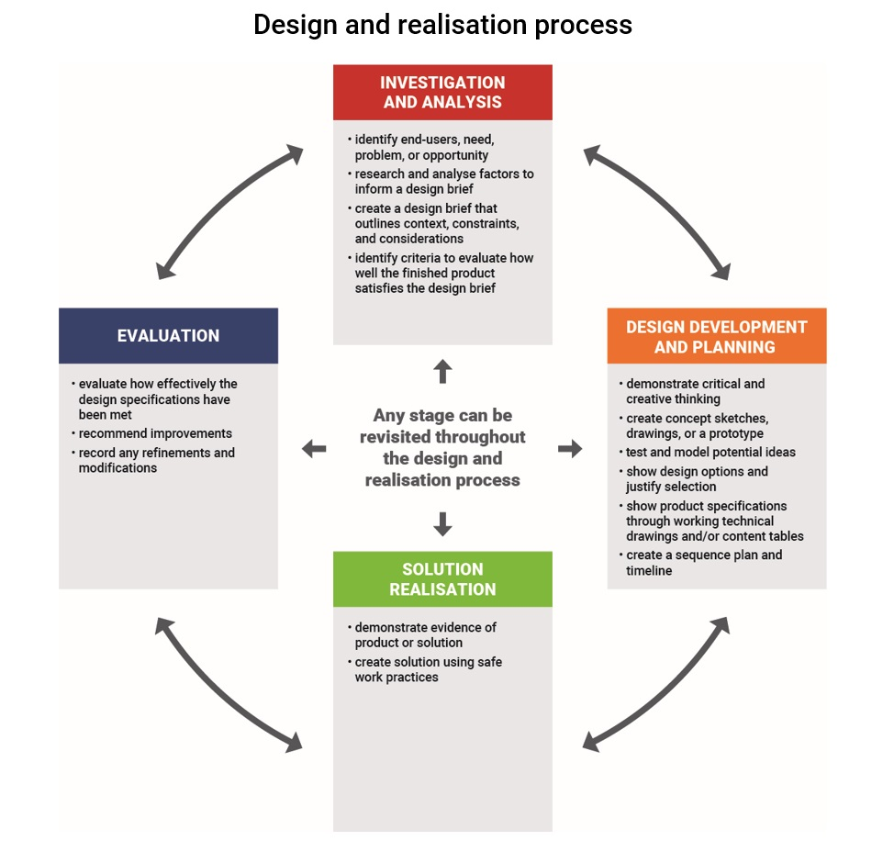
The design and realisation process is a flexible framework and forms the structure of the subject. The following diagram shows the components of a coherent and dynamic design progression. This process is rarely linear, and designing should be seen as a cyclical process with many possible solutions, rather than simple step-by-step process.

Investigation and analysis
The design and realisation process should begin with the identification of a problem or opportunity, followed by an initial investigation and research analysis. The design brief should specify constraints and considerations, and propose creative and innovative solutions. Students define criteria to evaluate how well the finished solution meets the requirements of the design brief.
Possible investigation and analysis strategies or techniques may include:
- use creative thinking techniques (e.g. visualisation, lateral thinking, brainstorming) to define the problem and seek solutions
- collaborating with peers to use visual tools (e.g. mind mapping) to explore concepts, problems, or opportunities
- investigating and interpreting solution design factors such as:
- technologies: tools, processes, and manufacturing methods
- materials: characteristics and properties
- innovation and creativity: inventing or improving products
- sustainability: life-cycle analysis, carbon footprint, potential to reuse or recycle, fair trade, customs, carbon footprint
- target audience, end user and potential for entrepreneurship and marketing
- ethical use and application of the end product
- ethical concerns related to health and safety, discrimination, social media, advertising, use of data and images, and conflicts of interest
- historical and cultural influences including social trends, the changing nature of work, technological change
- legal responsibilities: patents, safety requirements, intellectual property, creative commons, Australian International Standards, regulations and legislation including OH&S, safety of the product for the user
- economic considerations: costing of products including materials, labour, and equipment and machinery, responsible use of resources, product longevity, time management, and material availability.
- creating a written or multimodal design brief that includes key criteria and/or constraints such as function and/or aesthetics
- analysing existing product or system characteristics and features to inform the design and realisation process
- collecting and analysing data from target or end-point users for a purpose (e.g. survey, questionnaire)
- researching and analysing ideas from different contexts such as the manufacturing sector or emerging technologies
- researching historical design, period influences, or different cultural traditions
- acknowledging and correctly referencing sources of information and ideas
- conducting peer review and collecting feedback about the design brief
- critically analyse sources of information for reliability and validity.

Design development and planning
Another component of the design and realisation process is design development and planning in response to an established brief. This involves innovation, invention, iteration, and creativity in order to develop a solution for a problem or opportunity. Students document their design ideas and make plans to use the available resources such as time, materials, and technologies to realise the solution. They test, adapt, and validate the design prior to realisation.
Possible design development and planning strategies or techniques may include:
- using critical and creative thinking to devise a solution
- using ideation strategies such as adapting, modifying, substituting, or rearranging to improve the solution
- creating a design brief that shows specific aspects of the design development and planning
- creating working drawings, concept sketches, prototypes, story boards, flow charts, simulation, or 3D modelling
- working collaboratively, either face-to-face or online, with peers, industry, tertiary education, or communities to develop imaginative, innovative, and enterprising outcomes
- applying interdisciplinary concepts (e.g. artistic, scientific, mathematical, and engineering concepts) appropriate to the planning and designing of the product or system
- preparing timelines and procedures using visual organisers such as Gantt charts and tables that show sequencing
- testing possible materials and processes through experimentation, trial and error, or applying secondary research, and recording the results (e.g. photo essay, video, result tables, annotated images)
- collecting qualitative and quantitative data using scientific methodologies
- adapting the design development in response to results of testing and research
- justifying design solutions based on investigations and research analysis
- creating a table, chart, or diagram to define product specifications (e.g. measurement, materials to be used, processes required)
- applying the scientific method to the design and construction processes of the solution (e.g. testing material characteristics or suitability)
- using relevant digital technologies to communicate design intent.

Solution realisation
component (stage) of the design and realisation process involves realising a solution. A solution is the outcome of applying technological skills in order to meet the requirements of a design and realisation brief.
In this subject, a 'solution' is an outcome of the design and realisation process in relation to the chosen context. A solution may be fully realised or a model, prototype, system, part, process (i.e. procedures to output a product), or product.
Possible solution realisation strategies or techniques may include:
- producing a solution that is captured in multimodal form (e.g. photo story or short film)
- using appropriate processes and production techniques
- creating solutions that meet the planned design specifications
- developing skills and applying them to a range of applications
- creating an annotated multimodal product record of the creation of the product
- developing solutions to technical and engineering problems that may arise during realisation, such as accuracy of machinery, quality of materials and components, and understanding of software programs
- applying appropriate safety processes in physical and online environments.

Evaluation
The evaluation component of the design and realisation process involves judging the quality of the product against the criteria specified in the design brief, and identifying improvements.
Possible evaluation strategies or techniques may include:
- evaluating (individually and/or collaboratively) how effectively the requirements of the design brief specifications have been met
- reviewing criteria, standards, reliability, safety, quality, and cost-effectiveness
- reflecting on product or system outcomes in order to recommend modification or redevelopment of designs or ideas
- reflecting on the effectiveness of procedures used in the design and realisation process
- reflecting on personal learning (e.g. project management, practical skills, capabilities)
- testing of product or system with end-point users, and recording feedback in written or multimodal form
- collecting feedback from peers or an industry evaluation of solution
- creating a weekly journal to record the ongoing evaluation of the process and product
- evaluating potential publishing or entrepreneurship opportunities (e.g. patents, marketing and distribution, mass production, online publishing, crowd sourcing).

Contexts
Stage 2 Design, Technology, and Engineering is organised into four contexts:
- Digital Communication Solutions
- Industry and Entrepreneurial Solutions
- Material Solutions
- Robotic and Electronic Systems.
The contexts provide opportunities to develop design thinking, to investigate engineering solutions, to develop a plan, to realise the solution, and to evaluate the outcome. The context is chosen by the school to meet student needs and interests, taking into account the resources available.
Each of the four contexts provides a separate enrolment option for students.

Digital Communication Solutions
This context involves using symbols, signs, behaviour, speech, light, images, sound, or other data to design and make products that communicate information. Students produce outcomes that demonstrate the knowledge and skills associated with manipulation of digital communication media.
Examples of contexts for digital solutions include:
- application (app) development
- CAD
- digital animation
- film-making
- game production
- graphics
- multimedia
- photography
- sound
- virtual reality
- web design.

Industry and Entrepreneurial Solutions
This context involves designing solutions to meet industry requirements, or the invention of an entrepreneurial product that meets a need or solves a problem. This could be achieved using design programs such as computer-aided design to develop prototypes or products. Students demonstrate knowledge and skills associated with systems, processes, and materials appropriate for the prototype and final solution.
Examples of contexts for industry or entrepreneurial design solutions include:
- aerospace
- agricultural equipment
- architecture
- CAD/CAM
- construction
- food industry
- health and aged care equipment
- industrial design
- maritime equipment
- media, entertainment, music, and game industries
- product design
- software programming
- transport (e.g. automotive).

Material Solutions
This context involves the use of a diverse range of manufacturing technologies such as tools, machines, and/or systems to create a product using appropriate materials. Students produce outcomes that demonstrate the knowledge and skills associated with using systems, processes, and materials such as metals, plastics, wood, composites, ceramics, textiles, and foods.
Examples of contexts for material solutions include:
- clothing and textiles
- composite materials
- food
- jewellery manufacturing
- metal
- polymers
- timber.

Robotic and Electronic Systems
In this context, students can use a variety of hardware (components) that may be combined with software to design and realise a solution such as a device or system. Students produce outcomes that demonstrate the knowledge and skills associated with using electronic, mechatronic, electrical, or pneumatic systems. These can include electronic components, circuit design and assembly, robotic components, programming, wiring, gears, simulation, or systems integration.
The solutions may be hardware (e.g. an electronic circuit) or a combination of hardware and software (code).
Examples of contexts for electronic and robotic systems include:
- agricultural applications
- automated systems (e.g. programmable logic controllers)
- autonomous vehicles (e.g. model robot cars)
- biomedical engineering
- communication systems (e.g. radio telemetry, Bluetooth)
- electrical systems
- electronic circuits (printed circuit boards)
- electronic systems (including microcontroller boards such as Arduino and Picaxe)
- internet of things (IoT): web-connected sensors and devices (e.g. NodeMcu, WEMOS, Raspberry Pi)
- mechanical systems (e.g. using a variety of gear mechanisms)
- pneumatic, hydraulic, or fluidic systems.
- renewable energy systems (e.g. solar, wind, battery storage)
- robotics (building a programmed, autonomous, or remote-controlled robot.

Evidence of learning
All Stage 2 subjects have a school assessment component and an external assessment component.
The following assessment types enable students to demonstrate their learning in Stage 2 Design, Technology and Engineering.
School assessment (70%)
- Assessment Type 1: Specialised Skills Task (20%)
- Assessment Type 2: Design Process and Solution (50%)
External assessment (30%)
- Assessment Type 3: Resource Study (30%)
Students provide evidence of their learning through four to six assessments, including the external assessment component. Students complete:
- two specialised skills tasks
- one design process and solution task
- one resource study.

Assessment design criteria
The assessment design criteria are based on the learning requirements and are used by:
- teachers to clarify for the student what they need to learn
- teachers and assessors to design opportunities for students to provide evidence of their learning at the highest possible level of achievement.
The assessment design criteria consist of specific features that:
- students should demonstrate in their learning
- teachers and assessors look for as evidence that students have met the learning requirements.
For this subject the assessment design criteria are:
- Investigation and Analysis
- Design Development and Planning
- Production
- Evaluation.
The specific features of these criteria are described below.
The set of assessments, as a whole, must give students opportunities to demonstrate each of the specific features by the completion of study of the subject.

Investigation and Analysis
The specific features are as follows:
I1 Analyse the design features of products, processes, materials, systems, and/or production techniques.
I2 Analyse ethical, legal, economic, and/or sustainability issues related to a solution.

Design Development and Planning
The specific features are as follows:
D1 Communicate design concepts using technical language and visual representations.
D2 Plan, develop, test, and validate concepts and procedures.

Production
The specific features are as follows:
P1 Application of skills, processes, procedures, and techniques to create a solution.
P2 Development of solutions to technical problems or recommendations for improvement.

Evaluation
The specific features are as follows:
E1 Evaluation of the solution features, realisation process, and/or response to issues.

School assessment
The school assessment component for Stage 2 Design Technology and Engineering consists of two assessment types:
- Assessment Type 1: Specialised Skills Task
- Assessment Type 2: Design Process and Solution.

Assessment Type 1: Specialised Skills Tasks (20%)
Students complete two specialised skills tasks. They demonstrate skills and knowledge that will be required for the realisation of their solution. Tasks may be scaffolded to provide explicit guidance for students or may be student-developed. Students and teachers may negotiate whether it would be appropriate to demonstrate these skills in a single session, or over a more extended period of time.
Students develop knowledge and skills through completing these specialised skills tasks. They apply the skills, processes, and techniques in the chosen context. This informs the design development for a solution in Assessment Type 2. Students evaluate and assess the development of their own skills in this assessment task. They review how these processes and techniques may influence their solution.
Evidence for this assessment type should be provided in multimodal form to a maximum of 8 minutes if an oral, 1200 words in written form, or a combination of these.
Specialised skills may include:
- a simple circuit, such as an Arduino with a single input and output
- conducting a finite element analysis test using a CAD program
- programming a profile cut for a plasma cutter
- programming a hit-test collision for a game application
- using specialised equipment to decorate products through embellishment
- creating food products using molecular science strategies.
For this assessment type, students provide evidence of their learning primarily in relation to the following assessment design criteria:
- Production
- Evaluation.

Assessment Type 2: Design Process and Solution (50%)
Students produce one task in the design process and solution assessment type that together provide evidence of the stages of the design and realisation process. There is flexibility in this assessment type for students to complete a single assessment task or a series of up to three smaller, discrete sections to form the task.
The design and realisation process task(s) may include examples selected from those listed in the content section under the design and realization process section.
The task should be up to a total maximum of 3000 words, or the equivalent in multimodal form (where 6 minutes is equivalent to 1000 words). The task must showcase and evaluate the solution or product.
For this assessment type, students provide evidence of their learning primarily in relation to the following assessment design criteria:
- Investigation and Analysis
- Design Development and Planning
- Production
- Evaluation.

External assessment

The external assessment component for Stage 2 Design, Technology and Engineering consists of an investigation.

Assessment Type 3: Resource Study (30%)
Students undertake one resource study comprising two parts.
Part One: Resource Investigation
Students investigate and analyse the functional characteristics and properties of two or more materials or components that they are considering for use in the creation of their solution. They report on how their research into and testing of the functional characteristics and properties of these materials or components will affect the student selection for use in the realisation of their solution.
The specific features of the assessment design criteria assessed in this part are:
- Investigation and Analysis (I1)
- Design Development and Planning (D2).
Part Two: Issue Exploration
Students investigate and analyse ethical, legal, economic, and/or sustainability issues related to their solution.
The specific features of the assessment design criteria assessed in this part are:
- Investigation and Analysis (I2)
- Evaluation (E1).
The resource study should be presented in written or multimodal form. It should be up to a maximum of 2000 words if written or the equivalent in multimodal form (where 1000 words is equivalent to 6 minutes).
The following specific features of the assessment design criteria for this subject are assessed in the resource study:
- Investigation and Analysis (I1) (I2)
- Design Development and Planning (D2)
- Evaluation (E1).

Performance standards
The performance standards describe five levels of achievement, A to E.
Each level of achievement describes the knowledge, skills, and understanding that teachers refer to in deciding how well students have demonstrated their learning on the basis of the evidence provided.
During the teaching and learning program the teacher gives students feedback on their learning, with reference to the performance standards.
At the student’s completion of study of a subject, the teacher makes a decision about the quality of the student’s learning by:
- referring to the performance standards
- taking into account the weighting of each assessment type
- assigning a subject grade between A+ and E— for the assessment type.
The student’s school assessment and external assessment are combined for a final result, which is reported as a grade between A+ and E—.

Performance standards for Stage 2 Design, Technology and Engineering
- | Investigation and Analysis | Design Development and Planning | Production | Evaluation
A | Comprehensive and insightful analysis of the design features of products, processes, materials, systems, and/or production techniques.  Purposeful research and critical analysis of ethical, legal, economic, and/or sustainability issues. | Insightful and comprehensive communication of design concepts using relevant technical language and visual representations.  Insightful and thorough planning, development, testing, and validation of design concepts and procedures. | Highly proficient application of skills, processes, procedures, and techniques to create a solution.  Comprehensive development of solutions to technical problems that arise during the solution realisation. | Comprehensive and insightful evaluation of the solution features, realisation process, and/or response to issues.
B | Thoughtful and well-considered analysis of the design features of products, processes, materials, systems, and/or production techniques.  Detailed research and well-considered analysis of ethical, legal, economic, and/or sustainability issues. | Thoughtful and well-considered communication of design concepts, using relevant technical language and visual representations.  Well-considered planning, development, testing, and validation of design concepts and procedures. | Proficient application of skills, processes, procedures, and techniques to create a solution.  Thoughtful development of solutions to technical problems that arise during the solution realisation. | Well-informed and detailed evaluation of the solution features, realisation process, and/or response to issues.
C | Considered analysis of the design features of products, processes, materials, systems, and/or production techniques.  Research and some analysis of ethical, legal, economic, and/or sustainability issues. | Clear communication of design concepts, using technical language and some visual representations.  Competent planning, development, testing, and validation of some design concepts and procedures. | Competent application of skills, processes, procedures, and techniques to create a solution.  Development of solutions to technical problems that arise during the solution realisation. | Considered evaluation of the solution features, realisation process, and/or response to issues.
D | Identification of the design features of products, processes, materials, systems, and/or production techniques.  Some description of information about ethical, legal, economic, and/or sustainability issues. | Basic communication of design concepts, using some technical language.  Some planning and development of design concepts and/or procedures. | Basic application of some skills, processes, procedures, and techniques to create a solution.  Some endeavour to develop solutions to technical problems that arise during the solution realisation. | Some description of the solution features, realisation process, and/or response to issues.
E | Attempted identification of the design features of products, processes, materials, systems, and/or production techniques.  Some accessing of information about ethical, legal, economic, and/or sustainability issues. | Superficial and simplistic communication of design concepts.  Limited use of information to plan design concepts. | Limited application of emerging skills.  Attempted development of a solution to a technical problem. | Emerging recognition of the solution features, realisation process, and/or response to issues.

