

# Health and Wellbeing (Stage 1)

Subject Outline

# Subject outline changes

| From 2024 | To 2025 onwards |
| --- | --- |
| There are no changes to this subject outline | |

# Subject description

Health and Wellbeing is a 10-credit subject or a 20-credit subject at Stage 1.

In Stage 1 Health and Wellbeing, students develop the knowledge, skills, and understandings required to explore and understand influences and make decisions regarding health and wellbeing. They consider the role of health and wellbeing in different contexts and explore ways of promoting positive outcomes for individuals and global society.

Health and Wellbeing is influenced by diverse social and cultural attitudes, beliefs, and practices. An understanding of the health and wellbeing status of individuals, communities, and global societies incorporates, for example, health determinants and strategies to improve lifestyle decisions. Students may explore principles and frameworks relating to health and wellbeing.

In Health and Wellbeing, student agency is promoted through providing opportunities to make responsible choices and decisions in a rapidly changing world. Students explore and develop skills as agents and advocates for change and consider moral and ethical perspectives.

Students evaluate current trends and issues that impact health and wellbeing. They reflect on personal and community actions to promote and improve sustainable outcomes for individuals, communities, and global society.

Teachers select from the concepts of Health Literacy, Health Determinants, Social Equity, and Health Promotion. These may be considered through the lens of individual and global contexts.

# Capabilities

The capabilities connect student learning within and across subjects in a range of contexts.

The SACE identifies seven capabilities.

Literacy

In this subject, students extend and apply their literacy capability by, for example:

* communicating with a range of people in different contexts
* asking questions, expressing opinions, and taking different perspectives into account
* reading, viewing, writing, listening, and speaking using digital technologies
* identifying, analysing, and evaluating appropriate sources
* understanding information in terms of individual and community health and wellbeing.

Numeracy

In this subject, students extend and apply their numeracy capability by, for example:

* sequencing events and creating timelines
* interpreting and analysing data from different sources
* collecting, designing, and explaining data, graphs, and charts to demonstrate an understanding of relevant health and wellbeing issues and trends
* using and analysing primary and/or secondary data.

Information and communication technology (ICT) capability

In this subject, students extend and apply their ICT capability by, for example:

* researching and accessing information using different digital technologies such as social media and apps
* collecting, representing, and analysing primary and/or secondary data electronically
* collaborating in a digital environment, including the use of social media
* using visual and multimedia sources to access information and present findings
* creating and identifying positive health and wellbeing digital footprints.

Critical and creative thinking

In this subject, students extend and apply their critical and creative thinking capability by, for example:

* exploring and understanding social equity issues
* selecting and considering appropriate evidence in relation to health and wellbeing
* asking questions, analysing data and opinions, and developing proposed actions
* accessing, analysing and evaluating media messages
* questioning the reliability of media around health and wellbeing issues and policies
* understanding the perspectives of others to facilitate tolerant understanding of differences among groups.

Personal and social capability

In this subject, students extend and apply their personal and social capability by, for example:

* collaborating with others to plan and implement health-promoting activities/social action
* considering and understanding the attributes of healthy relationships
* developing awareness of influences on health and wellbeing factors
* exploring and developing skills as agents and advocates for change
* understanding the roles of self, community, and culture in health promotion
* developing skills to take action to promote social equity
* developing skills to manage various aspects of life, including physical, emotional, spiritual, and mental wellbeing.

Ethical undeerstanding

In this subject, students extend and apply their ethical understanding capability by, for example:

* identifying different perspectives on health issues
* considering moral and ethical perspectives
* respecting confidentiality when gathering and sharing information about the health and wellbeing status of individuals and groups
* identifying and challenging the barriers that limit accessibility to health information and services
* exploring why people make different choices about health and wellbeing
* understanding the relationship between responsible use of digital technology and health and wellbeing outcomes.

Intercultural understanding

In this subject, students extend and apply their intercultural understanding capability by, for example:

* demonstrating an understanding of some global health issues
* identifying misinformation and challenging stereotypes
* understanding and appreciating the perspectives of others
* evaluating the impact of cultural diversity on health and wellbeing choices
* respecting and understanding the importance of being culturally sensitive and inclusive when addressing health and wellbeing topics
* respecting different cultural approaches and practices relating to health and wellbeing, including those of Aboriginal and Torres Strait Islanders.

# Aboriginal and Torres Strait Islander knowledge, cultures, and perspectives

In partnership with Aboriginal and Torres Strait Islander communities, and schools and school sectors, the SACE Board of South Australia supports the development of high-quality learning and assessment design that respects the diverse knowledge, cultures, and perspectives of Indigenous Australians.

The SACE Board encourages teachers to include Aboriginal and Torres Strait Islander knowledge and perspectives in the design, delivery, and assessment of teaching and learning programs by:

* providing opportunities in SACE subjects for students to learn about Aboriginal and Torres Strait Islander histories, cultures, and contemporary experiences
* recognising and respecting the significant contribution of Aboriginal and Torres Strait Islander peoples to Australian society
* drawing students’ attention to the value of Aboriginal and Torres Strait Islander knowledge and perspectives from the past and the present
* promoting the use of culturally appropriate protocols when engaging with and learning from Aboriginal and Torres Strait Islander peoples and communities

# Learning requirements

The learning requirements summarise the knowledge, skills, and understanding that students are expected to develop and demonstrate through their learning in Stage 1 Health and Wellbeing.

In this subject, students are expected to:

1. develop empathetic and ethical understanding of health and wellbeing issues
2. apply knowledge and understanding of health and wellbeing concepts to contemporary issues and make informed decisions
3. analyse and reflect on health and wellbeing trends and issues
4. take action to improve health and wellbeing outcomes individually or collaboratively
5. evaluate and reflect on personal and social action through reflective practice.

# Content

Health is a state of physical, mental, and social wellbeing. Wellbeing is a complex combination of all dimensions of health and is an implicit element of health. Health and Wellbeing is an evolving subject with varying contexts and perspectives. The term health encompasses wellbeing.

Stage 1 Health and Wellbeing is a 10-credit subject or a 20-credit subject. Teachers select from the following concepts:

* health literacy
* health determinants
* health promotion
* social equity.

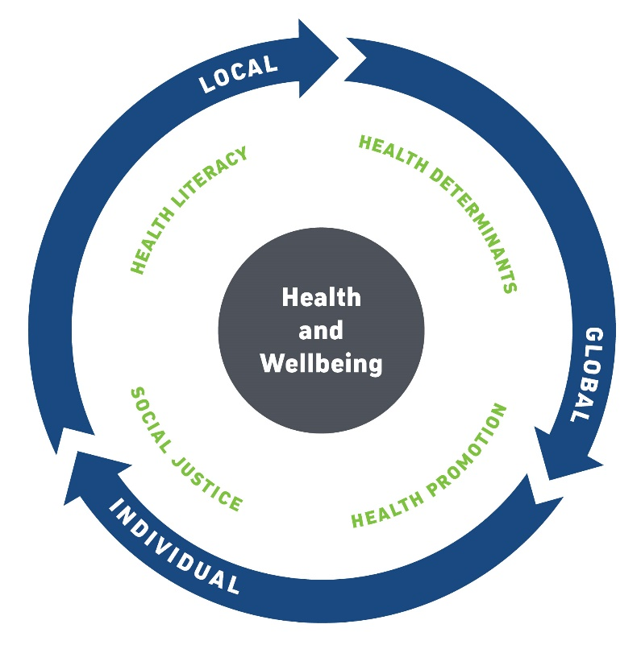

These interrelated concepts underpin the content of this subject, and may be considered in individual , local, and global contexts, as shown in the diagram.

They are not discrete topics taught in isolation but should be contextualised through case studies and real-life examples.

The following knowledge, skills, and understandings may be developed:

* mindfulness and self-reflection
* resilience
* self-development and management
* safe failure
* communication and collaboration
* open-mindedness and respecting diverse opinions
* beliefs, attitudes, and values.

Health literacy

In health literacy, students develop the skills to research and understand different sources of information. Students interpret and make decisions about health and wellbeing information and advice. They consider how and where to seek contemporary, valid, and reliable information to promote and maintain good health and wellbeing. Improving people's access to and understanding of health information empowers them to make informed decisions. Students may engage with individual, local, and global health and wellbeing trends.

*Learning activities*

The following learning activities are suggestions only. Teachers may select and adapt suitable activities from this list or design their own.

Students may develop an understanding of health literacy by:

* recognising and using appropriate health and wellbeing language
* developing and reflecting on their own values, beliefs, and attitudes, and on those of others
* expressing how they feel about the issue being considered
* analysing and interpreting sources for bias, relevance, and credibility
* sourcing appropriate primary sources of data or information
* analysing research findings
* responding to the dynamic and changing nature of media, and its influence on health issues
* exploring health and wellbeing theories, concepts, or methodologies.

Health determinants

In health determinants, students develop an understanding of the factors that determine health and wellbeing outcomes. The impact of health determinants and health status will differ according to individual, local, and global contexts.

Health determinants may include:

* environmental factors
* socioeconomic characteristics
* knowledge, attitudes, and beliefs
* health behaviours
* psychological factors
* safety factors
* biomedical factors
* individual physical and psychological make-up
* connection to Country/Place
* cultural and spiritual factors.

*Learning activities*

The following learning activities are suggestions only. Teachers may select and adapt suitable activities from this list or design their own.

Students may develop an understanding of health determinants by:

* recognising inequalities in health outcomes
* identifying the changing nature of health determinants
* challenging stereotypes that impact on health outcomes
* exploring how the media presents health issues
* analysing competing views about a contemporary issue
* assessing risk and making informed choices to maintain health and wellbeing
* examining the impacts of climate change on health and wellbeing
* assessing how displacement or mass-migration affects health and wellbeing
* exploring the influence of cultural and religious practices on health and wellbeing
* considering the impact of connection to Country/Place on the health and wellbeing of Aboriginal and Torres Strait Islander peoples.

Health promotion

In health promotion, students learn that humans have a right to health and wellbeing, and that these are crucial to our quality of life. Therefore, providing access to information, developing understanding, and improving skills is vital. Health promotion empowers individuals and communities to take control of their health and wellbeing. Delivering accurate and accessible information, building supportive environments, and coordinated action will lead to more effective health and wellbeing promotion.

Students investigate the role that health and wellbeing promotion has in improving outcomes. They will apply principles of health and wellbeing promotion and address global, local, and individual health issues. Students will evaluate the effectiveness of initiatives in improving health and wellbeing outcomes.

*Learning activities*

The following learning activities are suggestions only. Teachers may select and adapt suitable activities from this list or design their own.

Students may develop an understanding of health promotion by:

* exploring the partnerships required for effective health and wellbeing promotion
* examining sustainable health and wellbeing promotion strategies that empower individuals and/or communities
* reflecting on the impact of our physical environment on health and wellbeing
* conducting and reflecting on activities that promote health and wellbeing for a targeted audience, such as volunteering, awareness-raising, or fundraising
* celebrating significant days and events as to raise awareness. These may include National Reconciliation Week, Harmony Week, International Women’s Day, R U OK? Day, and International Day Against Homophobia, Biphobia, Intersexism and Transphobia (IDAHOBIT).

Social equity

An understanding of social equity principles is integral to understanding health and wellbeing in the local and global contexts. In social equity, students develop an understanding of fairness and equality. It is inclusive of all, especially those who are marginalised or disadvantaged for reasons such as age, gender, sexuality, disability, isolation, cultural, and socio-economic background.

Students develop an understanding of inequalities, including social and cultural factors that influence health and wellbeing. They recognise how social equity applies to the fair and equitable distribution of health resources and the availability and accessibility of health services and educational programs. Students develop the knowledge and skills to participate in responsible decision-making.

*Learning activities*

The following learning activities are suggestions only. Teachers may select and adapt suitable activities from this list, or design their own.

Students may develop an understanding of social equity by:

* identifying and applying language that reflects diversity, inclusivity, and empathy
* examining the health status of Australians and the factors that influence health trends
* exploring the relationship between wellbeing and disadvantage
* examining the role of organisations such as Beyond Blue and SHINE SA with regard to individual and/or community wellbeing
* reflecting on policies and procedures for inclusivity and equity in schools and/or community groups
* examining the role of social media as a platform for dissemination of information
* assessing stereotyping and its impact on news reporting.

# Evidence of learning

Assessment at Stage 1 is school based.

The following assessment types enable students to demonstrate their learning in Stage 1 Health and Wellbeing:

* Assessment Type 1: Practical Action
* Assessment Type 2: Issue Inquiry.

For a 10-credit subject, students should provide evidence of their learning through three assessments. Each assessment type should have a weighting of at least 20%. Students complete:

* at least one practical action task
* at least one issue inquiry task.

For a 20-credit subject, students should provide evidence of their learning through six assessments. Each assessment type should have a weighting of at least 20%. Students complete:

* at least two practical action tasks
* at least two issue inquiry tasks.

# Assessment design criteria

The assessment design criteria are based on the learning requirements and are used by teachers to:

* clarify for the student what they need to learn
* design opportunities for students to provide evidence of their learning at the highest possible level of achievement.

The assessment design criteria consist of specific features that:

* students should demonstrate in their learning
* teachers look for as evidence that students have met the learning requirements.

For this subject the assessment design criteria are:

* critical thinking
* application
* reflective practice.

The specific features of these criteria are described below.

The set of assessments, as a whole, must give students opportunities to demonstrate each of the specific features by the completion of study of the subject.

## Critical Thinking

The specific features are as follows:

CT1 Exploration and understanding of health and wellbeing trends and issues.

CT2 Development of an empathetic and ethical understanding of health and wellbeing issues.

CT3 Analysis of health and wellbeing concepts to solve problems or make recommendations.

## Application

The specific features are as follows:

AP1 Application of health and wellbeing concepts to contemporary issues.

AP2 Action to improve health and wellbeing outcomes, individually and/or collaboratively.

## Reflective Practice

The specific features are as follows:

RP1 Personal reflection on health and wellbeing trends and issues in individual, local, or global contexts.

RP2 Evaluation of personal and/or social action through reflective practice.

# School assessment

The school assessment component for Stage 1 Health and Wellbeing consists of two assessment types:

* Assessment Type 1: Practical Action
* Assessment Type 2: Issue Inquiry.

## Assessment Type 1: Practical Action

For a 10-credit subject, students undertake at least one practical action.

For a 20-credit subject, students undertake at least two practical actions.

Students undertake action on an individual or community issue, in order to improve health and wellbeing outcomes. This action may be undertaken individually or collaboratively, and within the school environment or the wider community. A practical action task may include the following components:

* defining the context of the practical action by identifying the purpose and audience
* considering existing strategies and/or potential new initiatives to develop action
* implementing and/or actively participating in action
* reflecting on the success of the action to improve personal or social outcomes.

Tasks may include:

* reviewing and contributing to an existing community initiative
* undertaking a personal health action and evaluating the success of the initiative
* collaborating to develop a health and wellbeing event or showcase
* developing an educational resource at a target audience
* creating a local activity to address a current and/or emerging health issue.

A practical action task should be a maximum of 1000 words if written, or a maximum of 6 minutes if oral or in multimodal form.

For this assessment type, students provide evidence of their learning primarily in relation to the following assessment design criteria:

* application
* reflective practice.

## Assessment Type 2: Issue Inquiry

For a 10-credit subject, students undertake at least one issue inquiry.

For a 20-credit subject, students undertake at least two issue inquiries.

Students research a current health or wellbeing trend or issue. Students may research an aspect of a topic already identified, or an issue of their choosing.

An issue inquiry task may include the following components:

* identifying aspects of health and wellbeing trends and issues for inquiry
* analysing a variety of relevant contemporary sources of information and data
* solving problems or making recommendations
* reflecting on their attitudes to the issue and the values that influence those attitudes.

Tasks may include:

* investigating a mental or emotional health issue and explore how effective health agencies support, promote, and educate the community
* using a media stimulus, such as a film, to identify and explore an issue through different perspectives
* exploring what it means to be a ‘healthy’ person, and how that has changed over time
* analysing the impact of social media and messages regarding personal identity.

An issue inquiry task should be a maximum of 1000 words if written, or a maximum of 6 minutes if oral or in multimodal form.

For this assessment type, students provide evidence of their learning primarily in relation to the following assessment design criteria:

* critical thinking
* reflective practice.

# Performance standards

The performance standards describe five levels of achievement, A to E.

Each level of achievement describes the knowledge, skills, and understanding that teachers refer to in deciding how well students have demonstrated their learning on the basis of the evidence provided.

During the teaching and learning program the teacher gives students feedback on their learning, with reference to the performance standards.

At the student’s completion of study of a subject, the teacher makes a decision about the quality of the student’s learning by:

* referring to the performance standards
* taking into account the weighting of each assessment type
* assigning a subject grade between A and E.

Performance standards for Stage 1 Health and Wellbeing

|  |  |  |  |
| --- | --- | --- | --- |
| - | Critical Thinking | Application | Reflective Practice |
| A | Sophisticated exploration and understanding of health and wellbeing trends and issues.  Astute, empathetic, and ethical understanding of health and wellbeing issues.  Insightful analysis of health and wellbeing concepts to solve problems or make recommendations. | Comprehensive and astute application of health and wellbeing concepts to contemporary issues.  Comprehensive implementation of action to improve health and wellbeing outcomes individually or collaboratively. | Astute personal reflection on health and wellbeing trends and issues in individual, local, or global contexts.  Perceptive evaluation of personal and/or social action through critically reflective practice. |
| B | Well-informed exploration and understanding of health and wellbeing trends and issues.  Well-considered, empathetic, and ethical understanding of health and wellbeing issues.  Mostly in-depth analysis of health and wellbeing concepts to solve problems or make recommendations. | Well-considered application of health and wellbeing concepts to contemporary issues.  Thoughtful implementation of action to improve health and wellbeing outcomes individually or collaboratively. | Well-considered personal reflection on health and wellbeing trends and issues in individual, local, or global context.  Well-considered evaluation of personal and/or social action through mostly critically reflective practice. |
| C | Informed exploration and understanding of health and wellbeing trends and issues.  Considered, empathetic, and ethical understanding of health and wellbeing issues.  Some analysis of health and wellbeing concepts to solve problems or make recommendations. | Competent application of health and wellbeing concepts to contemporary issues.  Competent implementation of action to improve health and wellbeing outcomes individually or collaboratively. | Considered personal reflection on health and wellbeing trends and issues in individual, local, or global contexts.  Considered evaluation of personal and/or social action through reflective practice. |
| D | Basic exploration and understanding of some health and wellbeing trends and issues.  Some empathetic and ethical understanding of health and wellbeing issues.  Description of health and wellbeing concepts to solve problems or make recommendations. | Application of some health and wellbeing concepts to contemporary issues.  Basic implementation of action to improve health and wellbeing outcomes individually or collaboratively. | Some description of personal reflection on health and wellbeing trends and issues in individual, local, or global contexts.  Description of personal and/or social action through some reflective practice. |
| E | Limited exploration and understanding of health and wellbeing trends and issues.  Limited empathetic and ethical understanding of health and wellbeing issues.  Limited description of health and wellbeing concepts to solve problems or make recommendations. | Limited application of some health and/or wellbeing concepts to contemporary issues.  Attempts to implement action to improve health and wellbeing outcomes individually or collaboratively. | Attempted description of personal reflection on health and wellbeing trends and issues in individual, local or global contexts.  Limited description of personal and/or social action. |