

# Drama (Stage 1)

Subject Outline

# Subject outline changes

Below are the current changes to the subject outline. Teachers are encouraged to explore the changes in detail and make relevant adjustments to their teaching, learning, and assessment programs.

|  |  |  |
| --- | --- | --- |
| From 2024 | To 2025 onwards | page |
| Stage 1 | | |
|  | Where ‘audience’ appears in the subject outline, this can be considered in the broadest possible form, including live, virtual, and/or intended audience performance modes. | 7, 10 |
|  | Evidence provided to the SACE Board of a recorded performance for an intended audience will be sufficient; however, performance to a live audience, where possible, is desirable. | 11 |

# Subject description

Drama is a 10-credit subject or a 20-credit subject at Stage 1.

In Drama, students develop their creativity, collaboration, critical thinking, and communication skills. They refine their literacy, numeracy, ethical understanding, and intercultural understanding, and develop self-belief and self-confidence.

Students learn as artists and as creative entrepreneurs through their exploration of shared human experience, which is at the heart of the study of Drama. Students learn to engage meaningfully with others through the creation of original relationships between presenter, audience, idea, and story. They learn that shared narratives underpin our understanding of everything we think and do in the world around us, and that our cultural narratives are created collaboratively. Drama is active and participatory, involving the process of imagining, developing, and creating original narratives, viewpoints, and artistic products.

In Drama, students adopt roles from the dramatic fields of theatre and/or screen. They apply the dramatic process to create outcomes and take informed artistic risks to present the unique voices of individuals, communities, and cultures. Through focused, practical, and collaborative learning opportunities, students refine their skills and increase their confidence as communicators by creating live, multimodal, oral, and written products.

Drama students learn the transferable skills of creative collaboration and critical thinking to visualise, develop, and present culturally valuable outcomes. Through the dramatic process they develop their understanding of aesthetics, and improve their skills as creative problem-identifiers and problem-solvers, critical thinkers, innovators, productive artists, practical entrepreneurs, and cultural leaders. They grow as cultural leaders by providing original and/or alternative artistic perspectives, viewpoints, and stories.

# Capabilities

The capabilities connect student learning within and across subjects in a range of contexts.

The SACE identifies seven capabilities.

Literacy

In this subject students extend and apply their literacy capability by, for example:

* presenting ideas, thoughts, opinions, and feelings in different forms
* researching, explaining, and justifying their ideas and approaches as they experiment, plan, edit, synthesise, and make aesthetic decisions about their drama practice
* developing dramatic vocabulary in order to express and communicate ideas
* developing vocal, physical, and group skills and strategies needed to express, interpret, and communicate complex information and ideas
* conceiving, exploring, and creating dramatic texts, such as plays for theatre, and/or screenplays for film.

Numeracy

In this subject students extend and apply their numeracy capabilities by for example:

* using measurements to quantify and analyse the physical world through a dramatic context
* using logical sequencing to create narratives and present dramatic ideas
* using spatial sense and geometric reasoning to visualise, represent, and make sense of dramatic works
* using systems of graphical representation, such as timelines, storyboards, technical drawings, graphical illustrations, charts, maps, and diagrams, to represent ideas
* demonstrating entrepreneurial skills to estimate costs, record expenditure, and keep budgets
* gathering and analysing data on audiences, such as demographics and attendance trends.

Information and communication technology (ICT) capability

In this subject students extend and apply their ICT capability, by for example:

* using ICT to research, conceptualise, explore, experiment with, refine, create, and/or evaluate a range of dramatic works
* using digital technologies in the timing, sequencing, and staging of live and recorded productions
* using digital technologies in the staging, researching, and recording of drama performance and responses
* exploring and experimenting with video and other technology, using, for example, voiceover and software programs as a tool for reflection on the drama practices of self and others
* exploring the use of new technologies, such as special effects, computer-generated images, robotics, and 3D-projected landscapes in drama products.

Critical and creative thinking

In this subject students extend and apply their critical and creative thinking capability by, for example:

* drawing links between conventions and practice through exploration, taking informed artistic risks, and practical experimentation
* applying the dramatic process to conceive, create, and present tangible outcomes
* critically analysing and evaluating their own and others’ dramatic outcomes for their artistic and cultural merit
* working individually and collaboratively through the creative process to research and find solutions to problems.

Personal and social capability   
In this subject students extend and apply their personal and social capability by, for example:

* building self-confidence through taking risks, having confidence in decisions, and achieving success through participation
* building skills and strategies to increase resolve and resilience and to accomplish personal goals, such as performing for a live audience
* evaluating and reflecting on their own participation in the development of dramatic works
* collaborating to create a theatre and/or screen company and product
* working collaboratively to create a performance for a live audience or a screen company screening its production to a live or online audience
* building confidence in demonstrating entrepreneurial skills when working individually or in collaboration with others
* being actively involved in workshops, mentorships, and/or masterclasses, where possible.

Ethical understanding

In this subject students extend and apply their ethical understanding capability by, for example:

* considering the role that drama plays in representing and shaping cultural identities and issues, such as the refugee experience
* exploring and analysing a variety of perspectives through drama
* considering ethical strategies in relation to access, inclusivity, and equity in drama
* understanding of the place of drama in creating discussion about ethical issues.
* respecting the rights of individuals with regards to their personal values about subject matter, movements, space, physical contact, and communication style.

Intercultural understanding

In this subject students extend and apply their intercultural understanding capability by, for example:

* investigating dramatic texts and styles from local, global, contemporary, and/or historical contexts
* exploring theatre traditions to extend appreciation of cultural diversity
* understanding and exploring the tension between sensitivity and provocation in dramatic outcomes
* exploring and analysing the theatre and/or film of Aboriginal artists for its perspectives on and contributions to Australian and global drama.

# Aboriginal and Torres Strait Islander knowledge, cultures, and perspectives

In partnership with Aboriginal and Torres Strait Islander communities, and schools and school sectors, design that respects the diverse knowledge, cultures, and perspectives of Indigenous Australians.

The SACE Board encourages teachers to include Aboriginal and Torres Strait Islander knowledge and perspectives in the design, delivery, and assessment of teaching and learning programs by:

* providing opportunities in SACE subjects for students to learn about Aboriginal and Torres Strait Islander histories, cultures, and contemporary experiences
* recognising and respecting the significant contribution of Aboriginal and Torres Strait Islander peoples to Australian society
* drawing students’ attention to the value of Aboriginal and Torres Strait Islander knowledge and perspectives from the past and the present
* promoting the use of culturally appropriate protocols when engaging with and learning from Aboriginal and Torres Strait Islander peoples and communities

# Learning requirements

The learning requirements summarise the knowledge, skills, and understanding that students are expected to develop and demonstrate through their learning in Stage 2 Drama.

In this subject, students are expected to:

1. explore and understand dramatic theories, texts, styles, conventions, roles, and processes
2. experiment with dramatic theories, ideas, aesthetics, processes, and technologies
3. apply dramatic ideas, theories, and practice to develop dramatic outcomes collaboratively and individually
4. apply and integrate the skills of drama to create and present original and culturally meaningful dramatic products
5. analyse and evaluate dramatic theories, practice, works, styles, events, and/or practitioners from a range of personal, local, global, contemporary, and/or historical contexts.

# Content

Stage 1 Drama is a 10-credit subject or a 20-credit subject that consists of the following three areas of dramatic study:

* Company and Performance
* Understanding and Responding to Drama
* Drama and Technology.

In Drama, students engage in learning as dramatic artists. The three areas of dramatic study are integrated to provide students with opportunities to learn dramatic conventions and elements, and the dramatic process of conceiving, experimenting, developing, making, presenting, analysing, and evaluating drama.

Students explore, experiment with, and respond to ideas, processes, and viewpoints from a range of drama, which may include texts, innovators, styles, and professional productions. They interpret drama for its meanings, and develop dramatic language skills to identify and analyse dramatic conventions, styles, contexts, skills, and choices.  

Students learn and apply creative and analytical skills to produce their own dramatic outcomes, individually and in collaboration. They analyse and evaluate professional dramatic works and draw links between these and the development of their own practice. Students develop their understanding of drama, their thinking as artists, and their skills as practitioners in one or more dramatic roles.   
  
Teachers are encouraged to provide students with opportunities to engage with local theatre and/or screen practitioners, where possible. Programs of study should consider the interests of students, as well as the availability of resources. Students are encouraged to integrate the innovative use of technology in the creation of their outcomes, where possible.   
  
The three areas of dramatic study for Stage 1 Drama are discussed in more detail below.

Company and Performance

In the Company and Performance area of study, students draw links between theory and current dramatic arts industry practice to envision and form their own dramatic company. The company may involve the class as a whole or comprise several smaller companies from within the class. Students may choose to name their company and develop a rationale, vision statement, or mission statement of their shared dramatic intent.

Students explore what they want to say as artists and develop ideas for creative expression. They grow as cultural leaders by considering how their dramatic company may provide original and/or alternative artistic perspectives, viewpoints, and stories. They design opportunities for these to be presented using entrepreneurial thinking and processes.

Through investigation and experimentation, students identify the impact and significance of their ideas and potential products for audiences, and apply the dramatic process to create meaningful outcomes. Individual students adopt a role or roles, and collaborate to conceive, create, and present a realised dramatic product or products.   
  
Guided by the teacher, students specialise in one or more roles within their company and their performance, including, for example:

* actor
* designer#
* director
* stage manager
* dramaturge
* playwright
* screenwriter
* cinematographer
* editor
* publicist and promoter.

#e.g. set or production, costume, make-up and hair (and/or mask), publicity and promotions, lighting, sound, music and/or composition, SFX, multimedia, front-of-house.

In envisioning their company and creating a dramatic product or products, students develop the skills and understanding to realise themselves as artists. Teachers nurture students’ performance skills and ensemble skills, and mentor students in the development of their vocal, physical, psychological, intellectual, and emotional faculties as dramatic practitioners. Teachers are encouraged to foster an immersive classroom environment to maximise the experience of students as dramatic artists.

Students learn about, experiment with, and practise performance skills, including, but not limited to:

* voice
* characterisation
* movement and gesture
* focus and energy
* stagecraft
* ensemble skills
* conceptualisation of dramatic ideas.

To create their product, students apply the dramatic process. The dramatic process is a dynamic and flexible series of phases in the development of a dramatic outcome. Students apply each phase actively as they transform their ideas into concrete dramatic outcomes.   
  
The diagram below describes a version of the dramatic process. It is an example and not a comprehensive list of all of the activities within the phases of the process. It identifies the general principles and sequence of phases for making and presenting drama. It is not intended to be prescriptive, and valuable learning opportunities may be found in reconsidering and adapting this model to students’ immediate contexts. The diagram also models a version of entrepreneurial and design thinking and includes reference to entrepreneurial processes and activities.

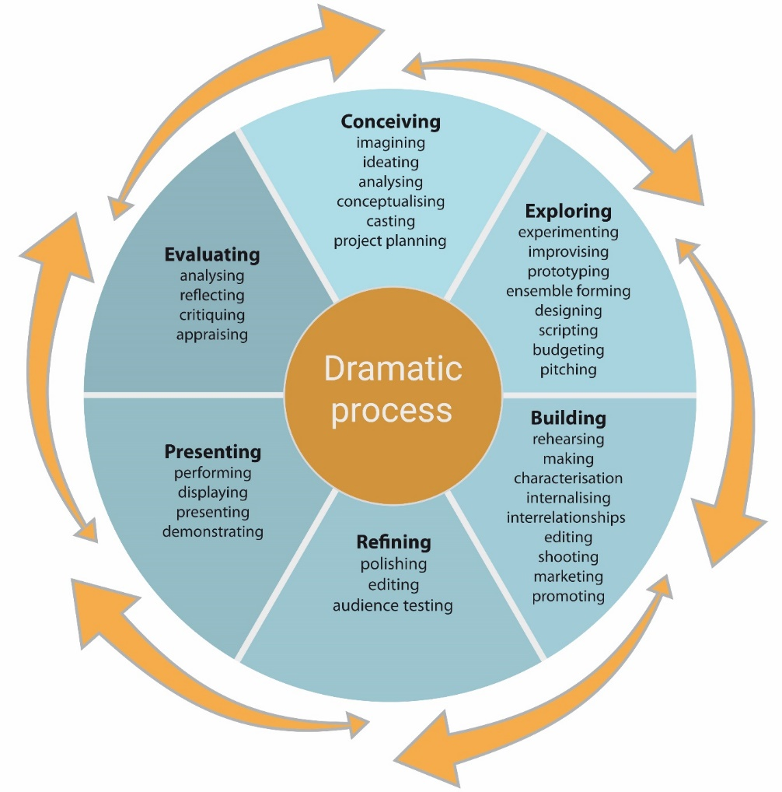

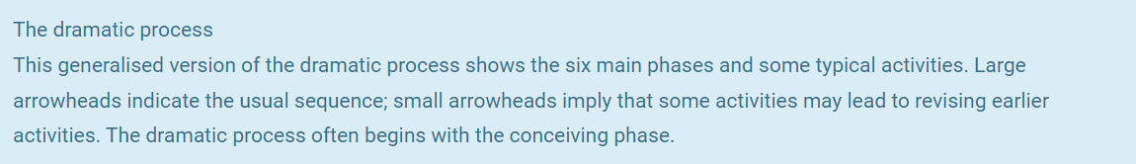

Students present their dramatic product to an audience. Where ‘audience’ appears in the subject outline, this can be considered in the broadest possible form (which includes live, virtual, and/or intended audience performance modes).

The scope and scale of the presentation of dramatic product is dependent upon the interests of the students, the context and culture of the school, and the resources available. For example, products may range from an in-class performance for peers, through to a full-scale production in a theatre or the equivalent for a screen production.

The choice of dramatic product is determined by the vision of the company and may be realised in a variety of forms including, but not limited to:

* a whole-class performance of a shared text or excerpts
* a series of devised or published vignettes linked by a dramatic text and/or style
* a short film in the style of a selected practitioner.

In realising their dramatic product, students should ensure that audience development and the leadership of artistic and cultural discussion feature as key considerations in their company’s vision. The identification of an established audience, as well as developing strategies for reaching new audiences, should be investigated. Entrepreneurial skills, including marketing, publicity, and promotions, should be a focus for each company in tangibly meeting its artistic intentions. For example, media releases, creating an online presence, and creative publicity may be featured in the company’s vision, and may be enacted, either hypothetically or in practice, to develop an audience for the dramatic product.

Understanding and Responding to Drama

In the Understanding and Responding to Drama area of study, students view and engage with drama. Students are encouraged to deepen their knowledge and understanding of contemporary dramatic practice, conventions, and traditions using live, online, and other resources. Resources may be productions or events, including, but not limited to, one or more of:

* live theatre
* online theatre
* film
* drama teleseries episode
* online masterclass
* onsite workshop.

In Understanding and Responding to Drama, students study at least one dramatic text and at least one dramatic style. The shared study of texts and styles should be led by the teacher and involve a combination of practical, experimental, and theoretical learning opportunities. Through their learning, students explore and experiment with their own actual or hypothetical dramatic outcomes.

Drama and Technology

In the Drama and Technology area of study, students research and analyse how technology is being used by dramatic artists, and how it has the potential to be applied creatively to enhance dramatic meaning and expression of ideas in theatre and/or screen products. Use of technology in drama can be accessed through online sources or live sources, where available. Technology plays an ever-increasing role in contemporary dramatic practice, and relationships between dramatic artists, audiences, and technologies are in a constant state of reinvention.

Students research and analyse contemporary drama that includes innovative technology. They explore possibilities and provide creative ideas as cultural leaders for the application of innovative technology in a hypothetical (or actual) dramatic product. Technologies for exploration may include, but are not limited to:

* projected scenic design
* creative relationships between live performers and video projection
* live on-stage filming and projections
* use of smartphones by performers and/or audience members within performances
* using YouTube and/or social media to promote and publicise a production
* creating a new script that applies technology in innovative ways
* online streaming of live performance
* innovative use of sound, including individualised experiences for audiences provided through headphones and smart devices
* engineered moving-parts set design
* real-time global performance
* intelligent lighting
* interactive multimedia
* special effects in film
* on-stage robotics.

Students conceive, describe, and justify their own original, hypothetical dramatic product that uses innovative technology, with the aims of stimulating an audience’s imagination, enhancing the audience’s engagement with the meanings of the work, and conveying relevant artistic ideas creatively.

The relationship between content and assessment is shown through the following diagram.

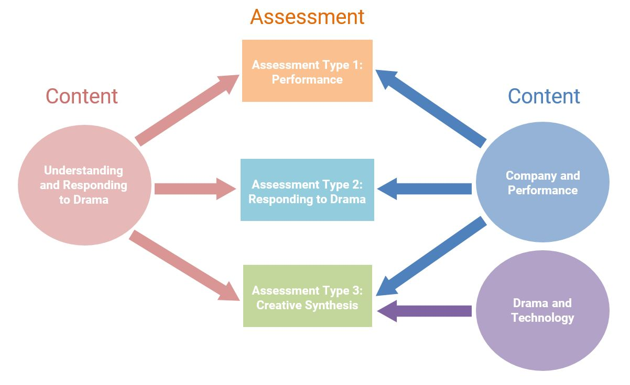

# Evidence of learning

Assessment at Stage 1 is school based.

The following assessment types enable students to demonstrate their learning in Stage 1 Drama:

* Assessment Type 1: Performance
* Assessment Type 2: Responding to Drama
* Assessment Type 3: Creative Synthesis.

For a 10-credit subject, students provide evidence of their learning through three assessments:

* one performance task
* one responding to drama task
* one creative synthesis task.

Each assessment type should have a weighting of between 20% and 50%.

For a 20-credit subject, students provide evidence of their learning through five assessments:

* two performance tasks
* two responding to drama tasks
* one creative synthesis task.

Each assessment type should have a weighting of between 20% and 50%.

# Assessment design criteria

The assessment design criteria are based on the learning requirements and are used by teachers to:

* clarify for students what they need to learn
* design opportunities for students to provide evidence of their learning at the highest level of achievement.

The assessment design criteria are the specific features that:

* students need to demonstrate in their evidence of learning
* teachers look for as evidence that students have met the learning requirements.

For this subject, the assessment design criteria are:

* understanding are exploration
* critical and creative thinking
* creative application.

The specific features of these criteria are described below.

The set of assessments, as a whole, must give students opportunities to demonstrate each of the specific features by the completion of study of the subject.

## Understanding and Exploration

The specific features are as follows:

UE1 Understanding and exploration of dramatic roles, conventions, and processes.

UE2 Understanding and exploration of dramatic ideas, texts, styles, and/or innovations.

## Critical and Creative Thinking

The specific features are as follows:

CCT1 Creative thinking and experimentation in the development of dramatic ideas.

CCT2 Analysis and evaluation of dramatic ideas, products, and technologies.

Creative Application

The specific features are as follows:  
CA1 Application of dramatic skills.

CA2 Collaborative application of dramatic ideas and processes to realise outcomes.

# School assessment

The school assessment component for Stage 1 Drama consists of three assessment types:

* Assessment Type 1: Performance
* Assessment Type 2: Responding to Drama
* Assessment Type 3: Creative Synthesis

## Assessment Type 1: Performance

For a 10-credit subject, students undertake one performance task.

For a 20-credit subject, students undertake two performance tasks.

*Process and performance*

For a performance, students are led by the teacher to work collaboratively through the framework of the Company and Performance area of study to conceive, explore, develop, produce, refine, and perform (or present) a dramatic work or product. They apply the dramatic process by undertaking roles and collaborating in an ensemble to achieve individual and shared outcomes.

Students present their performance to an audience. ‘Audience’ can be considered in the broadest possible form (which includes live, virtual, and/or intended audience performance modes).

The length of the performance or presentation is dependent upon the size of the group, the nature of the class of students, and the availability of resources. Teachers should ensure that each acting student has the opportunity for a minimum of 5 minutes in-focus stage or screen time, or the equivalent for off-stage presenters. The scale of the performance may range from an in-class performance for peers during a lesson, through to a full-scale production in a theatre or the equivalent for a screen production.

Students complete a performance in one of the following ways:

* a live performance of a published play(s) or excerpts (or self-devised work in either text form or conceptual form), involving all or most of the class members as a single theatre company
* two or more live performances of published plays or excerpts (or self-devised works) by smaller groups from within the class as small theatre companies
* the creation and screening of a short film or trailer(s) involving part or all of the class as a screen production company or companies
* an individual dramatic performance or presentation developed in collaboration with at least one other person from within or outside the class. Examples of collaboration by individual performers or presenters may include, but are not limited to:
* directing students from a younger year’s class in a live performance or film
* conceiving and producing a monologue performance which involves the technical, design, or directorial assistance of at least one other student or adult
* designing costumes in collaboration with a student or adult
* creating and presenting a film trailer for a hypothetical film, in collaboration with at least one other student or adult.

*Presentation of evidence*

Each student selects and presents evidence of their learning, including their understanding, creativity, analysis, evaluation, application and development. Evidence can be presented as an individual or group oral presentation, or an individual or group multimodal presentation, or an individual written document with accompanying visual evidence. Evidence provided to the SACE Board of a recorded performance for an intended audience will be sufficient; however, performance to a live audience, where possible, is desirable.

Examples of forms for the presentation of evidence may include, but are not limited to:

* a live oral presentation in the form of an arts-show panel, analysing and justifying their creative choices (students should ensure that each individual company member is provided equivalent speaking time in this option)
* a video essay
* an annotated multimedia presentation to analyse and justify dramatic choices
* a vlog with analysis and evaluation of learning and development
* a written analysis clearly linking still and/or video images from rehearsal and performance to the student’s written text
* a video of excerpts from rehearsal and performance accompanied by a written commentary
* a video diary.

The aim of the presentation of evidence is to demonstrate each student’s analysis and evaluation of their learning and skills development throughout the process and performance.

Students may choose to begin their presentation of evidence with a question to be answered or an artist’s statement of intent to establish the context of their dramatic intention and learning throughout the process and performance.

Features of the presentation may include, but are not limited to:

* discussion of creative, conceptual, developmental, analytical, and evaluative learning
* articulation of how the intentions of the performance support the artistic intent of the company
* analysis of well-chosen moments and features of the process and performance with regard to students deepening their learning of roles, both individually and collaboratively
* reflection on collaboration and collaborative learning in drama, relevant to the production
* analysis of and reflection on page-to-stage or page-to-screen choices
* analysis of and reflection on the artistic merit of individual and collaborative choices
* analysis of creativity skills and development
* analysis of real and potential audience development for the production.

For a task, the presentation of evidence in oral or multimodal form should provide *each student* with up to a maximum of 6 minutes presentation time (or equivalent). The presentation of evidence in written form may be up to 1000 words *per student* plus optional images.

For this assessment type, students provide evidence of their learning primarily in relation to the following assessment design criteria:

* understanding and exploration
* critical and creative thinking
* creative application.

## Assessment Type 2: Responding to Drama

For a 10-credit subject, students undertake one responding to drama task.

For a 20-credit subject, students undertake two responding to drama tasks.

Students demonstrate their understanding, analysis, and evaluation of professionally created dramatic works and/or events (such as workshops and masterclasses) in an oral, multimodal, or written response.

Students choose to respond to one or more dramatic works and/or events in their response. They analyse and evaluate the contribution of practitioners to the artistic and cultural value of the works and events. Students should consider the intention and realisation of the professional dramatic artists’ creative choices in their response.

Examples of tasks may include, but are not limited to:

* a multimodal response analysing and evaluating a live theatre performance
* an oral presentation that analyses and evaluates the experience of a workshop or masterclass by visiting professional performers to the school, and how the student artist might link the learning gained to inform and improve the development of their own practice
* a tutorial presentation analysing the links between a theatre or screen production, a professional workshop, and the student’s development as an actor creating a character
* a written review through the lens of a student-artist as designer or director that analyses and evaluates a theatre or screen production.

A task should be a maximum of 5 minutes if oral or multimodal, or 800 words if written.

For this assessment type, students provide evidence of their learning primarily in relation to the following assessment design criteria:

* understanding and exploration
* critical and creative thinking.

## Assessment Type 3: Creative Synthesis

For a 10-credit subject, students undertake one creative synthesis task.

For a 20-credit subject, students undertake one creative synthesis task.

In a creative synthesis task, students apply the dramatic process to a published dramatic text or self-devised piece to create a concept or vision for a hypothetical (or actual) dramatic product. In the creation of their product, students also apply technology imaginatively and innovatively, and take creative risks.

Students may choose to create their hypothetical (or actual) dramatic product in response to the shared dramatic text studied in the Understanding and Responding to Drama area of study. Alternatively, they may select another text by negotiation with the teacher, or create a self-devised dramatic work.

Students adopt a dramatic role and discuss their artistic intentions, including their ideas and rationale for the use of innovative technology in the hypothetical staging or screening of the product.

Roles that students may adopt include, but are not limited to:

* designer
* director
* film-maker
* playwright or screenwriter
* actor.

Students present their dramatic product either in an oral or multimodal presentation, or in a written response. The duration or length of one task is a maximum of 6 minutes if oral or multimodal (or equivalent), or 1000 words if written plus optional images.

For this assessment type, students provide evidence of their learning primarily in relation to the following assessment design criteria:

* understanding and exploration
* critical and creative thinking
* creative application.

# Performance standards

The performance standards describe five levels of achievement, A to E.

Each level of achievement describes the knowledge, skills, and understanding that teachers refer to in deciding how well students have demonstrated their learning on the basis of the evidence provided.

During the teaching and learning program the teacher gives students feedback on their learning, with reference to the performance standards.

At the student’s completion of study of a subject, the teacher makes a decision about the quality of the student’s learning by:

* referring to the performance standards
* taking into account the weighting of each assessment type
* assigning a subject grade between A and E.

Performance standards for Drama Stage 1

|  |  |  |  |
| --- | --- | --- | --- |
| - | Understanding and Exploration | Critical and Creative Thinking | Creative Application |
| A | UE1 Focused and astute understanding and exploration of dramatic roles, conventions, and processes.  UE2 Highly detailed and in-depth understanding and exploration of dramatic ideas, texts, styles, and/or innovations. | CCT1 Highly creative thinking and experimentation in the development of dramatic ideas.  CCT2 Perceptive analysis and evaluation of dramatic ideas, products, and technologies. | CA1 Highly creative and proficient application of dramatic skills.  CA2 Focused and sustained collaborative application of dramatic ideas and processes to realise outcomes. |
| B | UE1 Thorough understanding and exploration of dramatic roles, conventions, and processes.  UE2 Detailed understanding and exploration of dramatic ideas, texts, styles, and/or innovations. | CCT1 Creative thinking and experimentation in the development of dramatic ideas.  CCT2 Comprehensive analysis and evaluation of dramatic ideas, products, and technologies. | CA1 Creative and capable application of dramatic skills.  CA2 Focused collaborative application of dramatic ideas and processes to realise outcomes. |
| C | UE1 Competent understanding and exploration of dramatic roles, conventions, and processes.  UE2 Considered understanding and exploration of dramatic ideas, texts, styles, and/or innovations. | CCT1 Generally creative thinking and experimentation in the development of dramatic ideas.  CCT2 Analysis and evaluation of dramatic ideas, products, and technologies. | CA1 Generally competent application of dramatic skills.  CA2 Generally focused collaborative application of dramatic ideas and processes to realise outcomes. |
| D | UE1 Some understanding and exploration of dramatic roles, conventions, and processes.  UE2 Attempted understanding and exploration of dramatic ideas, texts, styles, and/or innovations. | CCT1 Attempted creative thinking and experimentation in the development of dramatic ideas.  CCT2 Some general reflection on dramatic ideas, products, and technologies. | CA1 Partial application of dramatic skills.  CA2 Some focused collaborative application of dramatic ideas and processes to realise outcomes. |
| E | UE1 Limited understanding and exploration of dramatic roles, conventions, and processes.  UE2 Limited understanding and exploration of dramatic ideas, texts, styles, and/or innovations. | CCT1 Limited thinking and experimentation in the development of dramatic ideas.  CCT2 Limited reflection on dramatic ideas, products, and technologies. | CA1 Limited application of dramatic skills.  CA2 Limited collaborative application of dramatic ideas and processes to realise outcomes. |