STAGE 1 MATHEMATICS

ASSESSMENT TYPE 2: MATHEMATICAL INVESTIGATION

TRIGONOMETRY

NAME :

Your report on the mathematical investigation should include the following:
- an outline of the problem and context
- the method required to find a solution, in terms of the mathematical model or strategy used
- the application of the mathematical model or strategy, including:
  - relevant data and/or information
  - mathematical calculations and results, using appropriate representations
  - the analysis and interpretation of results, including consideration of the reasonableness and limitations of the results
- the results and conclusions in the context of the problem
- a bibliography and appendices, as appropriate.
The format of an investigation report may be written or multimodal.
The investigation report should be a maximum of 8 A4 pages if written, or the equivalent in multimodal form.

Assessment Design Criteria

Concepts and Techniques
CT1 Knowledge and understanding of concepts and relationships
CT2 Selection and application of mathematical techniques and algorithms to find solutions to problems in a variety of contexts
CT3 Application of mathematical models
CT4 Use of electronic technology to find solutions to mathematical problems

Reasoning and Communication
RC1 Interpretation of mathematical results
RC2 Drawing conclusions from mathematical results, with an understanding of their reasonableness and limitations
RC3 Use of appropriate mathematical notation, representations, and terminology
RC4 Communication of mathematical ideas and reasoning to develop logical arguments
RC5 Development and testing of valid conjectures

TRIGONOMETRY INVESTIGATION
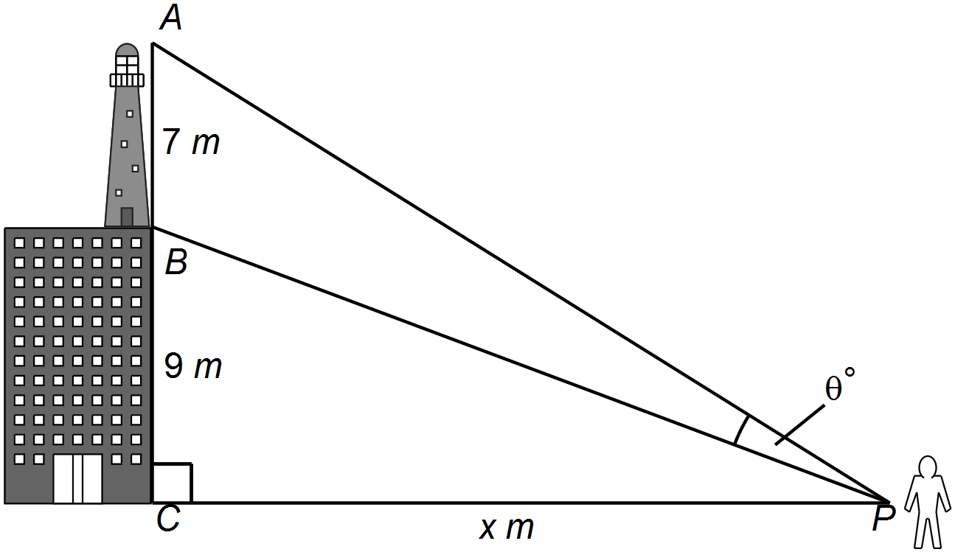A tower, 7m high, stands on top of a building 9m high. An observer at the bottom of the building notices that, as she walks away from the building, the angle which the tower subtends at her eyes seems to increase in size for a certain distance and then to decrease.

In the two right angled triangles above, P is a variable distance, x m , from C.

Part 1 – Trigonometry Approach
For different values of x determine the size of angle and then investigate what position of x maximizes the angle . Consider strategies that can be used and give clear explanations of the method you then used to find this position, annotating your steps of working.

Part 2 – Trigonometry and Algebra Approach
Using and find an algebraic expression for in terms of x. Graph this algebraic expression to determine the value of x which maximizes .
Compare the results from Part 1 and Part 2.

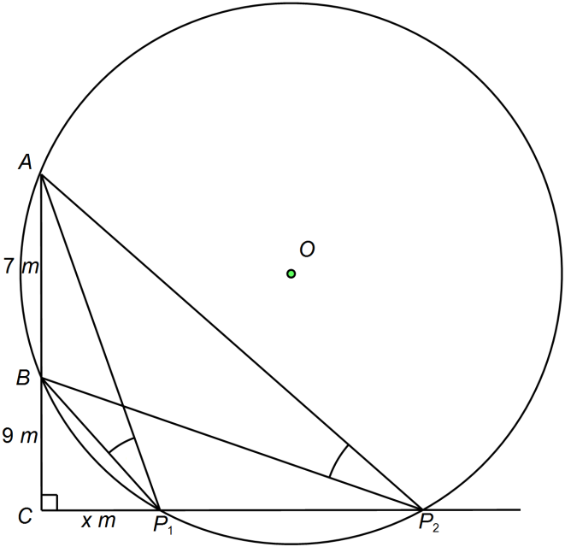
Part 3 – Geometry Proof Approach

A circle is drawn through points A and B cutting the base line at P₁ and P₂.
If the observer is at position P₁ or P₂ then make a conjecture about the relationship between the angles from the observer to A and B. Provide a formal proof for the conjecture.
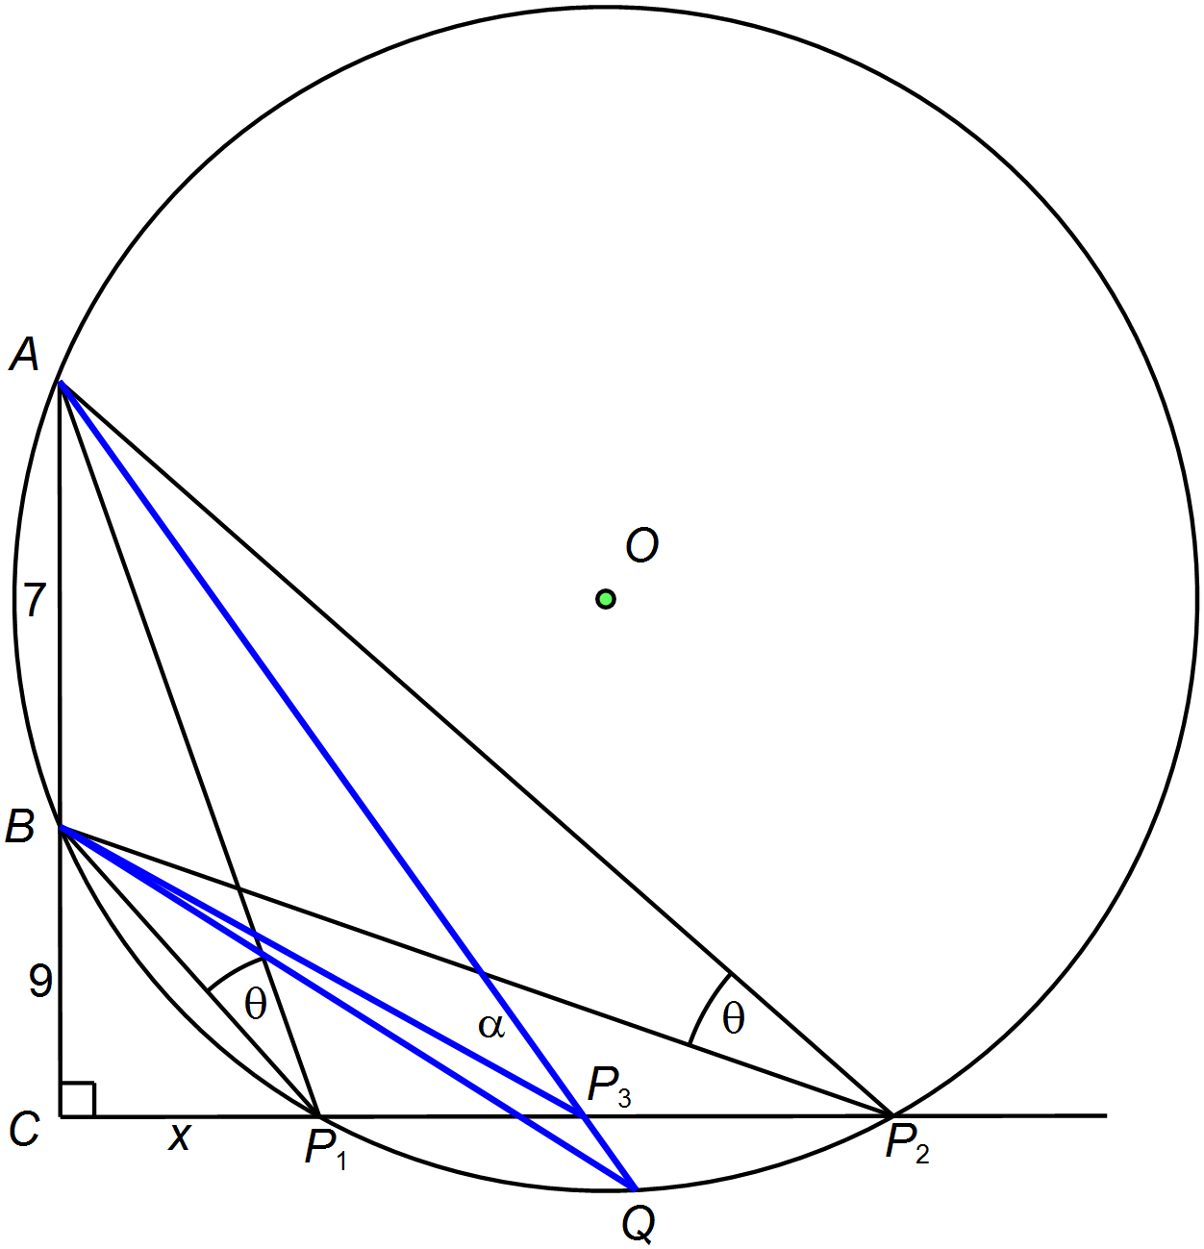This would indicate that, at P₁, has not yet reached its greatest value and that at P₂, it has gone beyond it. At any point between P₁ and P₂, will be greater than at P₁ and P₂.
Use geometry to explain why, referring to the diagram on the right.
Let
By considering BP₃ Q, explain why
and then explain why .

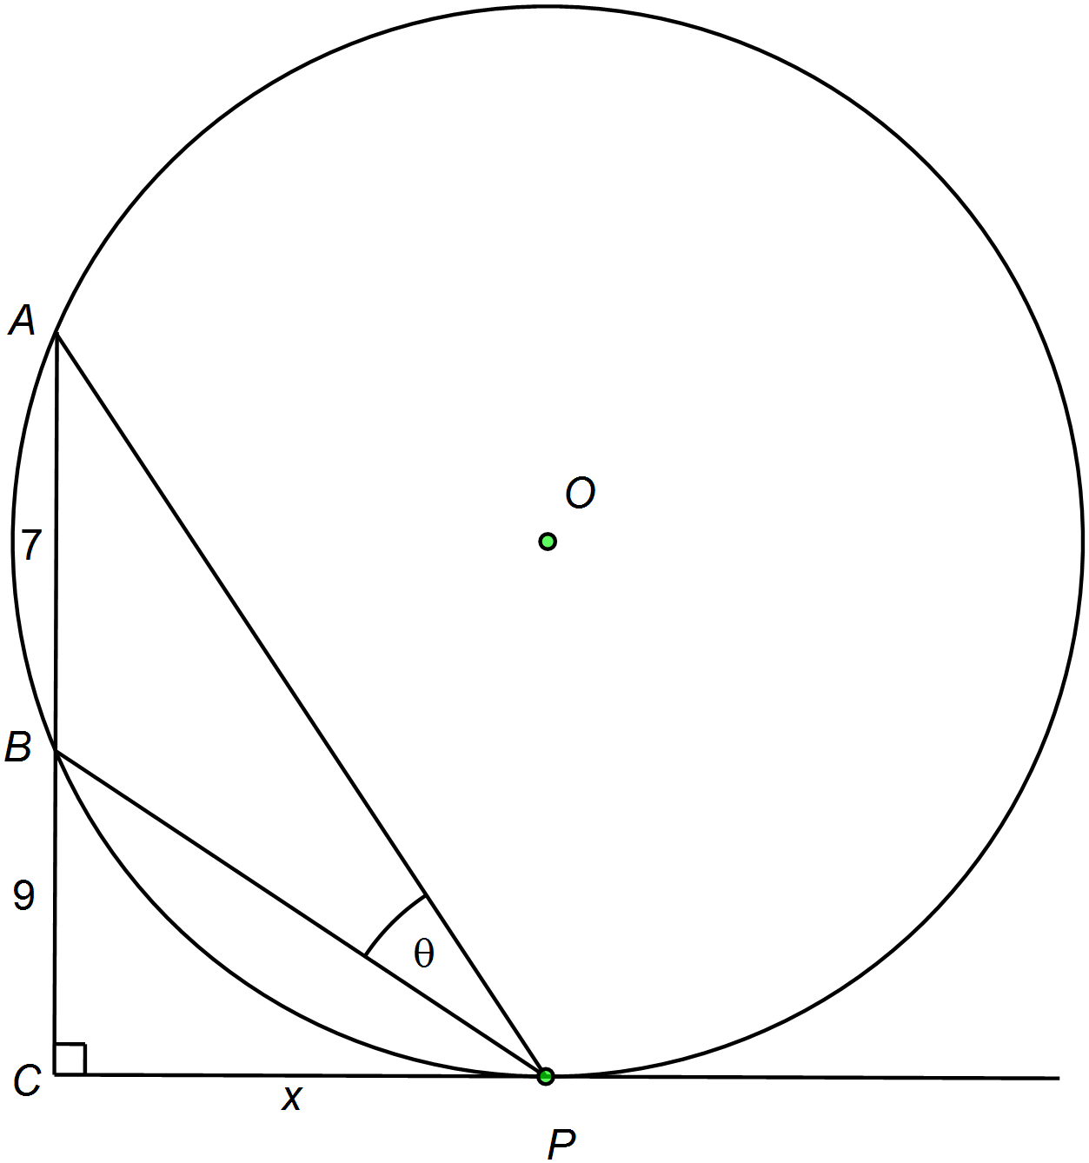

Points P₁ and P₂ are brought closer to each other so that they eventually are touching at P as shown in the diagram on the right.
Give a conjecture about the relationship between $∠$BPC and $∠$CAP. Prove the conjecture.
Prove that the triangles ACP and PCB are similar.
Hence, determine the relationship between x and your results from Part 1 and Part 2.

Part 4 – Drawing Conclusions
Summarize results from Parts 1, 2 and 3, making links where appropriate. Draw conclusions and discuss and limitations or assumptions made.

Performance Standards for Stage 1 Mathematics
 | Concepts and Techniques | Reasoning and Communication
A | Comprehensive knowledge and understanding of concepts and relationships.  Highly effective selection and application of mathematical techniques and algorithms to find efficient and accurate solutions to routine and complex problems in a variety of contexts.  Successful development and application of mathematical models to find concise and accurate solutions.  Appropriate and effective use of electronic technology to find accurate solutions to routine and complex problems. | Comprehensive interpretation of mathematical results in the context of the problem.  Drawing logical conclusions from mathematical results, with a comprehensive understanding of their reasonableness and limitations.  Proficient and accurate use of appropriate mathematical notation, representations, and terminology.  Highly effective communication of mathematical ideas and reasoning to develop logical and concise arguments.  Effective development and testing of valid conjectures.
B | Some depth of knowledge and understanding of concepts and relationships.  Mostly effective selection and application of mathematical techniques and algorithms to find mostly accurate solutions to routine and some complex problems in a variety of contexts.  Some development and successful application of mathematical models to find mostly accurate solutions.  Mostly appropriate and effective use of electronic technology to find mostly accurate solutions to routine and some complex problems. | Mostly appropriate interpretation of mathematical results in the context of the problem.  Drawing mostly logical conclusions from mathematical results, with some depth of understanding of their reasonableness and limitations.  Mostly accurate use of appropriate mathematical notation, representations, and terminology.  Mostly effective communication of mathematical ideas and reasoning to develop mostly logical arguments.  Mostly effective development and testing of valid conjectures.
C | Generally competent knowledge and understanding of concepts and relationships.  Generally effective selection and application of mathematical techniques and algorithms to find mostly accurate solutions to routine problems in a variety of contexts.  Successful application of mathematical models to find generally accurate solutions.  Generally appropriate and effective use of electronic technology to find mostly accurate solutions to routine problems. | Generally appropriate interpretation of mathematical results in the context of the problem.  Drawing some logical conclusions from mathematical results, with some understanding of their reasonableness and limitations.  Generally appropriate use of mathematical notation, representations, and terminology, with reasonable accuracy.  Generally effective communication of mathematical ideas and reasoning to develop some logical arguments.  Development and testing of generally valid conjectures.
D | Basic knowledge and some understanding of concepts and relationships.  Some selection and application of mathematical techniques and algorithms to find some accurate solutions to routine problems in some contexts.  Some application of mathematical models to find some accurate or partially accurate solutions.  Some appropriate use of electronic technology to find some accurate solutions to routine problems. | Some interpretation of mathematical results.  Drawing some conclusions from mathematical results, with some awareness of their reasonableness or limitations.  Some appropriate use of mathematical notation, representations, and terminology, with some accuracy.  Some communication of mathematical ideas, with attempted reasoning and/or arguments.  Attempted development or testing of a reasonable conjecture.
E | Limited knowledge or understanding of concepts and relationships.  Attempted selection and limited application of mathematical techniques or algorithms, with limited accuracy in solving routine problems.  Attempted application of mathematical models, with limited accuracy.  Attempted use of electronic technology, with limited accuracy in solving routine problems. | Limited interpretation of mathematical results.  Limited understanding of the meaning of mathematical results, their reasonableness or limitations.  Limited use of appropriate mathematical notation, representations, or terminology, with limited accuracy.  Attempted communication of mathematical ideas, with limited reasoning.  Limited attempt to develop or test a conjecture.

