
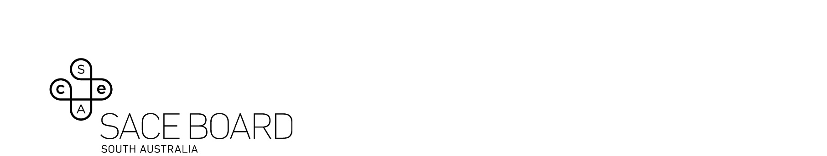

Recognition of Aboriginal Cultural

Knowledge and Learning

Community-led learning

Operational guidelines and framework

Contents

Introduction………………………………………………………………………………………………………………………………………………………………… 3
General information………………………………………………………………………………………………………………………………………………….. 3
The three pathways of Aboriginal cultural knowledge and learning……………………………………………………………….. .4
Cultural considerations for community-led recognition……………………………………………………………………………………. 7
Guidelines for recognition of cultural knowledge and learning — community-led………………………………………. 8
Framework for Aboriginal cultural knowledge and learning — community-led……………………………………………. 8
Examples of above and below the bar community-led learning and processes ………………………………………… 10
Applying for recognition of Aboriginal cultural knowledge and learning – Stage 2..……………………….…………. 11
Recognition requirements………………………………………………………………………………………………………………………………………. 12
How to result……………………………………………………………………………………………………………………………………………………………..12

Introduction

We would like to acknowledge this land is the traditional lands of the Kaurna people and we respect their spiritual relationship with their country. We also acknowledge the Kaurna people as the custodians of the Adelaide region and that their cultural and heritage beliefs are still as important to the living Kaurna people today.
The purpose of the community-led learning — Operational guidelines and framework is to provide students, schools, and community organisations with information about community-led, student-led and co-delivered learning, and how it can contribute towards the award of the South Australian Certificate of Education (SACE).
This document uses the terms ‘Aboriginal’, ‘Aboriginal people’ and ‘Aboriginal Communities’ to recognise the diversity within Aboriginal cultures and communities. This document uses a range of phrases used to represent Aboriginal people, including Aboriginal and Torres Strait Islander people, Indigenous Australian people, and First Nations people.

General information

Rationale
The Aboriginal Education Project explores approaches that will enable Aboriginal students to demonstrate and share their language and cultural learning skills and capabilities, and for that cultural knowledge and learning to be recognised and valued in the SACE. Key drivers are Aboriginal students’ agency and sense of belonging.
As highlighted in the Alice Springs (Mparntwe) Declaration and the Shergold Review into senior secondary pathways (Recommendation 16); Aboriginal students should be able to draw on their cultural knowledge and competency to demonstrate their learning, in language, or on country. To support the SACE to become a culturally responsive qualification that provides opportunities for Aboriginal students to utilise their living history, languages, and cultures as an integral part of their SACE, the Aboriginal Education project commenced work to develop comparable recognition models for Aboriginal students’ knowledge and learning to be recognised as part of the SACE completion requirements.

Relevant legislation
This project has not been framed within the boundaries of existing legislation or policy, but with a co-design approach to acknowledge, respect, and meet the needs and advice of Aboriginal communities and students.
However, the proposed recognition model for Aboriginal Community-led cultural learning has been interpreted as within the remit of the SACE Board of South Australia Act 1983. Section 15 (1) of the act sets out the functions of the Board. The functions that relate to this policy are:
(g) to recognise, in such manner and to such extent as the Board thinks fit.
(i) assessments of students made by schools, institutions or other authorities or organisation.
(ii) the achievements of a student in or towards completion of any activities or requirements recognised by the Board for the purposes of the SACE.
To this end, the term ‘authorities’ in point (i) above, has been interpreted to extend to assessments of students made by Aboriginal cultural authorities.

Policy principles
The proposed approach to Aboriginal recognition aligns strongly with the following existing policy principles as stated in the Recognition Arrangements for Courses in the SACE Policy and Procedures:
- that the recognition of learning is consistent with the principles, requirements, and standards of the SACE (consistency with SACE principles)
- that the amount and level of recognition of learning maintains and enhances the integrity of the SACE (integrity of the SACE)
- that the recognition arrangements balance the opportunity for students to personalise the components of the SACE and at the same time maintain coherence in the SACE (coherence in the SACE)
- that the recognition arrangements promote diverse pathways but do not duplicate the pathways provided by the SACE (not duplicate identical pathways)
- that the recognition process focuses on the learning achieved (achievement-focused)
- that the recognition process considers the nature and scope of the learning and the complexity of the learning, and that judgments about the complexity of learning are made against evidence of learning (evidence-based)
- that the reporting of community learning is consistent with the valuing of other, accredited learning towards the SACE (consistency in reporting learning)
- that the quality assurance processes of learning providers in guaranteeing the integrity of student results are respected (quality assurance)
- that the integrity of cultural assessments is dependent on the interconnected responsibilities of the students, school leaders, SACE Board, families, and community (interconnected responsibilities)
- that the recognition process is based on the principles of fairness, transparency, and consistency in the application of the procedures (equitable process)

The three pathways of Aboriginal cultural knowledge and learning
To enable the greatest accessibility and opportunity for Aboriginal students to have their cultural knowledge recognised, three separate recognition pathways have been developed. One pathway recognises knowledge and learning developed from within a student’s community which is generally taught by Elders, leaders, or family members from that community (community-led). The second pathway recognises cultural learning that students drive themselves in an area of cultural interest or passion (Student-led). The third pathway provides Aboriginal students with the opportunity to explore and develop an understanding of Aboriginal culture in a relevant and meaningful way while making community connections (co-delivered).

Community-led pathway
The community-led recognition pathway recognises significant knowledge and/or learning of Aboriginal cultures held by Aboriginal students which is being done in and by community for the purpose of students gaining SACE credits (Stage 2 20-credits). It is not a specifically curated learning experience for the purpose of students gaining SACE credits. It is the passing on of Aboriginal cultural knowledge and ways of knowing, doing and being over time.

Learning criteria
Aboriginal communities, through consultation, have confirmed that ongoing leadership, authority, and responsibility are valued as the highest levels of learning. When students are given ongoing leadership, ongoing responsibility, and ongoing authority, they have developed and demonstrated deep understanding of aspects of their culture.

Recognition
It is SACE’s position that neither SACE, nor the school, require tangible evidence or even direct knowledge of the activities undertaken, only the type of learning that has been undertaken (as outlined above).
To ensure ownership of cultural knowledge and assessment remains within the student’s Aboriginal community, a recognised ‘cultural authority’ from within the student’s community (nominated by the student and/or their family) will verify the learning.

Quality assurance
Quality assurance of this learning will be managed through a set of defined criteria and standards for recognition. The SACE Board will not be involved in the assessment or the verification of Community-led learning, instead the quality assurance will come through a model of trusted partnerships between the SACE Board and the school (principal), the school and the student’s community and recognition criteria and standards. A formalised community/cultural authority—school partnership agreement will need to be signed by the school and the nominated cultural authority, prior to recognition being awarded.
Refer to the Community-led — Operational guidelines and framework for further details.

Student-led pathway
The student-led pathway recognises cultural learning undertaken by Aboriginal students in an area of personal cultural interest. This pathway has been specifically developed in response to concerns from stakeholders regarding the large number of Aboriginal young people who do not hold existing ties to their community/culture, and Aboriginal students wanting a pathway that supports them to explore their Aboriginality in ways that are meaningful to them.
The activities that the student undertakes will be of personal interest to them, and learning is driven by the student rather than community or the school.

Learning criteria
The Student-led learning criteria have been developed using the model of Knowing, Doing, Being, which provides a framework for cultural learning. The framework highlights three domains of cultural capability, drawing upon the Knowing, Doing, and Being framework used by Snook et al (2012). In each domain there are core and functional areas of capabilities that can be applied.
- Knowing: Knowledge and understanding
- Doing: Impact and contribution
- Being: Personal Meaning
Learning indicators have been co-developed with community and school stakeholders and are informed by the Stronger Smarter Recommendation 16 consultation paper that articulates nationally defined Aboriginal cultural competencies.

Recognition
Student-led cultural learning is assessed by a SACE accredited school-based assessor. The recognition of learning can be through multiple discussions if required. This supports the assessment to be focussed on the learning and not the evidence produced, or the performative nature of a one-off interview.
Recognition will be available for Stage 1, 10 or 20 credits and Stage 2, 10 or 20-credits depending on the depth of learning demonstrated by the student through their discussions.

Quality assurance
Discussions are conducted with a SACE accredited school-based assessor.
At Stage 1, a criteria and indicator checklist is signed and stored in a central location at the school.
At Stage 2, a criteria and indicator checklist is signed and may need to be uploaded to schools online along with the recorded discussion, or other evidence of learning (can include teacher notes).
Refer to the Student-led — Operational guidelines and framework for further detail.

Co-delivered pathway
Recognition of Aboriginal Cultural Knowledge and Leaning co-delivered program provides recognition of students cultural learning with communities and or cultural authorities towards the completion of the South Australian Certificate of Education (SACE). The program celebrates and acknowledges Aboriginal students’ learning that is the result of Aboriginal communities and schools working together to develop and deliver programs for students that connect them to culture.
The program supports students to learn more about their culture, and themselves while deepening students’ sense of belonging, identity, and connections.

Learning criteria
Schools are required to co-develop a cultural learning plan with Aboriginal cultural authorities and or Aboriginal communities describing activities, tasks, and learning that students will participate in.
Students are assessed across three learning domains: Knowing, Doing, Being.
The evidence described in the three learning domains should be equivalent to a 60-hour, Stage 1, 10-credit course, and can be met by students participating in multiple tasks and activities.
The recognition model of Knowing, Doing, Being, provides a framework for cultural learning. The framework highlights three domains of cultural capability, drawing upon the Knowing, Doing, and Being framework used by Snook et al (2012). In each domain there are core and functional areas of capabilities that can be applied.

Recognition
Recognition of Aboriginal Cultural Knowledge and Learning co-delivered program is a 10-credit option Stage 1. Students can only receive credits for one instance of Recognition of Aboriginal Cultural Knowledge and Learning – Co-delivered program.

Quality assurance
Schools are required to co-develop with an Aboriginal cultural authority or community a ‘Co-delivered cultural learning plan’. Plans must be cosigned by a cultural authority or their delegate and should be kept in a central location by the school.
For other information regarding SACE recognition policies please contact askSACE, telephone 1300 322 920, or visit the VET and recognised learning pages of the SACE website (www.sace.sa.edu.au), which provides more information about community learning.
Refer to the Co-delivered —Operational guidelines and framework for further detail.

Cultural considerations for community-led recognition
When speaking with a cultural authority or community member for recognition of community-led learning, the student (and or their family) may need to be involved in a ‘warm introduction’, it may not be appropriate / effective to have an initial meeting with them by yourself.
Conversations with students and/or cultural authorities/community member should be arranged at a mutually convenient time and place (using technology where appropriate).
Students should not feel pressured into pursuing or not pursuing these recognition pathways. However, teachers and support staff should feel comfortable to encourage students to consider it where appropriate.
The assessment discussion processes may take more than one meeting/conversation. Students can produce and bring any relevant artefacts and materials if they wish to.
When conducting a conversation with students, advocates and communities the following should be taken into consideration:
The school trained assessor’s role is not to question if the learning activity has happened as described, their role is to facilitate and support the following:
- Provide opportunities for students to demonstrate their understanding of what they are receiving credits for and against which learning criteria.
- Share and discuss the framework with the students so they know what they need to demonstrate to the assessor or advocate as part of their assessment.
- Ensure the cultural safety for students, their families and cultural authorities involved by building a partnership that respects and honours participants expertise.
- Ensure that students, families and cultural authorities understand that specific details about cultural activities or knowledge (sometimes referred to as secret business, closed business, lore) do not need to be shared with the school or SACE if it would be inappropriate to do so.
- Ensure students know they are entitled to have an advocate present during all discussions.
- Communicate outcome/decision to student and any other people involved in the process (i.e. student advocate). Provide an explanation of why.

Guidelines for recognition of cultural knowledge and learning — community-led
Individual students are invited to have their community-led cultural learning considered for recognition as part of their SACE. To gain recognition towards their SACE, students must acknowledge their intent to participate in their recognition pathway with a member of staff from the school.
A nominated cultural authority/community member will verify the student’s cultural learning against the criteria and learning standards in the community-led learning framework Evidence of learning is not required, and judgment is made by the cultural authority. Details may be shared if appropriate, but it is not a requirement.
A ‘community-led nominated cultural authority and school partnership agreement’ or a ‘community-led nominated community and school partnership agreement’ is required to be completed and signed by the nominated cultural authority or member of the community, and principal’s delegate.
The learning must be demonstrated through a significant cultural learning experience(s) in the current calendar year and should reflect learning that is appropriate for senior secondary level. Demonstration of learning is restricted to one criteria per cultural experience/activity.
Students who are applying for recognition of Aboriginal cultural knowledge and learning – community-led must be enrolled in the SACE.
‘The school is required to submit the ‘community-led – school sign-off form’, and signed ‘nominated community and school partnership agreement’, or signed ‘nominated cultural authority and school partnership agreement’. If details of the learning event are provided, then these can be included in the sign off sheet but are not necessary. The documents must be signed by all parties. Unsigned documents will not be accepted.
The appraisal of community-led cultural learning involves the:
- students showing a desire to have their cultural learning recognised through the cultural recognition pathway
- student and family nominating a cultural authority / community member to verify the learning has occurred with the school
- nominated cultural authority / community member to sign a cultural authority community – school partnership agreement.
- nominated cultural authority / community member informing the school of the learning that has occurred and signing a declaration that supports this
- school reporting of the outcomes of the community-led decision to the SACE Board.
The school does not verify the learning or need to make any judgements about the learning when credits are awarded.
The school will ensure that they have conducted clarifying conversations that support the mutual understanding and agreement of credits being awarded through the signing of a ‘community-led – school sign-off form’, and a signed ‘nominated community and school partnership agreement’, or signed ‘nominated cultural authority and school partnership agreement’.

Framework for Aboriginal cultural knowledge and learning — community-led

Learning
Through a community-led activity, the student demonstrates learning at a high level through:
- ongoing leadership
- ongoing authority
- ongoing responsibility.

Assessment criteria
The student is required to nominate a cultural authority or community who will have witnessed the activity/learning and can verify that the learning is deep and significant in line with the criteria and learning standards below.
The following framework for community-led cultural learning applies to any learning undertaken within the community.
Learning criteria | Examples
Ongoing leadership  Holding a significant leadership role within the community  Student demonstrates their ability to influence or guide people within community or others outside of community | Management of people and/or community events/activities (e.g., activities related to Sorry Business/Funerals or initiation)  Leading within a corporate body, guiding mining companies on use of the land
Ongoing authority  Becoming an authority on cultural knowledge, practices or protocols  Students demonstrate they understand cultural protocol, make decisions for others, and ensure adherence to cultural protocols | Entrusted to hold and pass on knowledge and skills on to other people within the community (e.g. language, songlines, stories, food etc.)  Authority for approving land access requests
Ongoing responsibility  Holding a significant responsibility within the community  Student demonstrates their duty to deal with cultural requirements within their community | Management of community/natural resources (e.g. waterholes or endangered species)

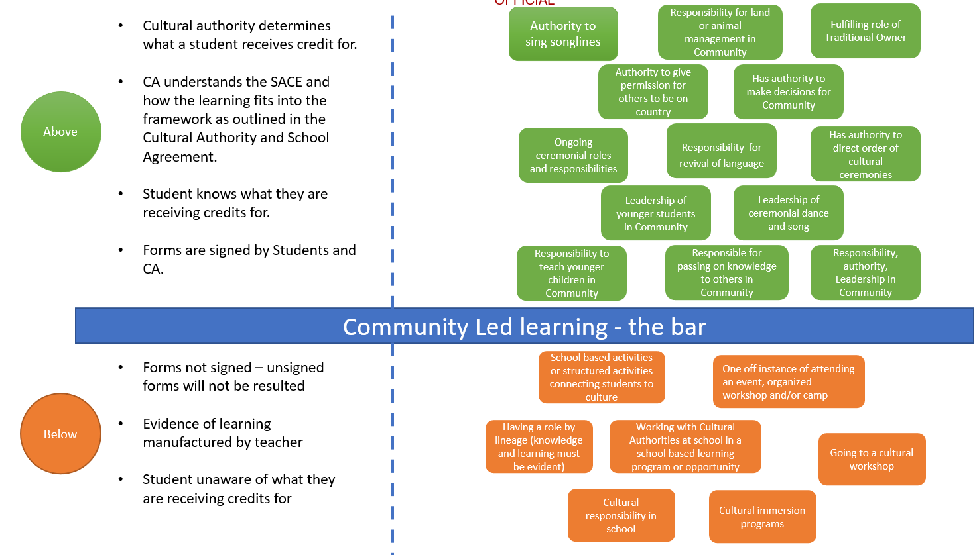
Examples of above and below the bar community-led learning and processes

Applying for recognition of Aboriginal cultural knowledge and learning — Community-led Stage 2
2.Student informs school of intent to have learning recognised
3. Family nominates Cultural Authority or Community
4. Community/ Cultural Authority partnership Agreement signed
(Clarifying)
6. Cultural Authority /Community confirms learning with school
(confirming)
7. School records recognition, signs and submits paperwork to SACE
(Verification/Warranting)
5. Learning event occurs
(Retrospective within school year)
1.Learning/recognition opportunity identified

The key steps in the process are:
1. Student and teacher discuss applying for recognition
The student and teacher should have a preliminary discussion to see if an application for recognition of the student’s community-led cultural learning is the optimal way of gaining credit for the learning, or whether the needs of the student might be more appropriately met by using another option in the SACE curriculum, such as Community Studies.
2. Student informs the school of the intent to have a learning opportunity recognised
If the student decides this is the most suitable option, he or she confirms with the school that they are going to be participating in an event that they would like the learning recognised. It is encouraged that this event is identified before it takes place rather than retrospective, however it is acknowledged that this is not always possible and therefore it can be identified post event. For the purpose of community-led recognition this can be retrospective within the current academic year.
3. Family nominates cultural authority or community
After the student informs the school of the recognition opportunity, the school will contact the family to identify who will be verifying the learning.
This person needs to have some cultural authority within community.
4. Partnership agreement is signed by both stakeholders.
The SACE Board requires a community or cultural authority and school partnership agreement is signed by both parties to ensure all stakeholders are aware of their responsibilities in the process. This must be submitted to the SACE Board with the ‘school sign-off form’.
If a community and school partnership agreement is being signed, the agreement can be signed by a representative on behalf of the whole community. It will be the responsibility of the signee for the community to ensure relevant people know of their responsibilities.
The partnership requires a clarifying conversation to occur between the community and school. It is at this point that the school will inform the nominated person of the recognition criteria and learning standards for the student to receive Stage 2, 20 credits.
5. The learning event occurs
The student attends the event with the nominated person from cultural authority or community.
It may be that a member of the school is also able to attend the event as a guest, however, the assessment still needs to come from the nominated person given by the family.
6. Nominated person from community informs the school of their verification decision
After the event, the nominated person identified by the family will inform the school of the verification decision and will complete the ‘community-led school sign off form’.
There is no expectation that evidence needs to be provided to verify the learning.
7. School submits assessment result to SACE Board.
The school does not need to verify the learning. The only requirement for the school is to submit the final assessment result made by the nominated person, with a signed partnership agreement. Unsigned documents will not be accepted. All documentation will need to be emailed to AskSACE (askSACE@sa.gov.au). Should you require any support, or need any advice on how to result students, please call the askSACE team on 1300 322 920.

Recognition requirements
Students are awarded 20-credits at Stage 2.
Where one of the following criteria are demonstrated by a student and verified by a cultural authority nominated by a student and/or their family, recognition will be granted at Stage 2, 20 credits.
- ongoing leadership
- ongoing authority
- ongoing responsibility
Evidence of students’ cultural knowledge/learning must be demonstrated within the current school year (the time period undertaken for the learning does not matter).

Snook, Scott, Nitin Nohria, and Rakesh Kurana (2012, XV) The Handbook for Teaching Leadership; Knowing, Doing and Being. Thousand Oaks, CA: SAGE Publications.
Snook, Scott, Nitin Nohria, and Rakesh Kurana (2012, XV) The Handbook for Teaching Leadership; Knowing, Doing and Being. Thousand Oaks, CA: SAGE Publications.

