GeologicaI-History From the Quarry Face

Part 1: Identifying Features in the Quarry Face:
Source: Whiting D. A Visitor Guide to the Geology of the Granite Quarry at Mannum. S.A.C.A.E, Salisbury, p.6.
Application
Applies geological concepts and evidence from investigations to suggest solutions to complex problems in a new context.
Stand where you can see the quarry face, as shown in the above diagram.
1. On the above diagram of Mannum Quarry face, label:
- the dolerite dyke
- the unconformity
- the calcrete layer
Analysis and Evaluation
Analyses and evaluates observations and other evidence systematically to formulate logical and highly relevant conclusions about the geological history of the Quarry.
- the granite.
- the Mannum Formation limestone.
- Describe the geological history of the Quarry by completing the table below. Remember to put the oldest rock types and events at the bottom and the youngest at the top.

 | Rock Types | Events
Youngest | Calcrete | Accretion / Deposition of calcium carbonate
 | Mannum Limestone | Incursion of the sea
 | - | Erosion
 | Dolerite dyke | Intrusion
Oldest | Granite | Intrusion of magma
The diagram below shows the whole quarry area and the locations at which we will study features of geological interest.
Cross-section of Mannum Quarry

Where appropriate, cross out the incorrect words in the following statements:

A The Dolerite Dyke
1. (a) The boundary between the dolerite and the granite is:
(sharp with no mixing of rock types / blurred and rock types are mixed together).
(b) This implies that when the dolerite magma intruded:|
(the granite was soft and partially molten / hard and the granite was solid and hard).
2. (a) When touched, the surface of the dolerite feels (rough / smooth).
(b) The texture of the dolerite is (crystalline / elastic) and (coarse / fine-grained).
Knowledge and Understanding
Demonstrates a broad knowledge and understanding of a variety of geological features by correctly answering A and B (a), (b) and (d).
B Mannum Granite
1. (a) The grain size of the granite is (coarse and fine / a mixture of coarse and fine).
(b) We normally explain grain size difference in igneous rocks by saying that coarse-grained rocks are formed from magma cools (slowly / fast) and fine-grained rocks are formed when magma cools (slowly /fast).
(c) Explain why a different interpretation is needed for the granite of the quarry face.
It is expected to cool at the same rate.

(d) Magma is not homogeneous (the same at all points). Some parts are less viscous than others.
Non viscous magmas probably solidify (quickly / slowly) and form (small / large) grains.
Analysis and Evaluation
Analyses and evaluates evidence to formulate a simple and generally relevant conclusion about the granite of the quarry face in B 1(c).
Viscous magmas probably solidify (quickly / slowly) and form (small /large) grains.

2. Name and describe 4 minerals that are visible in the coarse-grained granite.
(i) Orthoclase feldspar (pink) with shiny cleavage planes
Application
Uses appropriate geological terms effectively in 2.
(ii) Quartz (grey)
(iii) Biotite, part of mica group, with pearly lustre.
(iv) Hornblende with dull phases
C ‘Strangers'
Throughout the granite there are areas of dark rock that are definitely not granite. An example of such a feature is shown in the adjacent photograph.

These features are called xenoliths.

The adjacent diagram shows how they came embedded in the granite.

As the magma pushed upwards into the country rock, pieces of the country rock fell from the roof of the magma chamber and fell into the magma.

After some time in the hot magma, the xenoliths begin to melt and they may eventually become part of the magma itself. This is called assimilating.
1. Locate a xenolith that probably fell into the granite just before the granite solidified.
Investigation
Obtains, records, and displays findings of the investigation using appropriate conventions mostly accurately and effectively in C 1 – 4.
(a) What colour is it? Black
(b) Its boundary with the granite is (sharp / blurred)
Some are blurred.
2. Now locate a xenolith that probably fell into the granite a long time before the granite solidified.
Knowledge and Understanding
Demonstrates some depth and breadth of knowledge and understanding of the geological concept – xenoliths, in questions C 1 – 4.
(a) What colour is this xenolith? Pale grey
(b) Its boundary with the granite is (sharp / blurred).
3. Use the evidence provided by the xenoliths to describe the nature of the country rock into which the magma intruded.
Black (probably a schist)
Analysis and Evaluation
Demonstrates ability to use clear analytical skills to examine connections between concepts, and observations in geology, in questions C 3 and 4.
4. What has happened to most of that country rock?
The layering / foliation was destroyed by the heat (partially assimilated).
D A line of ‘Black Blobs'
As you walk northwards in front of the quarry face, you will notice a line of `black blobs' across the face of the quarry.
A line of `Black Blobs'

1 Mark this line on the above photograph of the quarry face.
There are at least two explanations for this line of `black blobs'
One is that it consists of a cluster of xenoliths that were swept into line by a current of magma moving through the magma body when it was liquid.
The other explanation is that it was an intrusion of basaltic magma into granitic magma that had not yet solidified.

E Surface of the 'Unconformity’
As you walk up the northern side of the quarry, you can examine the weathered surface of the granite.
1 You are now walking on the surface of the unconformity, which forms the boundary between the:
Knowledge and Understanding
Demonstrates some depth and breadth of knowledge and understanding of the weathered surface of granite by correctly answering questions 1 and 2.
granite which is 490 years old and the Mannum Formation Limestone aged 40 years.
2 Describe two features that are present on the granite surface about half way up the Quarry face.
(i) Smooth, polished surface of the granite.
(ii) Potholes
The adjacent photograph shows similar features that can be seen in the granites at Port Elliot.  They are found in the area between high tide and low tide, where the rocks are pounded by waves.  3. What does this evidence tell you about the conditions in this area several million years ago?  Intertidal zone several million years ago. | 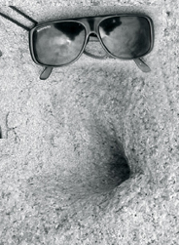  Analysis and Evaluation  Analyses and evaluates evidence to provide relevant conclusion about the conditions in the area several million years ago.

4. Name the principle that you used when answering question 3.
Principle of uniformitarianism.
F The Mannum limestone
1 Describe the Mannum Limestone.
Application
Uses appropriate geological terms and conventions effectively when describing the Mannum Limestone in question 1.
(a) Colour: Sandy yellow, orangey brown.
(b) Texture: Medium fine.
(c) Most obvious feature: Fossils
(d) What can you deduce from this feature? Shallow water in the inter-tidal zone.

The diagrams below show two of the most common fossils you are likely to find, and explain the functions of some of the features found on the surfaces of the fossils.
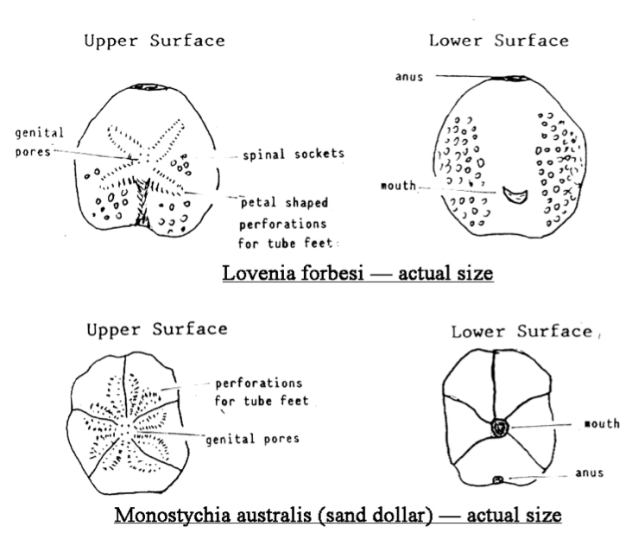
Source: Whiting D. A Visitor Guide to the Geology of the Granite Quarry at Mannum. S.A.C.A.E, Salisbury, p.23.
Other fossils in the Mannum Limestone are shown in the following diagrams.
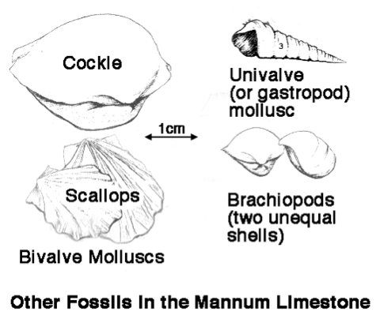
Source: Field Geology Club of South Australia: A Field Guide to the Coastal Geology of Fleurieu Peninsula. Adelaide 1986.

2. Use the above diagrams and your observations to name any fossils you have found.
Scallops, cockles and gastropods
Investigation
Obtains and records findings of investigations using appropriate conventions accurately and effectively in F 2 and G 1, 2 and 3.

G The Calcrete Layer
1. Explain why you would expect to find calcrete as the top rock layer at this location.
Calcrete forms in a dry climate. It forms as the result of calcium deposits
Analysis and Evaluation
Uses perceptive and thorough analytical skills to examine connections between calcrete and Mannum Limestone in the field.
2 Compare the calcrete with the Mannum Limestone in terms of:
(a) Colour: white.
(b) Grain size: Fine (1 mm).
(c) Presence of Fossils: No
3 Describe some features of the calcrete that are not present in the Mannum Limestone.
Formation of rounded nodules

H Past Human Activity
Look for small shell fragments at the top of the quarry.
1. Describe the colour of the soil around these fragments.
Darker brown
This area has not been under the sea since the Mannum Limestone was formed, so the shells are not from marine molluscs.
2 Where might these molluscs have lived?
In the river.
Analysis and Evaluation
Systematically analyses and evaluates evidence to formulate logical and highly relevant conclusions in responses to 2 and 3.
3 Suggest how the shell fragments reached the top of the granite and why the soil around them is dark.
The shells might have been brought up by people millions of years ago and the soil is dark because of there are probable camp fires made and charcoal has made the soil darker.

J Dyke or Xenolith?
At the southern end of the quarry there is a large black rock, several metres high and wide with a wedge of granite through its centre.
Investigation
Obtains and records findings of investigation mostly accurately and effectively overall in J 1, 2 and 3.
1. Describe the black rock in terms of:
(a) clastic or crystalline Crystalline.
(b) grain size in mm Approx 1 mm.
(c) foliated or not-foliated Not foliated.
(d) hard or soft. Hard.
2. Which of the rock types we have seen today does it most resemble? Dolerite
3 In the space provided below, sketch this black rock, and the rock around it.
Label the areas of black rock and granite, and indicate the size of the black rock.
Application
Uses appropriate geological terms, conventions, and diagrammatic representations in all responses in J - highly effectively overall.
Applies evidence from the investigation to suggest a geological category for the black rock.
4. Name two features consisting of black rock that we have seen in the quarry today.
Dyke and Xenolith
5. Which one of these two features do you think the black rock might be? Xenolith because it is not in sheet form.

K SpheroidaI Weathering

1 The large black rock shows an example of weathering that occurs to rocks when they are just below the surface of the ground. The rocks have already been broken into cubes by weathering processes that occurred deep under the ground.
(a) State where you would normally expect to see evidence of this form of weathering.
Analysis and Evaluation
Systematically analyses and evaluates evidence to formulate logical and highly relevant conclusions.
It occurs below the ground.
(b) Explain why we can see it in this situation.
It has been exposed by the quarrying

2 The photograph below shows spheroidal weathering.

Investigation
Obtains, records, and displays findings of investigations using appropriate conventions mostly accurately and effectively.

Label the above photograph to show:
(a) The area of unweathered rock. Middle.
(b) The weathered rock: The edges.
(c) The shape of the original block: Square.
Analysis and Evaluation
Systematically analyses and evaluates data and other evidence to formulate logical and relevant conclusions.
(d) The shape of the new block: Round
3 Explain how and why this weathering process changes the shapes of the blocks of rock.
The solidified rock expands and forms cracks as the rock above it is eroded away (of-loading).

L Features of Granite Weathering
11
After granites become exposed at the Earth's surface weathering continues to round the blocks of granite, forming granite tors.
These become smaller and smaller by a process known as exfoliation, or onion-skin weathering.
Since rocks are poor conductors of heat, their outer become hot and expand while the inside remains cool.
This sets up stresses between the inner and outer layers of the rock, so eventually the outer layers peel off like the skin of an onion.
1 Locate some granite tors. Draw a labelled sketch of a boulder that shows onion-skin weathering and indicate where the onion-skin weathering is occurring.
Give an indication of the size of the granite tor.
2 Sketch and label any other features you can see that are formed by weathering of granite

Investigation
Obtains, records, and displays findings of investigations of granite tors mostly accurately and effectively and uses appropriate conventions e.g. scale in both sketches, clear labels in 2.

Please turn to the next page for additional comments about teacher assessment.

Additional comments
- There is a range of question types requiring demonstration of knowledge and understanding of geology, and application, and analysis and evaluation of geological information to provide opportunities for students to demonstrate higher order skills.
- More than one assessment task would need to be considered to assess a student’s ability to Consistently demonstrate a deep and broad knowledge and understanding of a range of geological concepts. (Knowledge and Understanding)
- Observation would be used to assess the student’s ability to:
- manipulate apparatus and technological tools carefully and highly effectively to implement safe and ethical work practices (Investigation)
- demonstrate initiative in applying constructive and focused approaches to individual and collaborative work. (Application)

Performance Standards for Stage 1 Geology
 | Investigation | Analysis and Evaluation | Application | Knowledge and Understanding
A | Designs a logical, coherent, and detailed geological investigation.  Critically and logically selects and consistently and appropriately acknowledges information about geology and issues in geology from a range of sources.  Manipulates apparatus, equipment, and technological tools carefully and highly effectively to implement well-organised safe and ethical investigation procedures.  Obtains, records, and displays findings of investigations using appropriate conventions and formats accurately and highly effectively. | Systematically analyses data and their connections with concepts, to formulate logical and perceptive conclusions and make relevant predictions  Logically evaluates procedures and suggests a range of appropriate improvements. | Applies geological concepts and evidence from investigations to suggest solutions to complex problems in new and familiar contexts.  Uses appropriate geological terms, conventions, and diagrammatic representations highly effectively.  Demonstrates initiative in applying constructive and focused individual and collaborative work skills. | Consistently demonstrates a deep and broad knowledge and understanding of a range of geological concepts.  Uses knowledge of geology perceptively and logically to understand and explain social, economic, or environmental issues.  Uses a variety of formats to communicate knowledge and understanding of geology coherently and highly effectively.
B | Designs a well-considered and clear geological investigation.  Logically selects and appropriately acknowledges information about geology and issues in geology from different sources.  Manipulates apparatus, equipment, and technological tools carefully and mostly effectively to implement organised safe and ethical investigation procedures.  Obtains, records, and displays findings of investigations using appropriate conventions and formats mostly accurately and effectively. | Logically analyses data and their connections with concepts, to formulate consistent conclusions and mostly relevant predictions  Evaluates procedures and suggests some appropriate improvements. | Applies geological concepts and evidence from investigations to suggest solutions to problems in new and familiar contexts.  Uses appropriate geological terms, conventions, and diagrammatic representations effectively.  Applies mostly constructive and focused individual and collaborative work skills. | Demonstrates some depth and breadth of knowledge and understanding of a range of geology concepts.  Uses knowledge of geology logically to understand and explain social, economic, or environmental issues.  Uses a variety of formats to communicate knowledge and understanding of geology coherently and effectively.
C | Designs a considered and generally clear geological investigation.  Selects with some focus, and mostly appropriately acknowledges, information about geology and issues in geology from different sources.  Manipulates apparatus, equipment, and technological tools generally carefully and effectively to implement safe and ethical investigation procedures.  Obtains, records, and displays findings of investigations using generally appropriate conventions and formats with some errors but generally accurately and effectively. | Analyses data and their connections with concepts, to formulate generally appropriate conclusions and make simple predictions, with some relevance.  Evaluates some procedures in geology and suggests some improvements that are generally appropriate. | Applies geological concepts and evidence from investigations to suggest some solutions to basic problems in new or familiar contexts.  Uses generally appropriate geological terms, conventions, and diagrammatic representations with some general effectiveness.  Applies generally constructive individual and collaborative work skills. | Demonstrates knowledge and understanding of a general range of geological concepts.  Uses knowledge of geology with some logic to understand and explain one or more social, economic, or environmental issues.  Uses different formats to communicate knowledge and understanding of geology with some general effectiveness.

 | Investigation | Analysis and Evaluation | Application | Knowledge and Understanding
D | Prepares the outline of a geological investigation.  Selects and may partly acknowledge one or more sources of information about geology or an issue in geology.  Uses apparatus, equipment, and technological tools with inconsistent care and effectiveness and attempts to implement safe and ethical investigation procedures.  Obtains, records, and displays findings of investigations using conventions and formats inconsistently, with occasional accuracy and effectiveness. | Describes basic connections between some data and concepts, and attempts to formulate a conclusion and make a simple prediction that may be relevant.  For some procedures, identifies improvements that may be made. | Applies some evidence to describe some basic problems and identify one or more simple solutions, in familiar contexts.  Attempts to use some geological terms, conventions, and diagrammatic representations that may be appropriate.  Attempts individual work inconsistently, and contributes superficially to aspects of collaborative work. | Demonstrates some basic knowledge and partial understanding of geological concepts.  Identifies and explains some geological information that is relevant to one or more social, economic, or environmental issues.  Communicates basic information to others using one or more formats.
E | Identifies a simple procedure for a geological investigation.  Identifies a source of information about geology or an issue in geology.  Attempts to use apparatus, equipment, and technological tools with limited effectiveness or attention to safe or ethical investigation procedures.  Attempts to record and display some descriptive information about an investigation, with limited accuracy or effectiveness. | Attempts to connect data with concepts, formulate a conclusion, and make a prediction.  Acknowledges the need for improvement in one or more procedures. | Identifies a basic problem and attempts to identify a solution in a familiar context.  Uses some geological terms or diagrammatic representations.  Shows emerging skills in individual and collaborative work. | Demonstrates some limited recognition and awareness of geological concepts.  Shows an emerging understanding that some geological information is relevant to social, economic, or environmental issues.  Attempts to communicate information about geology.

