STAGE 2 MATHEMATICAL STUDIES

ASSESSMENT TYPE 2: FOLIO – Volumes of Solids of Revolution

This investigation uses mathematical concepts from the integral calculus and modelling work completed this year.

You are encouraged to use technology where appropriate. If repetitive calculations are done, you should consider ways of tabulating your results for the reader to more easily see a summary of what you have done.

Be aware that more is not necessarily better. Be clear and succinct in the way you write about what you have done and how you interpret your results.

A completed report for the investigation should include:
• an introduction that outlines the problem to be explored, including its significance, its features, and the context
• the method required to find a solution, in terms of the mathematical model or strategy to be used
• the appropriate application of the mathematical model or strategy, including
– the generation or collection of relevant data and/or information, with details of the process of collection
– mathematical calculations and results, and appropriate representations
– the analysis and interpretation of results
– reference to the limitations of the original problem
• a statement of the results and conclusions in the context of the original problem
• appendices and a bibliography, as appropriate

Your work will be assessed against the performance standards given on the following page.
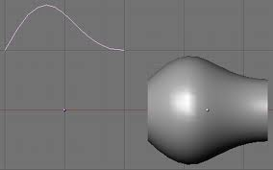



PERFORMANCE STANDARDS FOR STAGE 2 MATHEMATICAL STUDIES
 | Mathematical Knowledge and Skills and Their Application | Mathematical Modelling and Problem-solving | Communication of Mathematical Information
A | Comprehensive knowledge of content and understanding of concepts and relationships.  Appropriate selection and use of mathematical algorithms and techniques (implemented electronically where appropriate) to find efficient solutions to complex questions.  Highly effective and accurate application of knowledge and skills to answer questions set in applied and theoretical contexts. | Development and effective application of mathematical models.  Complete, concise, and accurate solutions to mathematical problems set in applied and theoretical contexts.  Concise interpretation of the mathematical results in the context of the problem.  In-depth understanding of the reasonableness and possible limitations of the interpreted results, and recognition of assumptions made.  Development and testing of valid conjectures, with proof. | Highly effective communication of mathematical ideas and reasoning to develop logical arguments.  Proficient and accurate use of appropriate notation, representations, and terminology.
B | Some depth of knowledge of content and understanding of concepts and relationships.  Use of mathematical algorithms and techniques (implemented electronically where appropriate) to find some correct solutions to complex questions.  Accurate application of knowledge and skills to answer questions set in applied and theoretical contexts. | Attempted development and appropriate application of mathematical models.  Mostly accurate and complete solutions to mathematical problems set in applied and theoretical contexts.  Complete interpretation of the mathematical results in the context of the problem.  Some depth of understanding of the reasonableness and possible limitations of the interpreted results, and recognition of assumptions made.  Development and testing of reasonable conjectures, with substantial attempt at proof. | Effective communication of mathematical ideas and reasoning to develop mostly logical arguments.  Mostly accurate use of appropriate notation, representations, and terminology.
C | Generally competent knowledge of content and understanding of concepts and relationships.  Use of mathematical algorithms and techniques (implemented electronically where appropriate) to find mostly correct solutions to routine questions.  Generally accurate application of knowledge and skills to answer questions set in applied and theoretical contexts. | Appropriate application of mathematical models.  Some accurate and generally complete solutions to mathematical problems set in applied and theoretical contexts.  Generally appropriate interpretation of the mathematical results in the context of the problem.  Some understanding of the reasonableness and possible limitations of the interpreted results and some recognition of assumptions made.  Development and testing of reasonable conjectures, with some attempt at proof. | Appropriate communication of mathematical ideas and reasoning to develop some logical arguments.  Use of generally appropriate notation, representations, and terminology, with some inaccuracies.
D | Basic knowledge of content and some understanding of concepts and relationships.  Some use of mathematical algorithms and techniques (implemented electronically where appropriate) to find some correct solutions to routine questions.  Sometimes accurate application of knowledge and skills to answer questions set in applied or theoretical contexts. | Application of a mathematical model, with partial effectiveness.  Partly accurate and generally incomplete solutions to mathematical problems set in applied or theoretical contexts.  Attempted interpretation of the mathematical results in the context of the problem.  Some awareness of the reasonableness and possible limitations of the interpreted results.  Attempted development or testing of a reasonable conjecture. | Some appropriate communication of mathematical ideas and reasoning.  Some attempt to use appropriate notation, representations, and terminology, with occasional accuracy.
E | Limited knowledge of content.  Attempted use of mathematical algorithms and techniques (implemented electronically where appropriate) to find limited correct solutions to routine questions.  Attempted application of knowledge and skills to answer questions set in applied or theoretical contexts, with limited effectiveness. | Attempted application of a basic mathematical model.  Limited accuracy in solutions to one or more mathematical problems set in applied or theoretical contexts.  Limited attempt at interpretation of the mathematical results in the context of the problem.  Limited awareness of the reasonableness and possible limitations of the results.  Limited attempt to develop or test a conjecture. | Attempted communication of emerging mathematical ideas and reasoning.  Limited attempt to use appropriate notation, representations, or terminology, and with limited accuracy.

STAGE 2 MATHEMATICAL STUDIES

ASSESSMENT TYPE 2: FOLIO – Volumes of Solids of Revolution

This task is in 2 parts:
Part A is a series of steps you can do to introduce yourself to the mathematics required for Part B. It forms only a minor part of the assessment of this investigation
Part B is the major part of the task on which you will be assessed and as such, must be presented in the form of a report as described on page 1.

PART A
- Consider the function
  - Draw the graph of the function on the axes below.
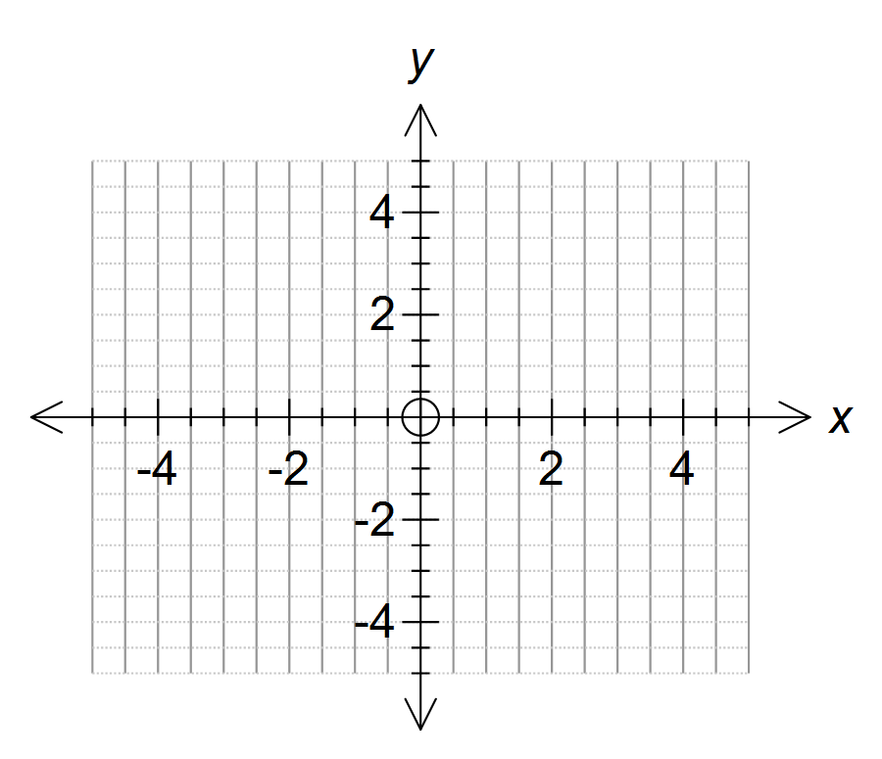

  - Explain briefly why only represents part of the relation described by .

- Consider the general case of a semi circle with centre at (0, 0) and a radius a units. The equation is of the form .

The graph of this function is drawn on the axes on the next page.

Imagine that the graph of the function is rotated about the x-axis as if the line
from x = -a to x = a is an axle, i.e. the line cuts out a solid sphere. The volume of this sphere can be calculated by the expression
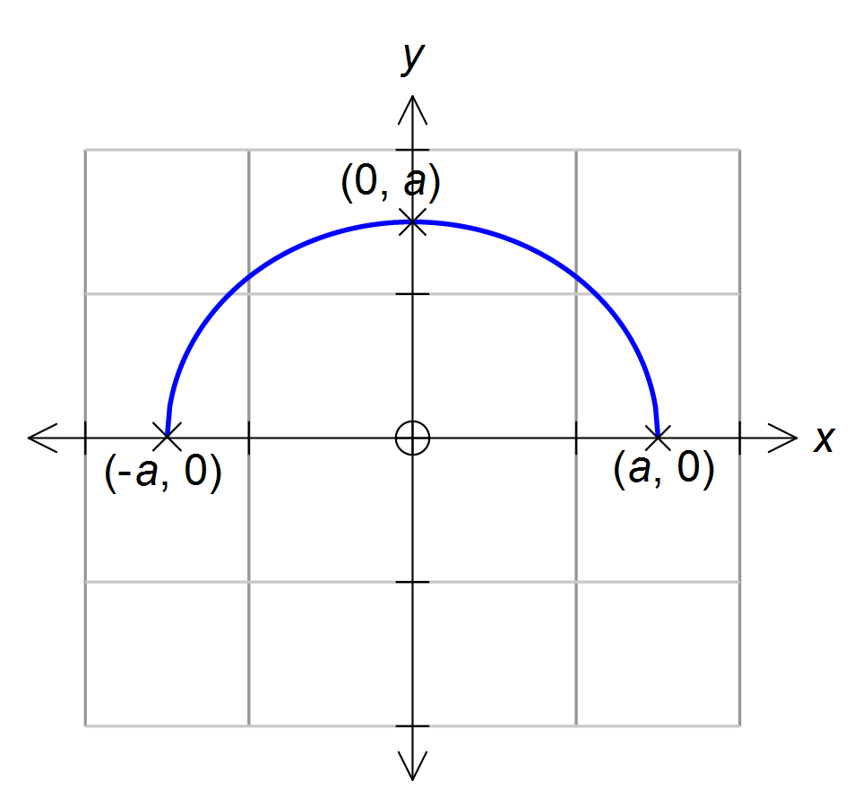

Calculate the volume of a sphere of radius 4, using the normal formula for volume of a sphere () and compare your answer with the answer you get using the appropriate integral expression.

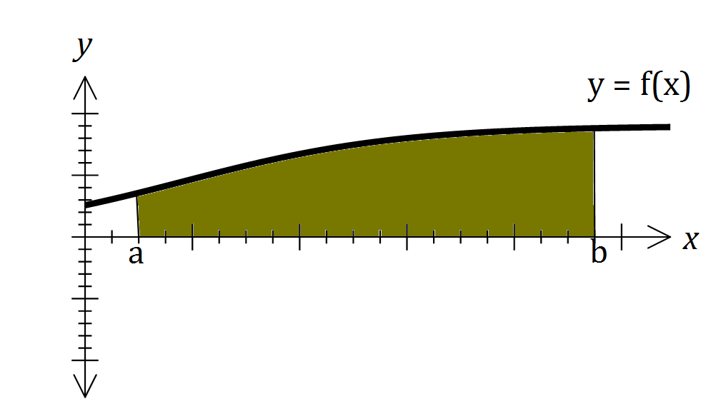In general, for any given function, the volume of the solid of revolution (i.e. the volume of the 3-dimensional solid formed by rotating the graph of the function about the x-axis) is given by the integral expression:

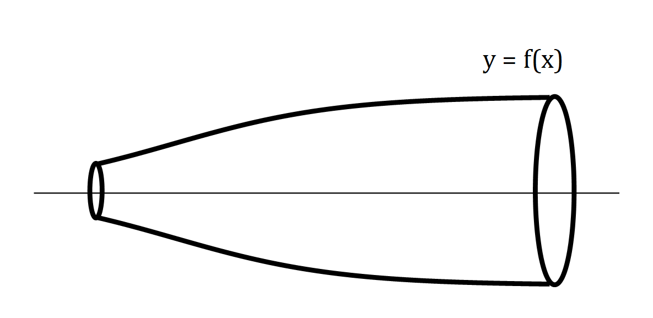

PART B

Your task is to choose an object in your home and use calculus to estimate the space within the object. You should also use another method of estimation to verify the answer achieved by your mathematics.

The object you choose can be any object from your home; a vase, a lampshade, a wine glass or another object for which you can map the shape of one side and find a function or functions that model the curve made by the outside edge of the object.

You may need to lay the object on its side to get a function you can easily model.

- Estimate the volume of the object using mathematical methods
- Explain how you developed and checked your estimation. Include mathematical working, written explanation, graphs, photographs, diagrams and any other means that you deem appropriate to support your explanation.
- Find a non-calculus method of estimation to check your mathematical value. Compare the accuracy of your methods.
- Discuss ways in which errors (could have) occurred and how they could be minimised.

Your work for Part B should be presented in the form of a report and should have:
- An introduction specific to the object you have selected
- Mathematical working with an explanation of what you have done
- Explanation of how you derived the equations you used to model the lines that follow the outer edge of the object
- Discussion of the accuracy of your mathematical estimation and methods(s) you used to check your mathematics. Comment specifically on places where errors and inaccuracies may have occurred and the extent to which these errors may have affected the accuracy of your estimations. Include discussion of ways in which the errors could be reduced.
- A conclusion that relates to your introduction and therefore the object that you selected.

Attach your working for Part A of the investigation to the back of your report.

