2020 Music Performance — Ensemble Subject Assessment Advice
Overview
Subject assessment advice, based on the 2020 assessment cycle, gives an overview of how students performed in their school and external assessments in relation to the learning requirements, assessment design criteria, and performance standards set out in the relevant subject outline. They provide information and advice regarding the assessment types, the application of the performance standards in school and external assessments, and the quality of student performance.
Teachers should refer to the subject outline for specifications on content and learning requirements, and to the subject operational information for operational matters and key dates.
School Assessment
Assessment Type 1: Performance
Students present an ensemble performance or set of performances to a maximum of 6–8 minutes, of a single work or a set of works by one or more composers, and individual evidence of each student’s contribution to the chosen ensemble through individual part-testing.
The more successful responses commonly:
- included part test-videos for each individual student
- displayed evidence of complexity through rhythmic, melodic, and harmonic (where applicable) elements within the chosen repertoire
- showcased a very high level of understanding and application of style
- presented a range of works that demonstrated the breadth and depth of the student’s musical and stylistic understanding and skills
- were familiar with process of part testing and had evidently completed formative part tests as part of their preparation
- demonstrated consistent control of tone and dynamics, and fluent technique in the performance and the part test.
The less successful responses commonly:
- did not include a separate part-test video for each individual student
- presented chosen works that did not allow students to demonstrate a wide variety of techniques or skills on their instrument
- lacked technical fluency within the performance of the repertoire
- lacked an understanding of the stylistic aspects of the repertoire
- performed parts that were not within their range i.e. vocalists singing in an inappropriate key
- displayed reluctance, or uncertainty during part testing.

Additional advice for teachers
- Remember that moderators are the audience who will view the videos of students’ performances. Teachers should ensure that all students in the moderation sample can be clearly identified in all videos by moderators who are unfamiliar with the class of students.
- Ensure that all students are clearly labelled in videos so moderators can identify each student in each video, (using arrows or similar — see PLATO Clarifying examples — and/or headshots or position descriptions).
- Submit each student’s individual part-test video on a separate file.
- Ensure students are clearly visible and not obscured within performance and part test videos. Multiple angles may be required for large ensembles. Smartphone/tablet video recording quality should sufficient for extra angles.
- Compress files where possible to mp4 for quicker upload and download.
- Provide students with a number of formative performance and part testing opportunities leading up to their assessment.
- Ensure audio sound checks are completed prior to recording where possible.
Assessment Type 2: Performance and Discussion
For this assessment type students present an ensemble performance, or set of performances to a maximum of 6–8 minutes, of a single work or a set of works by one or more composers, and individual evidence of each student’s contribution to the chosen ensemble through individual part-testing. This is accompanied by an individual discussion of key musical elements of the repertoire, with a critique of strategies to improve and refine each student’s performance to a maximum or 800 words if written, 4 minutes as an oral presentation, or the multimodal equivalent.
The more successful responses commonly:
- addressed the structural and stylistic elements of the chosen repertoire within the Discussion
- included a well-structured Discussion that focused on the analysis of a range of musical elements
- addressed within the Discussion practice strategies applied to develop and prepare their performance as an individual and member of an ensemble
- included consistent, appropriate, and highly effective use of musical terminology
- included appropriate referencing (and a word count in the case of written Discussions)
- were able to perform with a high degree of technical skill and musicality
- were able to demonstrate a high level of collaboration within the ensemble.
The less successful responses commonly:
- did not submit the Discussion which is a requirement for Assessment Type 2
- lacked depth and detail in relation to the elements of music in the Discussion
- lacked critique of strategies used to improve their skills, technique and accuracy of their performance in the Discussion
- included irrelevant information in the discussion (refer to subject outline)
- lacked technical fluency and stylistic aspects within the performance of the work(s)
- included performances that did not allow the student to demonstrate a variety of techniques and skills
- did not include a separate part-test video for each individual student.

Additional advice for teachers
- Teachers are reminded that in part testing, it is appropriate to give singers a note or sense of the key of the extract, but it is not acceptable for the accompaniment to continue throughout the part test.
- The part test should be long enough for the student to demonstrate their skills at their highest level. Moderators are assisted when the student is given the opportunity to clearly demonstrate their learning in a range of techniques, such as, intonation, dynamic contrasts, articulation, and maintenance of tempo and pulse.
- Teachers are encouraged to assist students in selecting repertoire that allows for an in-depth level of discussion.
- Ensure that the Discussion is submitted in a separate file with the performance. The focus of the Discussion should be on the musical elements – particularly analysis of structure and style, and practice strategies developed by the student to improve and refine their performance(s).
- Keep in mind that moderators are the audience who will watch the videos of your students. Teachers should ensure that every student being assessed can be clearly identified in all videos.
- Ensure students understand the differences between the purpose of the Discussion in Assessment Type 2, and the Evaluation in Assessment Type 3. The Discussion focuses on analytical and stylistic features of the repertoire, and practice techniques used to develop and refine the performance given in Assessment Type 2. The Evaluation in Assessment Type 3 focuses on an evaluation and critique of the final performance and the learning undertaken throughout the year.
- Mark all of the student’s evidence for the assessment type holistically. Teachers are reminded that there is no weighting to the Discussion. Teachers can mark against the features of the criteria as indicated in the diagram below:
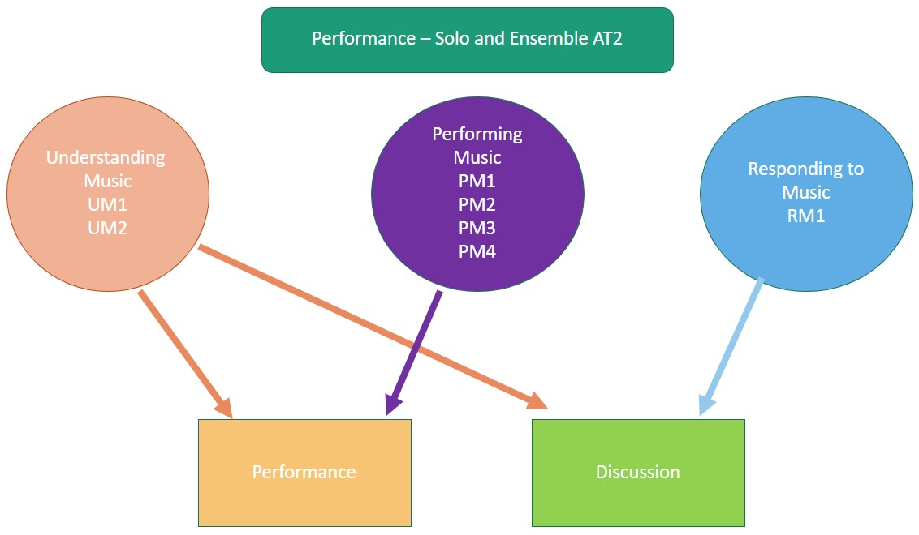
External Assessment
Assessment Type 3: Performance Portfolio
For this assessment type students present an ensemble performance or set of performances to a maximum of 6–8 minutes, of a musical work or works, and individual evidence of each student’s contribution to the ensemble through individual part-testing. They also provide an individual evaluation of their learning journey to a maximum or 500 words if written, 3 minutes as an oral presentation, or the multimodal equivalent.
The more successful responses commonly:
- organised the content according to the requirements described in the subject outline
- addressed aspects of responsiveness and collaboration within the ensemble for the performance and rehearsals, as well as how they had learnt from practice and preparation strategies prior to the performance
- demonstrated astute understanding of their role within the ensemble in the Evaluation
- included consistent, accurate and highly effective use of musical terminology in the Evaluation
- demonstrated a high level of technique, fluency and confidence within the performance and part-test
- showed close attention to all aspects of the repertoire during the performance and part-test
- featured part tests where the students were given clear instructions within a supportive environment.
The less successful responses commonly:
- did not submit the Evaluation which is a requirement of Assessment Type 3
- included irrelevant content in the evaluation (refer to subject outline)
- did not include a separate part-test video for each individual student
- in the Evaluation, lacked depth and concise detail in relation to responsiveness and collaboration within the ensemble
- lacked detail in relation to the learning that had occurred throughout the preparation for the performance, in the Evaluation
- lacked technical fluency and stylistic understanding within the chosen work
- included performances that did not allow the student to demonstrate a range of techniques and skills at the higher levels
- lacked attention to the detail of musical indications marked on the score (where scores were provided).
Additional advice for teachers
- Ensure that all students are clearly labelled and identified in both the performance and part test videos by SACE registration number. The performance and part test videos should be submitted as separate files. Compress files to mp4 for quicker upload and download.
- Ensure students are clearly visible and not obscured by line of sight within the performance and part test videos. Multiple angles may be required for large ensembles. Smartphone/tablet video recording quality is sufficient for extra angles.
- Ensure that the Evaluation is submitted. The focus within the Evaluation should be on the student’s development in performing the music within the ensemble. Refer to the subject outline for further information.
- Ensure students understand the differences between the purpose of the Evaluation in Assessment Type 3 and the Discussion in Assessment Type 2. While the Discussion focuses on analytical and stylistic features of the repertoire, and practice techniques used to develop and refine the performance given in Assessment Type 2. The Evaluation in Assessment Type 3 focuses on an evaluation and critique of the final performance and the learning throughout the year.
