Teaching activities for the first weeks of the Research Project
The following information outlines possible approaches to use when introducing the Research Project to students in the first few weeks of a program.

Overview
- Use the diagram Assessment Types for the Research Project from the Research Project minisite to explain the overall structure of the subject.

- Ask students to read the Research Project Student FAQS information from the Research Project minisite.

Choosing a Research Question

- Ask students to do the activities found within Beginning the Thinking for the Research Project which can be found under ‘Teaching Resources’ on the Research Project minisite.

- Ask students to brainstorm areas of interest and use one or more web-based tools to explore ideas to develop a question. For further information go to Attachment 1.

- View the YouTube clips entitled Bottle Bank Arcade, World’s Deepest Bin and Piano Stairs. Discuss the relevance of these clips to students undertaking their research projects.

- Allow students to explore the implications of choosing one or more capabilities for a particular Research Project. Using a range of different research topics, ask the class to brainstorm which capability(ies) they would choose, and what aspects they would focus upon. Teacher explanation of the nature of each capability would be useful.

Student activity: Student Worksheet on the Capabilities from the Research Project minisite.

- Use the document The Design of a Research Question from the Research Project minisite to discuss the design of a research question.

- Use the example of the Proposal on the 30 year Greater Adelaide Plan from the Research Project minisite (go to Preparing the Proposal) to discuss the possible content of proposals.

- View the Mock Netball Student video from the Research Project minisite and, afterwards, ask students to identify what they learnt about choosing a research question.

Research Skills

Ask students to undertake the Research Skills – Self Evaluation Checklist. Go to Attachment 2.

- Ask students to undertake the exercise on Research Skills. Go to Attachment 3.

- Use the document Evaluating Research Sources, from the Research Advice section on the Research Project minisite. Ask students to fill out checklists (on the final page) about five different types of sources.

- Download the document Research Development Evidence from the minisite and turn it into your own Word document. Delete the information in the ‘bubbles’ and photocopy for student use. Ask students to fill the ‘bubbles’ with their own responses according to the topic they are thinking of researching.

Ethical Issues
- Watch the video at http://www.adelaide.edu.au/schools/training/on Research Ethics. Ask students to note what they have learnt and conduct a class discussion about possible ethical issues faced by students.

- Look at the YouTube clip A Fair(y) Use Tale. Ask students to note the main points they learnt about copyright.

Student Work and Performance Standards
- In class, read through the Folio exemplar provided on the Research Project minisite about Making a Model of an Ecohouse. Assess the Folio using the Performance Standards. Compare student assessment decisions with those on the minisite.

Attachment 1: Tools for ‘Developing a Question’

Adapted from: DECS Senior Secondary Reform Team Moodle at
http://dlb.sa.edu.au/csmoodle/file.php/52/tools_for_Developing_a_topic.doc
NB: Some of the images have been removed from this document for copyright reasons.

There is evidence that different types of tools each have their own important place in enabling students to work through the requirements of the Research Project.

A number of teachers have pointed us towards useful search tools. These have some specific uses, most importantly:
- as a topic exploration tool for those who cannot even pin down an “area of interest”. Where a student does not have an idea to start with, these are very engaging visual tools that let a student drift with the current until they strike an interest. For example: Search Cube (http://search-cube.com/) allows them to enter the search keyword and “see dozens of related pages” (but remember that it is the search engine doing the selection not the students).

Search-cube graphic is included in the original source

- as a prompting device e.g. Tag Galaxy: (http://taggalaxy.de/). This is a brilliantly engaging visual picture search engine which quickly locates and displays related images that might stir a student’s imagination and interest, but it does not provide any context or underlying information.

Taggalaxy graphic is included in the original source

Sometimes visual search engines can be useful for students who have begun doing their research and are exploring the connections between what they know and what might be known, but these are possibly not going to contribute to their learning about the first stage of the research process: developing a question.

For example a Google Wonder Wheel search on Go Karts might yield this result:

Go karts plans
Go karts Go karts racing plans
parts plans
Go karts for sale
Go kart parts plans
Go karts racing plans
Go karts ideas
How to make Go karts

However we need to be aware that the search results are a combination of mechanical factors – the metadata attached to each individual web-page by its developer, and the logic programmed into the search engine. Following a path here is part guess work, part intuition and partly random.

Assessment Design Criteria P1 asks students to provide evidence of considering and identifying a research question, in particular:
- “exploring” a topic within their area of interest
- “refining” their particular research question

In the Performance Standards this is described as “Thorough” (A standard) through “Some consideration” (C standard) to “Attempted” (E standard). Thorough consideration and refinement of a research question must necessarily involve a student demonstrating that they have engaged with their question and that they have been involved in a learning process about:
- its potential and its links
- its limitations both as an area of research due to its speciality or lack of definition or the availability of sources of information - its manageability
- whether there will a point they could reach that will serve as an outcome – its achievability.

Ultimate success for the majority of students in the Research Project is very likely to depend on selecting a research question in an area of interest that is both manageable and achievable.

“I’m interested in….”
Consider the student who says, “I want to research go-karts”. Given that the “size” of a Stage 2 semester subject is 50-60 hours of programmed time, what will be achievable if

- the student wants to build a kart and they do not have unlimited access to tools, materials and workshop space is it sensible
- they were to first of all learn how the component parts work together i.e. understand the mechanics and the construction, would that process alone consume most of their time
- they had to learn how to weld before they could construct the frame (How many hours would that entail?)
- they had to learn about the benefits and disadvantages of different steering mechanisms (Would that be a significant time use by itself?)?

By thinking about these sorts of questions and all the others that spring from them, a student might come to the conclusion that just one aspect will be all they can manage to complete.

Using a visual search engine they may get some ideas of the directions that might be worth following but there is very little “discerning” going on.

Using mind map approaches such as software such as Inspiration or bubble.us, a pen and paper tool like a lotus diagram, or just hand-drawing a mind map is more likely to lead to consideration and refinement of a question.
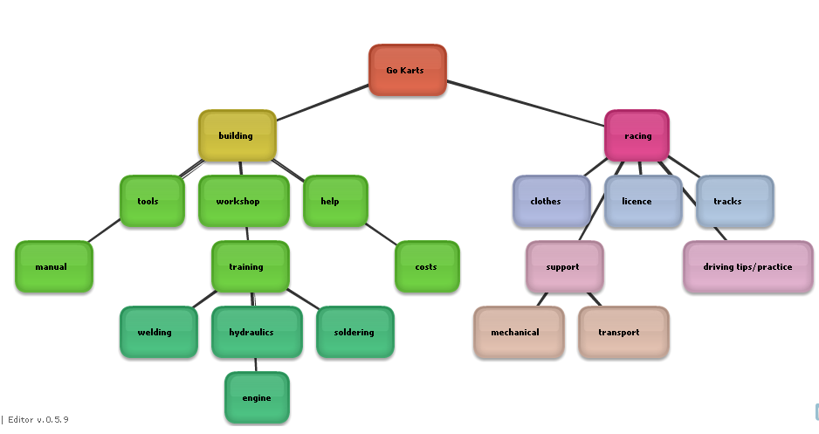
bubble.us example
http://bubbl.us/
(a free on-line tool but you need to create an account to save work)
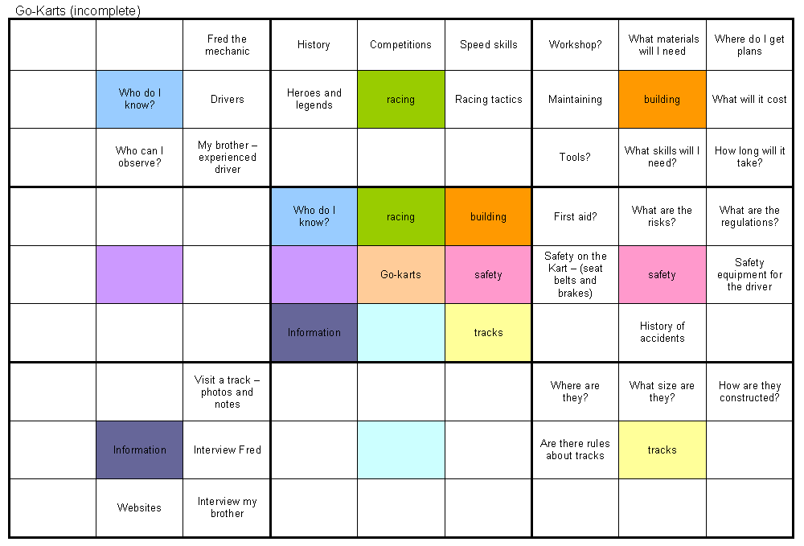
Lotus diagram example

Attachment 2: Research Skills – Self Evaluation Checklist

Adapted from: DECS Senior Secondary Reform Team Moodle, Research Project Bridging Course at http://dlb.sa.edu.au/csmoodle/file.php/65/SelfEvaluationChecklist.doc

RESEARCH SKILLS - SELF EVALUATION CHECKLIST
How do you think you rate as a researcher? Tick (✓) where you fit along the scale for each skill. You can then discuss and plan how to improve your skills with your teacher or your librarian.

DEFINING | ☺ 😐 ☹ ?  Always Sometimes Never I need to find  out what this  means
I analyse a topic and identify key words for use in search strategy.
I use my prior knowledge to brainstorm and map ideas.
I use graphic organisers to plan my searches.
I identify a variety of sources for use in searches.
I plan ahead to meet task deadlines and other requirements.
I create and then refine my own focus questions as I research.
LOCATING | ☺ 😐 ☹ ?  Always Sometimes Never I need to find  out what this  means
I identify and access a variety of information sources within school.
I identify and access a variety of information sources in the community.
I use simple and Boolean terms in a search inquiry.
I use email to request and share information.
I locate current information using periodical indexes and online sources.
I evaluate and selectively record information from print and electronic sources.
I understand the importance of purpose, credibility and currency when looking at sources.
I use a range of search engines, directories and databases to access information from the internet.

SELECTING | ☺ 😐 ☹ ?  Always Sometimes Never I need to find  out what this  means
I skim and scan information using Contents, Index, textual and contextual cues.
I compare information for relevancy from a variety of sources.
I make notes of relevant information only, in an appropriate format.
I can recognise fact and opinion, bias and omission in information sources.
I review and modify my focus questions and research plan as I progress.
I identify where information is lacking and locate additional information when necessary.
I record details of all sources of information used.
I understand and avoid plagiarism.

ORGANISING | ☺ 😐 ☹ ?  Always Sometimes Never I need to find  out what this  means
I synthesise information from different sources.
I arrange selected information under appropriate headings and subheadings.
I predict consequences from information found.
I make generalisations from information found.
I draw conclusions from information found.
I use ICT to organise and edit ideas and information.
I include statistics, diagrams, tables and graphics to validate and illustrate findings.

PRESENTING | ☺ 😐 ☹ ?  Always Sometimes Never I need to find  out what this  means
I can present solutions to a problem.
I discuss or debate an issue effectively.
I develop presentations appropriate to the audience and the topic.
I generate appropriate tables, graphs and graphics to support and illustrate ideas.
I use desk-top publishing skills.
I use software programs to construct multimedia presentations.
I communicate ideas and information clearly and logically in writing, orally and via media.
I acknowledge all sources used in a bibliography.
EVALUATING | ☺ 😐 ☹ ?  Always Sometimes Never I need to find  out what this  means
I consider what research methods worked and why.
I consider what research methods didn’t work and why.
I understand and accept feedback.
I analyse audience response to my presentation.
I analyse my own understanding and meeting of task requirements.
I identify my own learning strengths and weaknesses.
I think about strategies to improve my own skills.
I am able to assess the skills of others.
I appreciate my own success and that of others.

Attachment 3: Research Skills Exercise

Adapted from: DECS Senior Secondary Reform Team Moodle, Research Project Bridging Course at http://dlb.sa.edu.au/csmoodle/file.php/65/Skills_exercise.doc

Skills Exercise
Imagine that this is your Research Question:

What has been the impact of wheat and bread on western culture?

- Try and think of five different (but related) questions that might be areas of research under this broad heading:

  - ___________________________________________________________
  - ___________________________________________________________
  - ___________________________________________________________
  - ___________________________________________________________
  - ___________________________________________________________

- If you wanted to find out which were the most commonly eaten types of bread in Australia through an internet search, what key words or phrases would you use?
  - _________________
  - _________________
  - _________________

- Go on-line and try to find an answer to the question in “2”. Was it easy to find useful information?
Circle one response: Very easy / not very easy / hard / very hard

- The following page (web-link) gives you information about the many different kinds of bread. http://www.gograins.com.au/grainsnutrition/ns/ns9_3.html
  - Which part of the URL (web address) tells you about the organisation that has published the page?
____________________________________________________________
  - How would you go to the main page of that organisation?
____________________________________________________________
____________________________________________________________
  - Follow the link and decide whether the information is likely to be completely objective or not. (“Objective” means based on facts and evidence, not opinions, emotions or personal involvement.)
____________________________________________________________
____________________________________________________________
- Information on the constituents of wheat can be found at:
  - http://www.grainfieldsaustralia.com/US/ingredients/wheat.shtml
  - http://www.aaccnet.org/cerealchemistry/backissues/1970/Chem47_720.pdf
  - http://www.wheatfoods.org/AboutWheat-what-is-wheat/Index.htm

Which of these web-sites a, b, or c; provides you with the most useful AND reliable information? Explain your decision.
_________________________________________________________________
_________________________________________________________________
_________________________________________________________________

- Now find three websites that tell you similar information about what wheat is used for.
  - http://www.
  - http://www.
  - http://www.
Which of these web-sites a, b, or c; provides you with the most useful AND reliable information about your question? Explain your decision.
_________________________________________________________________
_________________________________________________________________
_________________________________________________________________

- There are many different kinds of internet search engines. Pick a topic to research and enter your key words in the same way into each of the search engines linked below.
  - http://au.altavista.com/
  - http://search-cube.com/
  - http://www.dogpile.com/
  - http://scholar.google.com.au/
Compare the results of your search. Which of the search engines gave you the best access to information that you might be able to use? Explain your decision.
_________________________________________________________________
_________________________________________________________________
_________________________________________________________________
_________________________________________________________________
_________________________________________________________________

- Would any of the information that you have found in these exercises help you to answer the focus question we began with? (What has been the impact of wheat and bread on western cultures?)
  - Yes
  - No
  - A bit!

Explain your choice:
_________________________________________________________________
_________________________________________________________________
_________________________________________________________________
_________________________________________________________________
_________________________________________________________________

How might you change the original focus question now that you have a better idea about what sorts of information you were able to find?

_________________________________________________________________
_________________________________________________________________
_________________________________________________________________

- Think about what other ways you might gather information in relation to the new focus question and describe at least two here:

  - (example) Take notes in a supermarket about the quantity and range of different bread products available.

  - –

  - –

  - –

