STAGE 2 NUTRITION
ASSESSMENT TYPE 1: Investigations Folio
Sensory Evaluation (Design)
Core Topic 3: Diet Evaluation and Food Selection

Aim:
The aim of this task if to work safely and collaboratively to complete a practical investigation to determine what type of XXX chocolate is more appealing using senses taste, smell and feel.

Hypothesis:
Using senses taste, smell and feel the XXX white chocolate will be more appealing than the XXX milk chocolate.

Safety:
There were not many safety considerations:
- Safe use of knives
- Food contamination with other group’s food products
- Wash hands before touching chocolate

Variables:
Investigation:
Designs well-considered and clear nutrition investigations.

Independent:
Different flavour of XXX chocolate given to class testers
Dependent:
The dependent variables will be the characteristics such as flavor, texture, aroma, strengths of chocolate and creamy
Constants:
- Blocks of XXX chocolate white chocolate given to testers
- Blocks of XXX chocolate milk chocolate given to testers
- Both chocolates will be served on identical serviettes
- Food will be kept at room temperature

The setup of chocolate in blocks of two on the serviettes

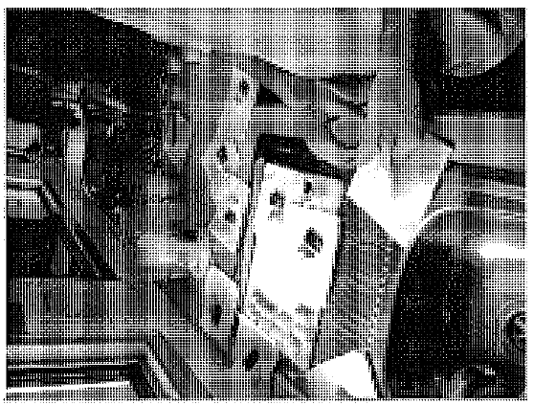

Method:

1. Organise score cards
2. Wash hands
3. Cut chocolate into blocks of two
5. Place chocolate on serviettes
6. Give chocolate and scorecard to each person
7. Gather scorecards and place serviettes in bin
8. Wash chopping boards and knives
9. Gather results from scorecards

Scorecard:
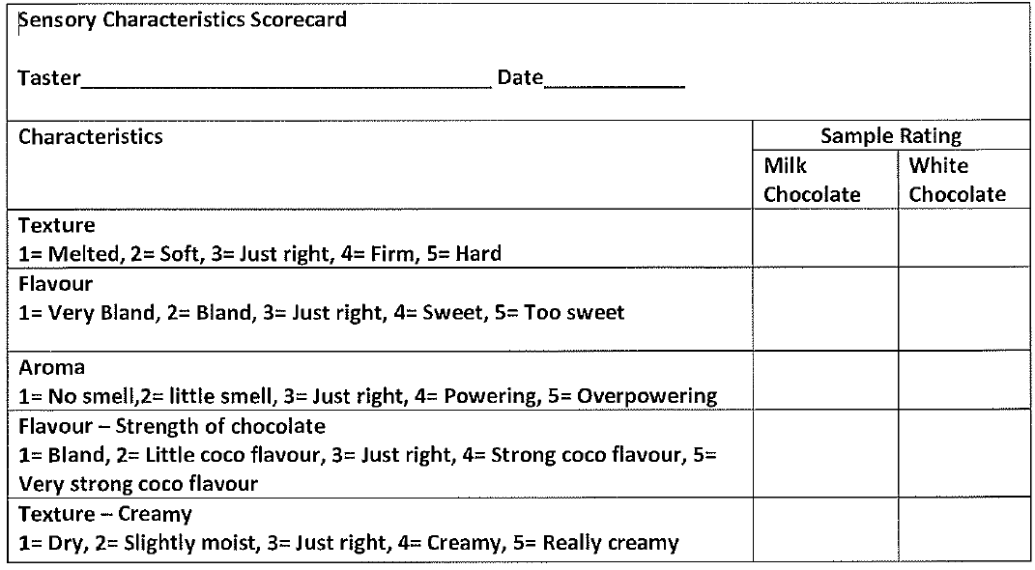

Results: See Appendix 1 for raw data
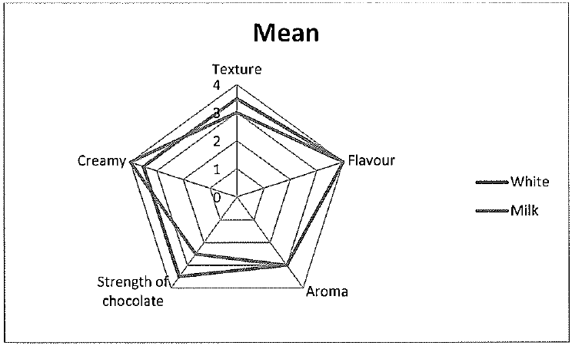
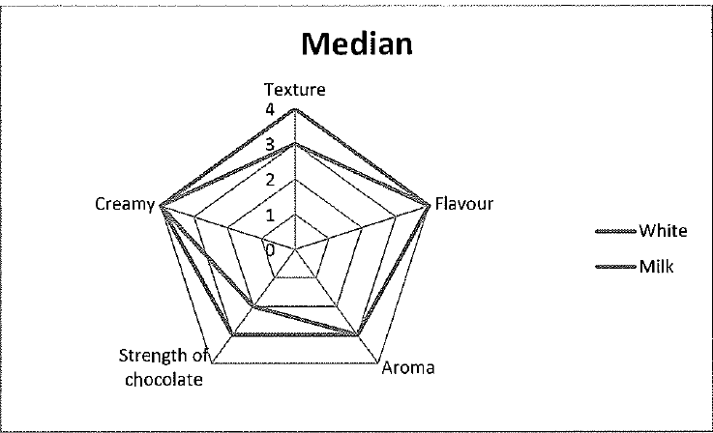
Investigation:
Obtains, records, and displays findings of investigations using generally appropriate conventions and formats with some errors but generally accurately and effectively.

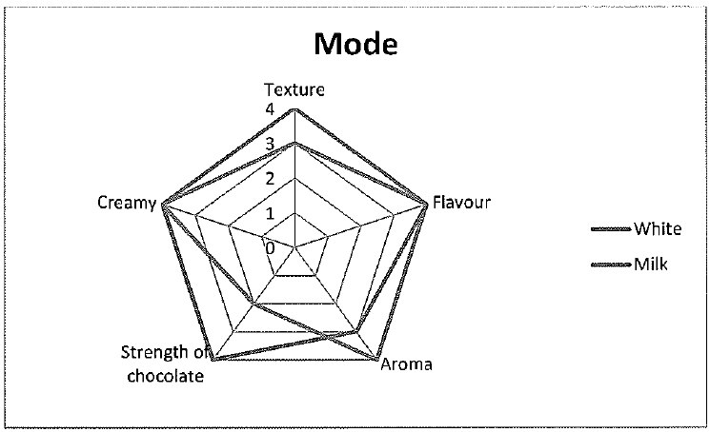
Discussion:
The results indicated that the milk chocolate was the closest to the neutral (middle) number of 3 for all characteristics. This however could come down to my personal preference. Some people may prefer the sweeter option or the creamier option. The graphs clearly indicate that milk chocolate had the overall higher numbers; therefore either most preferred or had the most stronger flavours, aroma etc. The nutritional values of the chocolate may influence feed preference for example milk chocolate has more sugar, which may appeal to people who like sweeter foods, however white chocolate has a higher fat total which may influence people to either avoid it or to like it more.
Strengths:
- Using something simple and distinctive to get the results we were after.
- Using chocolate benefitted us because it didn’t need to stay hot or cold. Something that needs to stay hot or cold is changed could affect the results greatly because it would not taste as nice.
- Another strength could be the characteristics we chose to judge. The characteristics were simple and would stand out through the chocolate which makes it easier for tasters.
Analysis and Evaluation:
Evaluates some procedures in nutrition and suggests some improvements that are generally appropriate.

- Picking something like chocolate that majority if people would like and/or wouldn’t be allergic to allowed for everyone to be a taster, therefore getting a wider variety of results
- Using different types of chocolate I think made it more focus on the characteristics rather than which one you prefer.

Weaknesses:
- Some weaknesses include not having a big range. We could have added dark chocolate to gain different data. We could have even done it with the same type of chocolate but different brands, although the different brands tend to have a very different taste.
Application:
Uses generally appropriate nutrition terms and conventions with some general effectiveness.

- Some errors include a few pieces of chocolate did not cut correctly and were a bit uneven. However, I do not think that would affect the results much. We didn’t really have many errors as the method was pretty simple to carry out. The data could have been affected by the testers’ taste buds being used to all the other tests they had done before eating the chocolate. There weren’t many errors that could have happened because the practical was fairly simple. I believe this could have also been because our choice of food to test.

Conclusion:
Looking at the results it seems that the milk and white chocolate results are very close. It does seem that milk chocolate if you were looking at which one has the most characteristics close to 3 which would go against our hypothesis; however that does not determine which one is preferred. Different people have different taste buds and prefer different flavours for example how creamy the chocolate is. Some people may prefer it to be really creamy or some people may prefer the opposite. Overall it seemed the milk chocolate had higher values therefore I can conclude it was the most preferred.

Additional comments
- Teacher observation during the implementation of the investigation, together with the student’s own review, enables assessment of safe food handling and ethical implementation of the investigation (Investigation) and collaboration (Application)
- Evidence from this investigation contributes to an overall assessment for the Investigations Folio of a student’s use of appropriate nutrition terms and conventions (Application)

Appendix 1: Raw data

Characteristics | Sensory Testers scores on XXX White Chocolate
Texture | 3 | 3 | 4 | 4 | 3 | 4 | 3 | 3 | 4 | 3 | 3 | 2 | 4 | 3 | 3 | 3 | 4
Flavour | 4 | 5 | 4 | 4 | 2 | 2 | 4 | 3 | 4 | 5 | 5 | 5 | 4 | 5 | 2 | 5 | 4
Aroma | 4 | 4 | 3 | 3 | 2 | 4 | 3 | 2 | 3 | 3 | 2 | 3 | 4 | 4 | 4 | 4 | 4
Strength of Chocolate | 2 | 3 | 3 | 2 | 2 | 1 | 3 | 2.5 | 3 | 3 | 2 | 2 | 2 | 5 | 2 | 4 | 2
Creamy | 5 | 3 | 3 | 4 | 3 | 2 | 3 | 4 | 5 | 4 | 4 | 5 | 3 | 4 | 4 | 4 | 4
Characteristics | Sensory Testers scores on XXX Milk Chocolate
Texture | 4 | 3 | 4 | 4 | 4 | 4 | 3 | 3 | 4 | 3 | 4 | 4 | 3 | 3 | 4 | 3 | 3
Flavour | 5 | 3 | 3 | 4 | 3 | 4 | 4 | 3 | 3 | 4 | 4 | 4 | 4 | 3 | 4 | 4 | 4
Aroma | 2 | 5 | 3 | 3 | 3 | 4 | 3 | 3 | 3 | 2 | 4 | 4 | 3 | 3 | 3 | 4 | 3
Strength of Chocolate | 4 | 4 | 3 | 4 | 3 | 3 | 4 | 3 | 4 | 4 | 3 | 3 | 4 | 3 | 3 | 4 | 2
Creamy | 3 | 3 | 3 | 3 | 4 | 4 | 4 | 4 | 4 | 4 | 4 | 4 | 3 | 4 | 3 | 3 | 3

Mean:

Characteristics | White | Milk
Texture | 3 | 3.5
Flavour | 4 | 4
Aroma | 3 | 3
Strength of Chocolate | 2.5 | 3.5
Creamy | 4 | 3.5

Medium:

Characteristics | White | Milk
Texture | 3 | 4
Flavour | 4 | 4
Aroma | 3 | 3
Strength of Chocolate | 2 | 3
Creamy | 4 | 4

Mode:

Characteristics | White | Milk
Texture | 3 | 4
Flavour | 4 | 4
Aroma | 4 | 3
Strength of Chocolate | 2 | 4
Creamy | 4 | 4

Milk Chocolate

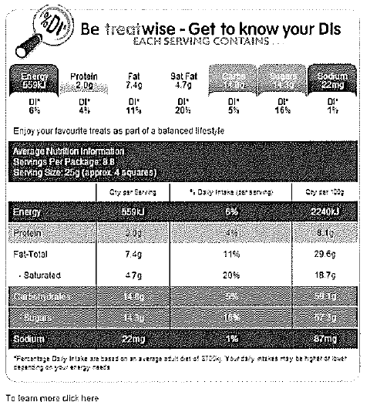

Legal Descriptions: XXX Milk Chocolate
Ingredients: Full Cream Milk. Sugar, Butter, Cocoa Mass, Milk Solids,Emulsifiers (Soy
Lecithin, 476), Flavours
Milk Chocolate contains Cocoa Solids 26%, Milk Solids 28%

White Chocolate

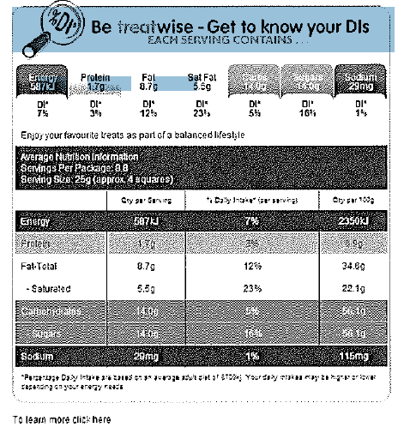
Legal Description: XXX Smooth and Creamy White Cholocate
Ingredients: Sugar, Milk Solids, Cocoa Butter, Emulsifiers (Soy
Lecithin, 476), Flavours

Performance Standards for Stage 2 Nutrition
 | Investigation | Analysis and Evaluation | Application | Knowledge and Understanding
A | Designs logical, coherent, and detailed nutrition investigations.  Critically and logically selects and consistently and appropriately acknowledges information about nutrition and issues in nutrition from a range of sources.  Manipulates apparatus, equipment, and technological tools carefully and highly effectively to implement well-organised safe and ethical investigation procedures.  Obtains, records, and displays findings of investigations using appropriate conventions and formats accurately and highly effectively. | Critically and systematically analyses data and their connections with concepts, to formulate logical and perceptive conclusions and make relevant predictions.  Logically evaluates procedures and suggests a range of appropriate improvements. | Applies nutrition concepts and evidence from investigations to suggest solutions to complex problems and to promote good health in new and familiar contexts.  Uses appropriate nutrition terms and conventions highly effectively.  Demonstrates initiative in applying constructive and focused individual and collaborative work skills. | Consistently demonstrates a deep and broad knowledge and understanding of a range of nutrition concepts.  Uses knowledge of nutrition perceptively and logically to understand and explain issues related to diet, lifestyle, culture, and health.  Uses a variety of formats to communicate knowledge and understanding of nutrition in different contexts coherently and highly effectively.
B | Designs well-considered and clear nutrition investigations.  Logically selects and appropriately acknowledges information about nutrition and issues in nutrition from different sources.  Manipulates apparatus, equipment, and technological tools carefully and mostly effectively to implement organised safe and ethical investigation procedures.  Obtains, records, and displays findings of investigations using appropriate conventions and formats mostly accurately and effectively. | Clearly and logically analyses data and their connections with concepts, to formulate consistent conclusions and make mostly relevant predictions.  Evaluates procedures and suggests some appropriate improvements. | Applies nutrition concepts and evidence from investigations to suggest solutions to problems and to promote good health in new and familiar contexts.  Uses appropriate nutrition terms and conventions effectively.  Applies mostly constructive and focused individual and collaborative work skills. | Demonstrates some depth and breadth of knowledge and understanding of a range of nutrition concepts.  Uses knowledge of nutrition logically to understand and explain issues related to diet, lifestyle, culture, and health.  Uses a variety of formats to communicate knowledge and understanding of nutrition in different contexts coherently and effectively.
C | Designs considered and generally clear nutrition investigations.  Selects with some focus, and mostly appropriately acknowledges, information about nutrition and issues in nutrition.  Manipulates apparatus, equipment, and technological tools generally carefully and effectively to implement safe and ethical investigation procedures.  Obtains, records, and displays findings of investigations using generally appropriate conventions and formats with some errors but generally accurately and effectively. | Analyses data and their connections with concepts, to formulate generally appropriate conclusions and make simple predictions, with some relevance.  Evaluates some procedures in nutrition and suggests some improvements that are generally appropriate. | Applies nutrition concepts and evidence from investigations to suggest some solutions to basic problems and to promote good health in new or familiar contexts.  Uses generally appropriate nutrition terms and conventions with some general effectiveness.  Applies generally constructive individual and collaborative work skills. | Demonstrates knowledge and understanding of a general range of nutrition concepts.  Uses knowledge of nutrition with some logic to understand and explain one or more issues related to diet, lifestyle, culture, and health.  Uses different formats to communicate knowledge and understanding of nutrition in different contexts with some general effectiveness.
D | Prepares the outline of a nutrition investigation.  Selects and may partly acknowledge one or more sources of information about nutrition or an issue in nutrition.  Uses apparatus, equipment, and technological tools with inconsistent care and effectiveness and attempts to implement safe and ethical investigation procedures.  Obtains, records, and displays findings of investigations using conventions and formats inconsistently, with occasional accuracy and effectiveness. | Describes basic connections between some data and concepts, and attempts to formulate a conclusion and make a simple prediction that may be relevant  For some procedures, identifies improvements that may be made. | Applies some evidence to describe some basic problems and identify one or more simple solutions, or to promote good health, in familiar contexts.  Attempts to use some nutrition terms and conventions that may be appropriate.  Attempts individual work inconsistently, and contributes superficially to aspects of collaborative work. | Demonstrates some basic knowledge and partial understanding of nutrition concepts.  Identifies and explains some nutrition information that is relevant to one or more issues related to diet, lifestyle, culture, and health.  Communicates basic information about nutrition to others, using one or more formats.
E | Identifies a simple procedure for a nutrition investigation.  Identifies a source of information about nutrition or an issue in nutrition.  Attempts to use apparatus, equipment, and technological tools with limited effectiveness or attention to safe or ethical investigation procedures.  Attempts to record and display some descriptive information about an investigation, with limited accuracy or effectiveness. | Attempts to connect data with concepts, formulate a conclusion, and make a prediction.  Acknowledges the need for improvements in one or more procedures. | Identifies a basic problem and attempts to identify a solution or promote good health in a familiar context.  Uses some nutrition terms or conventions.  Shows emerging skills in individual and collaborative work. | Demonstrates some limited recognition and awareness of nutrition concepts.  Shows an emerging understanding of an issue related to diet, lifestyle, culture, and health.  Attempts to communicate information about nutrition.

