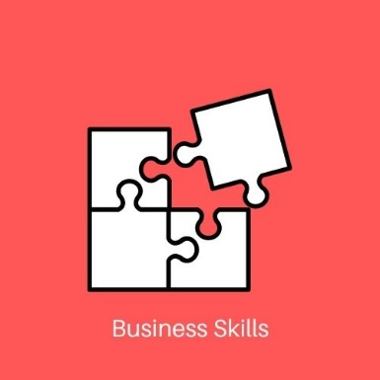
Stage 2 Business Innovation
Task 1: Create Your Own Business!
Assessment Type 1: Business Skills (40%)
Weighting: 20%

As part of this task, you will work within the designing business concept to create a business:
- That follows the design thinking process.
- That has taken a customer-focused approach to identify problems people face in their daily lives.
- With a proposed solution to the customer problem with a clear link between customer pains, gains and jobs and how your solution assists and alleviates these.
- With a prototype of your proposed solution.
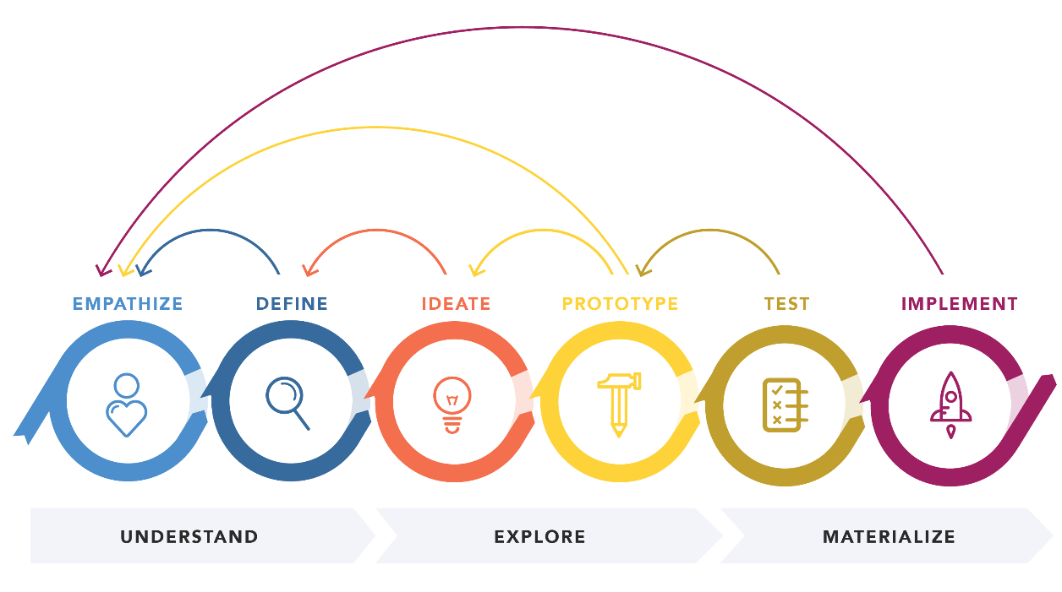

Phase 1: Understand
In groups of 3 or 4, you will spend the next 48 hours working collaboratively to brainstorm problems that people face in their daily lives across the world.
Collaboratively, create an empathy map as a way of empathising with your customer for one of the chosen problems from your brainstorming sessions.
When you have determined who your chosen customer is and the problem you believe they are facing (collaboratively), you will individually start to define your own customer and problem hypothesis through the use of an Experiment Board or Lean Validation Board. You may want to explore other problems that your group did not explore. Here you will engage in testing to validate (or invalidate) your problem and customer hypothesis. You may need to pivot.
You may need to engage in primary and secondary research here. It is recommended that you utilise the following resources to document your testing process. You may select:
- Test Card
- Learning Card
- A day in the life
- Experiment Card
- Any other tools from your textbook
**it is important to note, that the more tools you use, does not mean you will receive a higher grade. It is about being selective with what you choose to use and how you use them.
Provide a 500-word annotated Lean Validation Board or Experiment Board (whether it be with arrows pointing to sections of the LVD or EB, or in paragraph format underneath *or both*) discussing your pivot points, how you received feedback, decisions made, etc. refer to the tools you selected and why you chose them. You could use the sections of the LVD and EB as paragraphs for your annotation (if you like structure!)
There needs to be an outcome – was your problem and customer validated or invalidated and why/ why not? And how do you know this?

Phase 2: Explore
For your customer problem and hypothesis you will now complete a Value Proposition Canvas (VPC) describing:
- Customer Jobs
- Customer Pains
- Customer Gains
This is the circle side.
Coming back together with your group, you will attempt to generate possible solutions to the customer pains, gains and jobs for each group member. This could be done through mural or stormboard.
Refer to your LVB or EB and now document your solution hypothesis.
You will need to develop a prototype, a sketch or a full mock-up of your proposed solution (your MVP). You need to develop detailed drawings, annotations and notes outlining the product (good/service) and how it meets the customers’ needs and wants. You can engage in low profile (sketching, drawing) or high profile (3D model) prototyping.

Phase 3: Materialise
Here you will engage in the testing process again to validate (or invalidate) your proposed solution. The Testing Business Ideas textbook has a range of tests you might engage with to help validate your proposed solution. Be sure to document your pivots and decisions on your LVB or EB.
Complete a final LVB or EB
Finalise your VPC by describing your value proposition in terms of:
- Pain Relievers
- Gain Creators
- Products and Services
Provide a 500-word evaluation of the testing and prototype process referring to supporting documents and business intelligence within your portfolio.
Develop a 2-minute ‘pitch’ that highlights:
- The customer hypothesis, problem and proposed solution
- Key pivots and insights from your product development process
- Proposal of your Minimum Viable Product (MVP)
Your pitch must be multi-modal but can be in any format you choose e.g. promotional video, ad campaign etc

Assessment Conditions
You will submit and be assessed on:
- Your 500-word annotation LVB or EB (this includes all words included in the LVB/EB)
- Your 500-word evaluation
- 2-minute pitch (equiv to 200 words)
You will submit the following supporting documents but not be assessed on:
- Testing tools e.g. test card, LVB
- Your empathy map
- Brainstorming documents
Submission Format
A choice of:
- Adobe Spark Page
- Mural
- Weebly
- PDF
- Negotiated format

Assessment Design Criteria
FSP1 Identify and explore problems and/or needs using a customer-focused approach
FSP2 Generate viable solutions to problems and/or needs using customer-focused approaches
CA1 Contextual application of decision-making and project management tools and strategies
CA2 Create and apply business intelligence to iteratively develop business models and plans
CA3 Contextual application of communication and/or collaborative skills.

- | Finding and Solving Problems | Contextual Application | Analysis and Evaluation
A | Insightful identification and exploration of problems and/or needs using customer-focused approaches  Highly creative generation of innovative and viable solutions to problems and/or needs using customer-focused approaches | Perceptive and highly effective contextual application of decision-making and project management tools and strategies  Astute and highly strategic creation and application of business intelligence to iteratively develop business models and plans  Astute and perceptive contextual application of communication and/or collaborative skills. | Discerning evaluation of business models and plans  Critical analysis and perceptive evaluation of opportunities and challenges for business in the digital age  Insightful analysis and evaluation of social, economic, environmental, and/or ethical impacts of global and local business.
B | Well-considered identification and exploration of problems and/or needs using customer-focused approaches  Creative generation of viable solutions with some innovation to problems and/or needs using customer-focused approaches | Well-considered and mostly effective contextual application of decision-making, project management and change management tools and strategies  Strategic creation and application of business intelligence to iteratively develop business models and plans  Mostly perceptive contextual application of communication and/or collaborative skills. | Mostly discerning evaluation of business models and plans  Mostly critical analysis and evaluation of opportunities and challenges for business in the digital age  Well-considered analysis and evaluation of social, economic, environmental, and/or ethical impacts of global and local business.
C | Considered identification and exploration of problems and/or needs using customer-focused approaches  Mostly creative generation of viable solutions to problems and/or needs using customer-focused approaches | Considered contextual application of decision-making, project management and change management tools and strategies  Competent creation and application of business intelligence to iteratively develop business models and plans  Effective contextual application of communication and/or collaborative skills. | Considered evaluation of business models and plans  Some critical analysis and evaluation of opportunities and challenges for business in the digital age  Considered analysis and evaluation of social, economic, environmental, and/or ethical impacts of global and local business.
D | Some identification and exploration of problems and/or needs using customer-focused approaches  Some generation of solutions to problems and/or needs using customer-focused approaches | Some application of decision-making, project management and change management tools and strategies  Some creation and application of business intelligence to iteratively develop business models and plans  Some contextual application of communication and/or collaborative skills. | Some analysis and description of business models and plans  Some analysis and description of opportunities and challenges for business in the digital age  Some analysis and description of social, economic, environmental, and/or ethical impacts of global and local business.
E | Attempted identification and exploration of problems and/or needs using customer-focused approaches  Attempted generation of solutions to problems and/or needs using customer-focused approaches | Attempted application of decision-making, project management and change management tools and strategies  Attempted creation and application of business intelligence to iteratively develop business models and plans  Attempted application of communication and/or collaborative skills. | Attempted description of business models and plans  Description of opportunities and challenges for business in the digital age  Description of social, economic, environmental, and/or ethical impacts of global and local business.

