Supervision, Verification, and Breach of Rules:

Guidelines and Exemplars for Teachers

Supervision and Verification policy
The policy is underpinned by the following principle:

“Students must submit for assessment only work that is their own, produced without undue assistance from other people or sources.”
(SACE Board of SA, p. 2).

Supervision and Verification strategies
Some features of assessment tasks make it difficult to verify that students produce work that is their own. This may potentially lead to a breach of rules. Examples of these features include student work completed outside the direct supervision of a teacher, work that requires planning, research, and drafting, allowing teachers and others to give advice and/or feedback during the development process and allowing the use of ICT programs in design or music arrangements.

Prevention of breaches of rules is the best measure. Classroom activities that assist in ensuring adequate supervision and verification of student work include:
- Closely monitoring what students are doing, talking to them about their progress, and giving advice.
- Providing specific guidance on avoiding plagiarism and including appropriate referencing. (Refer to resources available on the SACE website).
- Advising students of suspected plagiarism or poor referencing during the drafting stages of their work, so they have the opportunity to fix it before submission.
- Encouraging students to use a variety of source material (including primary data), minimise direct quoting of material, and reference all ideas and sources appropriately.
- Requiring parts of the assessment task to be done in the classroom.
- Regularly developing new tasks, tests, assignments, and projects, and discarding ones from former years.
- Using a wide variety of assessment tasks that can provide a base for detecting anomalies.
- Setting appropriate assessment tasks that encourage student reflection and analysis of information rather than fact or information gathering, e.g. Why? and How? rather than Who? and What? (Refer to activities on page 2).
- Maintaining deadlines for assignments and keeping submitted work secure until assessed.
- Providing feedback on draft work that maintains the integrity of student’s work and does not directly change the original student response.
- Correcting or editing the student’s work. (Refer to Levels of Intervention, pages 3 and 4).
- Using verification sheets (required for some externally assessed tasks) to confirm that the student work was verified by the teacher throughout the development stage, from drafts to the final work submitted for assessment. (Refer to subject pages on website).

Plagiarism in Student Writing
Activity 1
The following is an excerpt of a student text.
Issue Analysis – Stage 2 Information Technology
Companies no longer require graphic design companies to assist in the production of publications. Instead, they publish in-house or sub-contract the work out to a home-based desktop publisher. Contractors are discovering that they can work from home with minimum start-up costs and that desktop publishing is one of the easiest and most cost-effective industries to establish. As a result, the expansion of desktop publishing as a small business opportunity has occurred.
Printing before desktop publishing came a long involved quite a lot of people doing lots of different things to get it together, things are a lot easier and quicker to do, as there aren’t so many people doing so many different jobs there is just the one or two maybe up to three people working on the same thing. In the future I think there will be more and more chances of more employment opportunities opening up because people are finding more and more uses for it, such as opening their own printing business in the home or doing it themselves without using a business.
How many authors?
What advice would you give to the student if this was a draft submission?
Activity 2
Discuss how the framing of these topics may present different opportunities for students to plagiarise material from other sources.
Example 1:
- Explain how local government works.
- To what extent does local government provide an opportunity for the community to participate in the democratic process?
Example 2:
- Alcoholism.
- Adelaide nightclubs and drunken street behaviour in the West End of Adelaide.
Example 3:
- The impact of take-away food on the health of teenagers.
- Takeaway food use by Year 12 students at ABC High School and the impact on their fitness and health.
In each example, topic (a) is very general and may lead to more opportunity for plagiarism, as information gathered is more likely to be from internet sources and include the use of secondary data and other people’s views and research.

Topic (b) of each example provides a better opportunity for students to investigate the issue in their local environment using primary data, gathered from surveys and interviews, and requires students to present their own conclusions.

Levels of Intervention
According to the Supervision and Verification of Students’ Work Policy:

“Work that is unacceptable because of undue levels of assistance includes that which incorporates corrections or changes that the teacher or another person made.”
(SACE Board of SA, p. 4).

Editing has its place in the writing process, but when a teacher assumes this role, it is difficult to ascertain what the student’s work is and what the teacher’s work is. The level of editing in the next example transforms the student’s work to a point where it can be argued it is no longer the student’s own work. An example of teacher editing rather than providing feedback about a student’s work, in a Biology practical report, follows.

The original student work has clearly been heavily edited. It is very difficult to read the original student responses in the edited version.

The following provides some examples of more appropriate feedback to a student on the draft Biology practical report, which maintains the integrity of the student’s work:

You could list these factors to help the reader.

Feedback or editing?
Feedback | Editing
- ‘To be effective, feedback needs to cause thinking’ (Leahy et al. 2005)  - Teaches the student  - Provides general advice  - Offers suggestions  - Maintains the integrity of students’ work | - Changes the text  - Is explicit  - Provides solutions  - Suggests specific changes  - Risks losing the student voice in the work
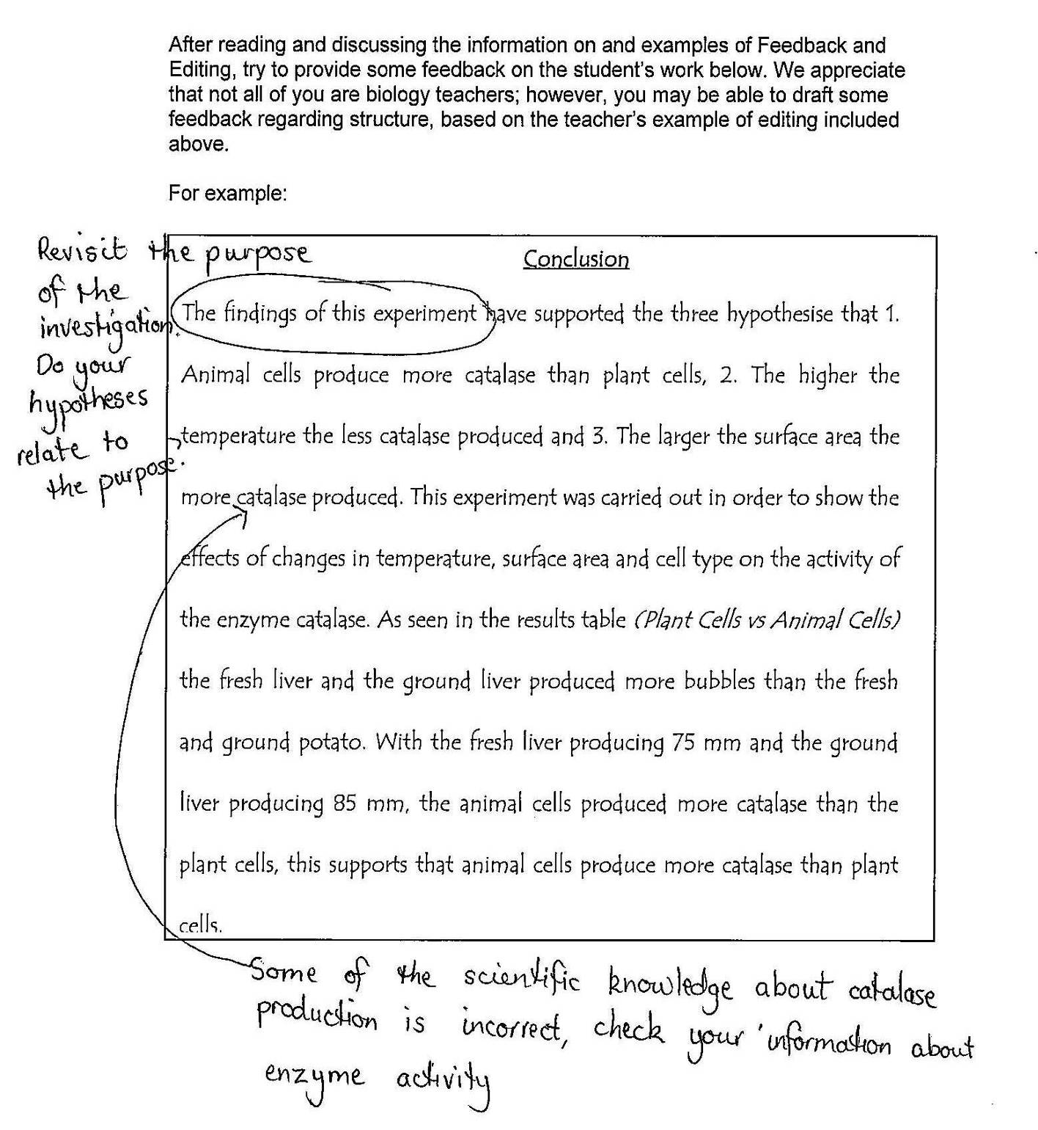
To support students to present their own work, ensure that:
Students know how to appropriately reference materials and sources

Students know what constitutes plagiarism
Students know the consequences of breaching the rules of assessment under direct or indirect supervision
A submitted assessment task that does not/may not represent the student’s own work could include work that:
- has been copied, without acknowledgment, from another person’s work or another source
- has quoted large sections verbatim from a source or sources, with little or no interpretation or comment
- closely paraphrases sentences or paragraphs from one or more sources without appropriate acknowledgment
- transcribes the ideas or material derived from other sources, with or without acknowledgment, even where the student minimally alters the material or not at all
- incorporates corrections or changes where the teacher or another person has given undue assistance
- the teacher has seen no development of and cannot verify that the work submitted is the student’s own.
Breaches of Rules procedures
If a breach of rules occurs in a school assessment:
- the school investigates and applies the penalty to the student mark/grade – see Breach of Rules (Information Sheet 3) for recommended penalties.
If a breach of rules occurs in an externally assessed task:
- the school investigates and reports the breach to the SACE Board using the Breach of Rules (Form 02) with relevant evidence and the recommended penalty. The penalty should not be applied to the student’s results.
For more information regarding the process for dealing with breaches of rules in both school and external assessment, please refer to Breach of Rules (Information Sheet 3) and the flowchart overleaf.

School Assessment (70%) – Moderation
‘Variations – Moderation Materials’ form (all subject minisites)
Breach of Rules (Information Sheet 3)
Breach of Rules (in school tasks) such as:
- plagiarism
- missed deadlines
- collusion
- undue assistance
- verification issues.
School investigates and applies penalties
(advice and suggestions available from the
SACE Board and Breach of Rules (Information Sheet 3)
Breach of Rules (Information Sheet 3)

Document decisions and processes at
the school (e.g. student interviewed)
Moderation
If student’s work is submitted for moderation and the marks/grades include a penalty for breach of rules, include a completed ‘Variations – Moderation Materials’ form (from the subject page on the website), in moderation bag, detailing the breach and the penalty applied.
Supervision, Verification, 8115 4854
SACE.SpecialProvisions@sa.gov.au

External Assessment (30%) – Marking
Breach of Rules (Information Sheet 3)

Breach of Rules in an external task such as:
- plagiarism
- exam breaches, e.g. conduct, unauthorised materials
- collusion
- undue assistance
- verification issues.
 | SACE Board investigates and applies penalties if appropriate (teacher marks at face value)
Breach of Rules (Form 02) | Breach of Rules form to the SACE Board  - include as much information/evidence as possible + recommendations
Results Sheets for External
- Tick Breach of Rules box for appropriate student/s (form submitted)
- Enter marks/grades at face value
 | SACE Board informs principal of outcome

Further Support
The following support materials and websites include information and tutorials that can be used by students as an introduction and guide to plagiarism and referencing.

Referencing
The following SACE Board publications have been developed to help students and teachers with referencing:
Guidelines for Referencing
Student Guide to Referencing
Academic Writing Skills: Referencing
Locating evidence: a guide for students
Evaluating online sources: Checklist for students

The following website would also be useful:
HSC: All My Own Work 2006, Board of Studies NSW, accessed 30 September, 2014
<http://amow.boardofstudies.nsw.edu.au/index.html>
- A series of modules on plagiarism and referencing sources.
Plagiarism
The following SACE Board publications have been developed to help students and teachers with plagiarism:
Avoiding plagiarism – Guidelines for Teachers and Students
Academic note taking templates
Academic writing skills: Paraphrasing and Summarising

The following websites/tutorials would also be useful:
You Quote It, You Note It! 2011, Acadia University Library, Nova Scotia, Canada, accessed 30 September, 2014 < http://library.acadiau.ca/tutorials/plagiarism/>
- A short tutorial on when and how to reference.

What is Plagiarism? 2014, Plagiarism.org, accessed 30 September, 2014
<http://www.plagiarism.org/plagiarism-101/what-is-plagiarism/>
- Information on what plagiarism is and how to avoid it. Strategies for students and teachers.

Is it all my own work? IPAwareness Foundation, accessed 30 September, 2014
<http://www.nothingbeatstherealthing.info/resources>
- Resource Downloads - Unit 2. Quiz and teacher guide focusing on what is considered legal or not when using digital resources.

Breach of Rules
Breach of Rules (Information Sheet 3)
Breach of Rules (Form 02)

These documents can be found on the SACE Operations minisite, or at
https://www.sace.sa.edu.au/web/sace-operations/documents/info-sheets-forms-a-z?v=1
References
Leahy, S., Lyon, C., Thompson, M., & Wiliam, D 2005, ‘Classroom assessment: Minute-by-minute and day-by-day’, Educational Leadership, vol. 63, no. 3, pp. 19–24.
SACE Board of SA, ‘Ethical Conduct of Research’, South Australia.
SACE Board of SA, ‘Supervision and Verification of Students’ Work’, South Australia.

