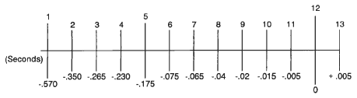**Timeline of events.**

When submitting an oral, multimodal or written PLAN as part of the task, a graphic timeline showing the sequence and specific timings of events occurring, could serve as a useful tool to develop a more thorough approach to guiding and developing your composition.

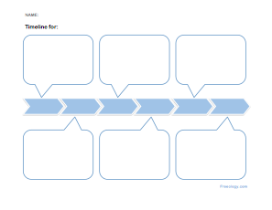. . .

10 sec

20 sec

30 sec

40 sec

50 sec

60 sec

70 sec

80 sec

90 sec

100 sec

110 s sec

120 s sec

If this timeline does not suit your purposes, devise one of your own that will cater to your individual needs.