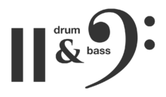
Stylistic interpretation is essential to any performance.
Investigate the conventions of the chosen style/ genre by answering the following series of questions and relate your answers back to the specific repertoire.
Your response is to be submitted PRIOR to the final ensemble performance. You may submit in a written format, oral presentation, multi modal presentation and/ or a combination of the above. You may also include musical examples with annotations if you wish.

- When was the music written that you are performing?
- Classify the music into a specific style / genre.
- Categorise the music into a specific geographical location or region.
- Place the repertoire into context - Why was the music written? Who was the intended audience?
- Does this change the way you interpret the music in a performance? How?
- Whilst not only discussing your own instrument or voice part, how should all of the other members of your ensemble aim to accurately interpret the style of the music?
- Is there a specific element of music that needs special attention for the stylistic interpretation to be accurate?
- Any other information?

