**Musical Links:**

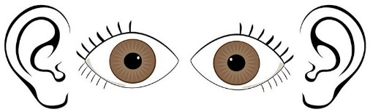**VISUAL** representation of phasing:

Wikipedia – Phase Music

“Rhythm_phasing_sixteen_parts_with_harmonic_series_pitches.ogv

<https://en.wikipedia.org/wiki/Phase_music>

**LISTENING** -You Tube

* Steve Reich “Clapping Music”

Shows a rolling score to see phasing / rhythmic displacement

<https://www.youtube.com/watch?v=lzkOFJMI5i8>

* Steve Reich “Electric Counterpoint, III”. Fast

Includes scrolling sheet music (visual representation)

<https://www.youtube.com/watch?v=_TKVpUSWCug>

* Steve Reich “Proverb”

For voices – overlapping of lyrics

<https://www.youtube.com/watch?v=I5lgAUHVFC4>