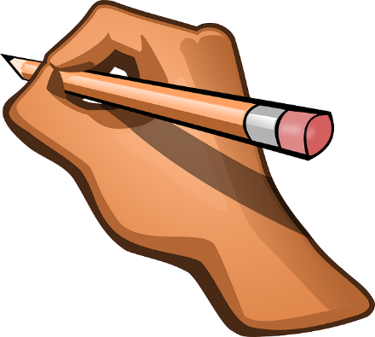
Graphic symbols may be used to represent your musical intentions within your arrangement. Create some here if you intend to use them within your arrangement:

Symbol | What it means
Example: | Upper inflection of the voice  i.e. starting a word with a low voice and immediately raising the voice to a higher sound

