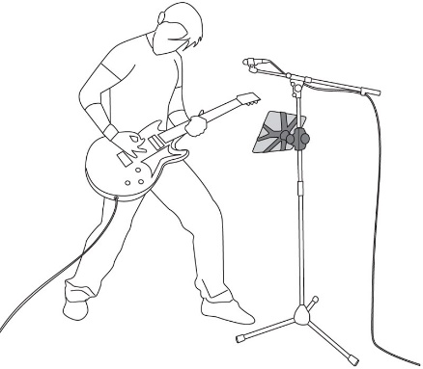

Checklist before you perform:
Ask yourself the following questions and reflect on personal goals and musicianship skills.

- How will I demonstrate appropriate performance practice?

- Have I seen a video of myself performing? What do I look like when I am performing? How would I describe my stage presence and ability to engage an audience?

- What do I need to do to effectively sound check prior to performing?

- Do I have the necessary skills and equipment to check my own intonation (tuning) prior to performing? How can I improve this?

- Am I organised? (music in order, stage set up etc)

