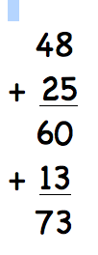
15 minutes of music - do the maths

Select several recordings of music for your radio show segment (You Tube, your personal music device, discs, vinyl record (they are making a comeback!)

Calculate the times of each selected chart and then add the times together – try doing this on paper for a bit of a brain workout - OR – there is a free downloadable Hours & Minutes Calculator Lite for iPad which is quick and easy to use.

Name of music and artist  Link / location of the recording | Total time of recording
Total time for playlist
__________ : __________

