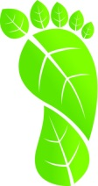
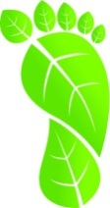
My Green Footprint!

Water | Please circle….
I turn off the tap when I’m brushing my teeth. | Rarely  2 | Sometimes  1 | Always  0
I am usually in the shower for.... | 10 Minutes  2 | 5 Minutes  1 | ≤ 3 Minutes  0
I use a bucket in the shower/bath to catch excess water to use on the garden. | Rarely  2 | Sometimes  1 | Always  0
I only half fill the kitchen sink when washing dishes | Rarely  2 | Sometimes  1 | Always  0
 | Total =
Waste
I put my breakfast, recess and lunch scraps in compost or green bins. | Rarely  2 | Sometimes  1 | Always  0
Any items I have that can be recycled I put into recycling bins. | Rarely  2 | Sometimes  1 | Always  0
I ask my mum/dad/caregiver to buy food with little or no packaging for my lunch and recess e.g. Nude food. | Rarely  2 | Sometimes  1 | Always  0
I try to re-use broken or old items for other purposes,  rather than buy new things, wherever I can. | Rarely  2 | Sometimes  1 | Always  0
 | Total =
Energy
I turn off my electric appliances (TV, Mp3 player, phone charger, laptop etc.) at the power point after I use them. | Rarely  2 | Sometimes  1 | Always  0
I switch off the lights when leaving a room. | Rarely  2 | Sometimes  1 | Always  0
I try to use only one electronic device at a time instead of having multiple appliances on (e.g. talking on a mobile, using a tablet to check social media, and having the TV on in the background). | Rarely  2 | Sometimes  1 | Always  0
I walk, ride, carpool or use public transport to travel to school, after-school & weekend activities (e.g. sports practice, visiting a friend, going to the shops etc.). | Rarely  2 | Sometimes  1 | Always  0
 | Total =
Consuming
I ask my parents to buy things that I need, rather than things I want. | Rarely  2 | Sometimes  1 | Always  0
All of my old clothes and unwanted items are handed down to family members and/or given to charity. | Rarely  2 | Sometimes  1 | Always  0
I avoid throwing out items just because they are no longer in fashion. | Rarely  2 | Sometimes  1 | Always  0
I ask my mum/dad/caregiver to only buy locally made or grown items, or items supporting socially and environmentally responsible organisations. | Rarely  2 | Sometimes  1 | Always  0
 | Total =

Mapping My Green Footprint
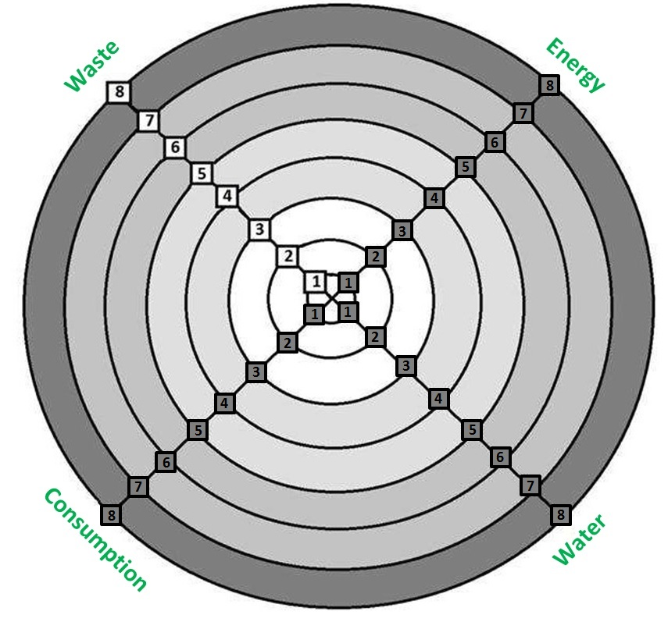
Where Can I Improve my Behaviour and Actions?
What are the areas  I can improve in? | What are some actions/behaviours I can adopt to improve in these areas?

